Karabiner Mountaineering Club
2005 Expedition.
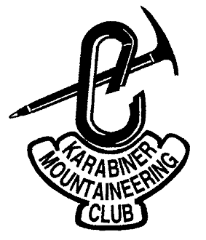

Tornarssuk Island, South Greenland.

19th July to 14th August 2005.

MEF Reference 05/26.

Final Report.

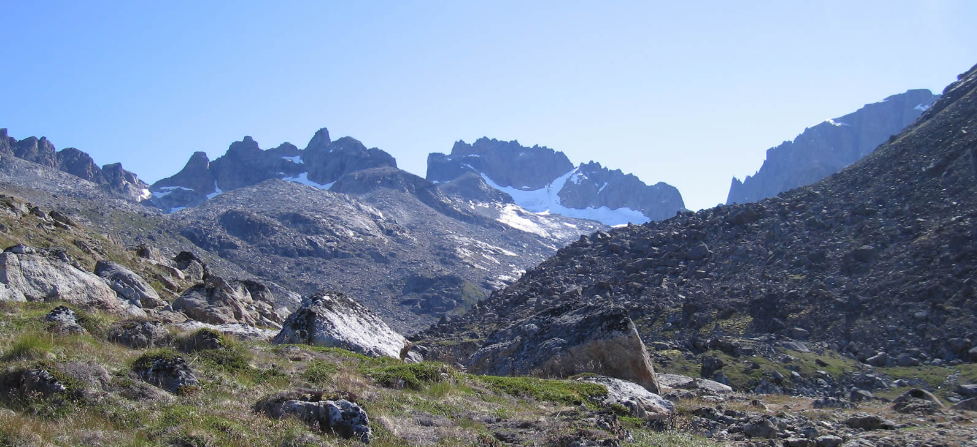
Edited by: David Bone. [Rev 1.0 29/10/05]
Flat 7, 6 Chatham Grove
Withington
Manchester
M20 1HS
United Kingdom.
Tel: +44 (0) 161 434 2717 (Evening)
Tel: +44 (0) 1925 247600 (Day)
Fax: +44 (0) 1925 247610
E-mail: dbone@norcott.co.uk. Club Website: www.karabiner.org.
Summary

This is the final report of the Karabiner Mountaineering Club’s 2005 Expedition to the island of Tornarssuk, Southern Greenland, near Cape Farewell. A mixed team of 5 emerged from a last minute debacle of cancellations and headed out by plane, helicopter and boat to the mouth of the Kukasit valley, on the west coast of Tornarssuk, an island not previously recorded as having a climbing team visit. The team had a generally poor and windy bag of weather, but with a few day or pair of days fine spells, managing to put up on few new rock routes around the valley, do much exploration, and some first ascents of various peaks. The expedition was considered a success under the circumstances, and some had their first experience of an expedition.
Contents:
1 Introduction. 3
2 Expedition Members: 3
3 Research. 4
3.1 Choices of area. 4
3.2 Tornarssuk and Quvnerit history. 5
3.3 Expedition Objectives. 6
3.4 Maps & Photographs. 7
4 Logistics. 7
4.1 Flights to Nanortalik. 7
4.2 Boat charter. 8
4.3 Accommodation. 8
4.4 Freighting. 8
5 Expedition Diary. 9
5.1 Maps and areas of interest. 17
6 Conditions. 18
6.1 Climbing and walking. 18
6.2 Weather. 19
7 Flora & Fauna. 20
7.1 Insect Life. 20
7.2 Flora. 20
7.3 Fauna. 21
8 Emergency & Contingency Handling. 21
8.1 Communications. 21
8.2 Communication plans. 21
8.3 Crisis Management. 21
8.4 Insurance & Permits. 22
9 Equipment. 22
9.1 Camping. 22
9.2 Stoves & Cooking. 22
9.3 Electronics. 22
9.4 Climbing kit. 23
9.5 Tools & Other Equipment. 23
10 Food & Shopping. 23
10.1 UK Shopping. 23
10.2 Greenland Shopping. 23
11 Environmental Practice. 24
12 Conclusion. 24
13 What’s left to do? 25
14 Acknowledgements. 26
15 Appendices. 28
15.1 Routes. 28
15.2 Topos & pictures. 28
15.3 Weather record. 33
15.4 Finances. 34
15.5 Bibliography. 34
15.6 Websites & Contacts. 35

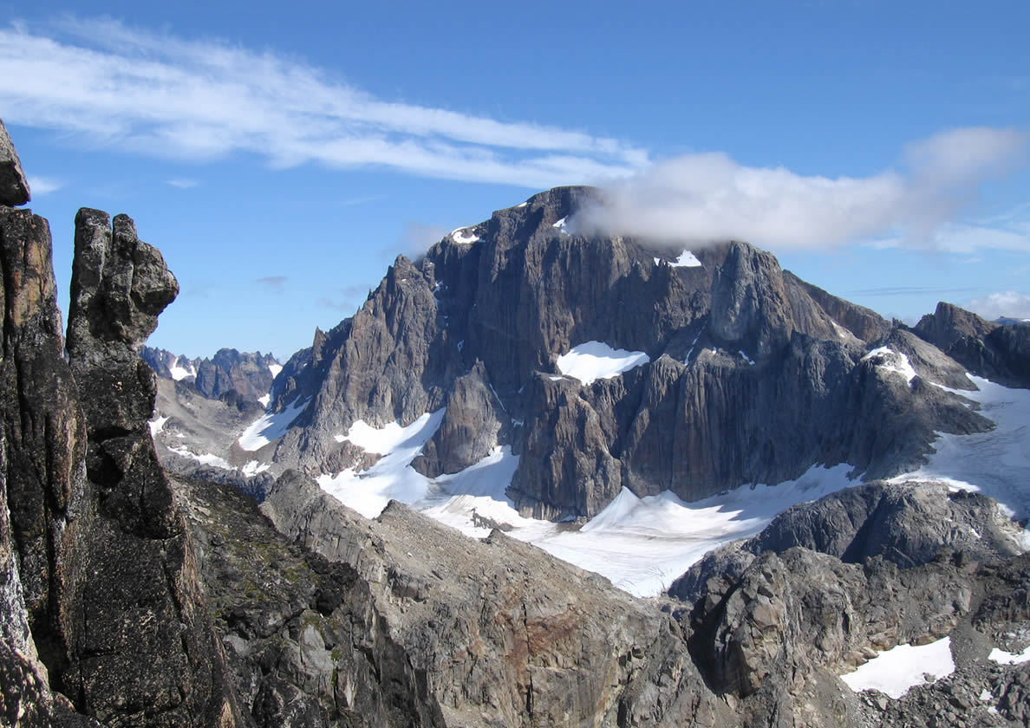
Figure 1. 1388m ("Valhalla") from pt1090m.

Cover: The skyline of the Kukasit Valley from base camp (looking east).

Introduction.
Following the Karabiner Mountaineering Club’s 2004 Expedition to the island of Pamiagdluk, Southern Greenland, the seeds of a return expedition to the area had been sown in the minds of several of the team. The sight of cliffs and jagged peaks in all directions indicated potential material for many visits to come and it was difficult to leave.
The expedition began with a small core group in November 2004 with a pile of marked up maps on the table - where to go this time? After the initial discussion, further research and several Emails, we found there were only a few holes in the exploration of the area. In the end it was the island of Tornarssuk, the next west of Pamiagdluk, and which we had had in mind as an interesting looking destination during the 2003 planning, that became the hot favourite. We could find little evidence of exploration and therefore had little more than the Aerial photographs to go on. We produced charts of interesting looking shadows from these. The linked island of Quvnerit had been visited in 2004 by a Swiss-German team, and contact with them encouraged us to press ahead. Due to work and home commitments, 3 of the old hands were lost by the new year, leaving the second time around leader, after further desperate recruitment, with a team of 6 all new to Greenland. This remained stable until the fortnight before departure when 2 more members were lost in quick succession because of the curse of work! This is the story of the preparation and of the fairly successful execution of the expedition.

Expedition Members:
With the exception of one based in Devon, all of the team are based in the Manchester area. The expedition membership varied considerably throughout the preparation phase with the event coming perilously close to cancellation on the weekend before we left. The final number left us a touch weak, and a trifle vulnerable in the eventuality of an accident. These who finally went were;
Dave Bone. Age: 43, occupation: Electronic Engineer. Expedition co-ordinator.
Dave graduated into climbing in 1989 from hill walking in UK, Europe and Tasmania. Since then he has climbed to E2 in throughout UK, Europe. USA & Canada. He has been winter/ice climbing in the UK and Alps, and has had a number of Alpine seasons with mixed and long rock routes plus some solo peak bagging. Dave has organized a group expedition to the Caucasus, with attempts on peaks in the Elbrus region (including Elbrus). Took part in a guided expedition to the Gangotri region of the Indian Himalayas, reaching 5900m on attempts on Peaks and mixed routes.
Dan O'Brien. Age: 21, occupation: Student.
Dan began hillwalking nine years ago and has been a keen rock climber for the past five years. He climbs regularly around the UK with Salford University MC and Karabiner MC. He is a competent leader to E1 and Scottish II/III. He has done three Scottish winter seasons, three alpine summers (including Mont Blanc). Dan enjoys all aspects of mountain sports, from multi-pitch winter routes to bouldering, and is a competent skier.
David Whittingham. Age: 55, occupation: Employment Law Consultant.
David has been climbing since the 1970's, leading to VS on rock and IV Scottish. He has climbed and walked extensively in Britain plus climbing trips to Spain and the Alps, with trekking in the Moroccan Atlas and the Nepal Himalaya. Other outdoor pursuits have included ocean racing and downhill skiing.
Marylise Dufaux. Age: 40, occupation: freelance educator.
Has been climbing for 7 years, enjoys adventurous climbing, leads HVS. Has several alpine seasons (summer and winter) under her belt and an expedition to the Indian Himalaya (self organised, attempt on unclimbed peak), where she organised food for the expedition. Climbing includes multi-pitch rock routes (eg. Dibonna in the Ecrins), alpine routes, eg. the Gervasutti couloir in the Mont Blanc range and a new route on a subsidiary peak in the Indian Himalaya (6,000 m, PD) (unable to find a passage through an ice fall barring access to the main peak).
Carl Pulley. Age: 40, (unemployed) lecturer.
Climbing for 12 years. Solid E1 climber. Climbed extensively throughout UK with numerous climbing trips to Europe and Tasmania. Some new routing in Outer Hebrides.

Research.
The core members researched the climbing history of the area amongst expedition reports and articles from the BMC, MEF, Alpine Club, American Alpine Club, DAV Panorama, RGS (with a visit to the reading room), magazines (eg. High Mountain services – www.planetfear.com ), and of course, the Internet. The source articles on the Internet may be accessed via the links in the following text, though they cannot be guaranteed to always work! And most importantly we talked to people who had been in the area before (see acknowledgements).
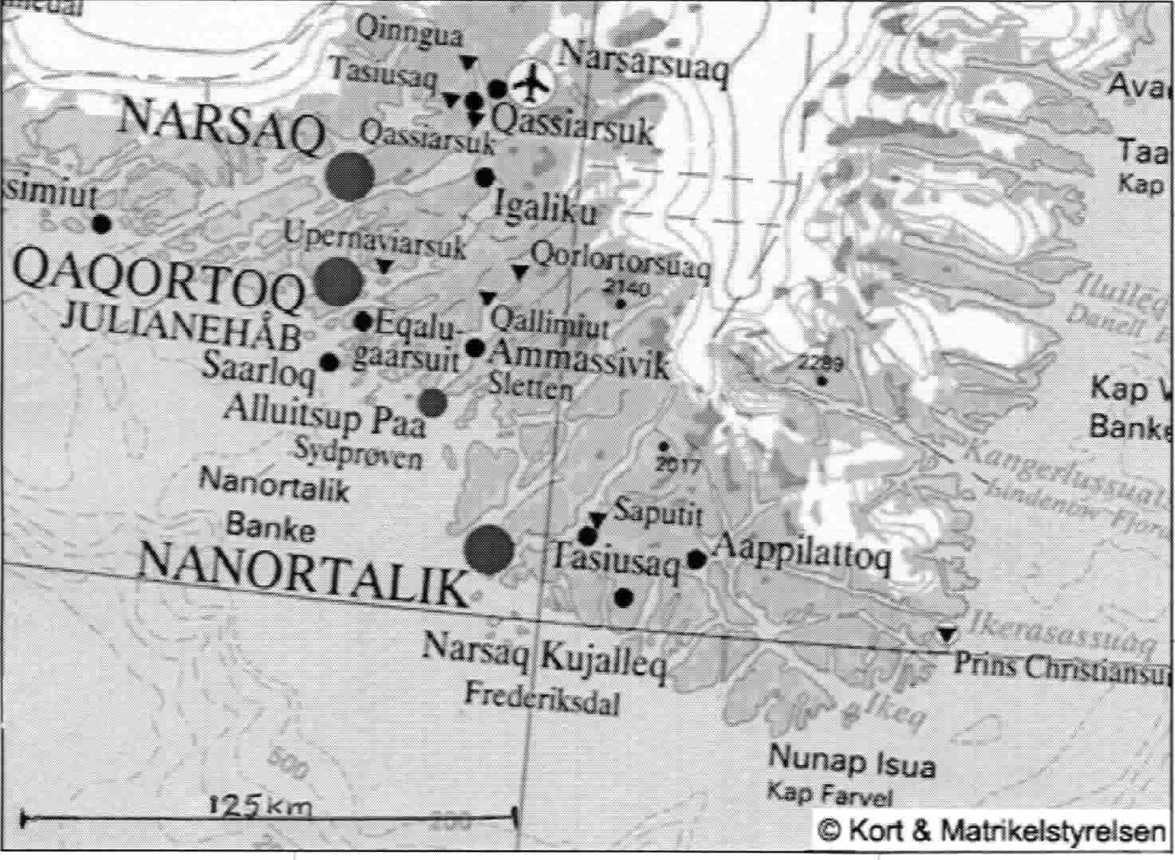
Tornarssuk
Figure 2. Southern Greenland general area map.

Choices of area.
The gateway to Southern Greenland is the town of Nanortalik. The general area is shown in Figure 2. We were looking for an area in the islands East of Nanortalik, which offered something new – our prior knowledge of Pamiagdluk naturally leading us to this area. We had to satisfy a range of experience, abilities and interests. Research concentrated on the Islands of Tornarssuk, Quvnerit, Pamiagdluk, Christian IV, Sangmissoq and their immediate surrounds. Other areas included Prins Christiansund and North of the settlement of Aappilattoq. The first inclination was to return to Pamiagdluk to land at a new access point as quite a lot was known on Pamiagdluk, it proving to be by far the most popular of the islands. Though a few small areas were left to explore, the limitations and uncertainty of access led the group to move on. The focus moved from island to island as more research showed that every island had had one expedition and perhaps a flying visit or two. However, all had plenty of pickings left but the length of boat journey to eastern Christian IV or Sangmissoq was a consideration to ponder. Eventually we returned to what had been our initial choice of area for 2004, Tornarssuk, where now the fact that little was known about it appealed more – there were just a few photographs from afar, giving tantalising glimpses of features that might be in the area. The island tends to be paired with Quvnerit to the East to which it is joined at low tide. There has been an increasing trend to not report activities, so we cannot claim to have traced a full account though.

Tornarssuk and Quvnerit history.
In looking into the history of climbing here back into the 50’s, we found the first record of a visit to the island was of a Danish expedition in 1970. However, this was not a climbing but a photographic expedition and there are only photographs from this, some of which may be found on http://www.arktiskebilleder.dk/siulleq/album/. The islands have also visited by Danish surveyors, with a number of old expeditions finding unexpected surveyors cairns on odd Tops as we did. There must be some interesting stories from those times.
The first ‘modern’ mountaineering record is of the University of St. Andrews expedition to Stordalens Havn (an Anchorage NW of Pamiagdluk) in 1975. They moved around a bit but visited North Pamiagdluk and Quvnerit as well (actually not Tornarssuk as the report suggests) and bagged 3 peaks on the NE corner of Quvnerit. A report recently appeared on the web at www.greenlandexpedition.com.
The Queens University Belfast Expedition of 1980 (based on Christian IV) paid a day visit by boat to the Itivdliaq isthmus. They indicated the channel is basically a boulder choke, but that access to the hills on either side of the channel was problematic, particularly so on Quvnerit, where the hills rise directly out of the fjord.
In 2004 a 7 strong Swiss-German team headed by Michi Wyser spent 6 weeks in the area from the end of July. They had a pair of inflatable boats shipped over, and used these to explore the coast and lakes of Quvnerit and the channel between Tornarssuk and Quvnerit, before concentrating their climbing efforts on the towers rising above the small glacier on the NE of Quvnerit (below pt 1180m). 9 new routes from 5.10 to 5.12 (A2) up to 20 pitches long were done, including one route on the E coast of the inter-island sound. They reported good rock and had excellent weather. DB had been in contact with Michi and had a few pictures of their climbs. However we have no identifiable pictures from any source of Tornarssuk.
Thus, there is no recorded climbing history of Tornarssuk, itself, that could be found. The two main valleys on the West coast gave the shortest boat approach with the Nanortalik Tourist office never having landed people before. The northern approach gave a greater range of options for a first visit, though hill approaches could be long. The island layout is shown in Figure 3.

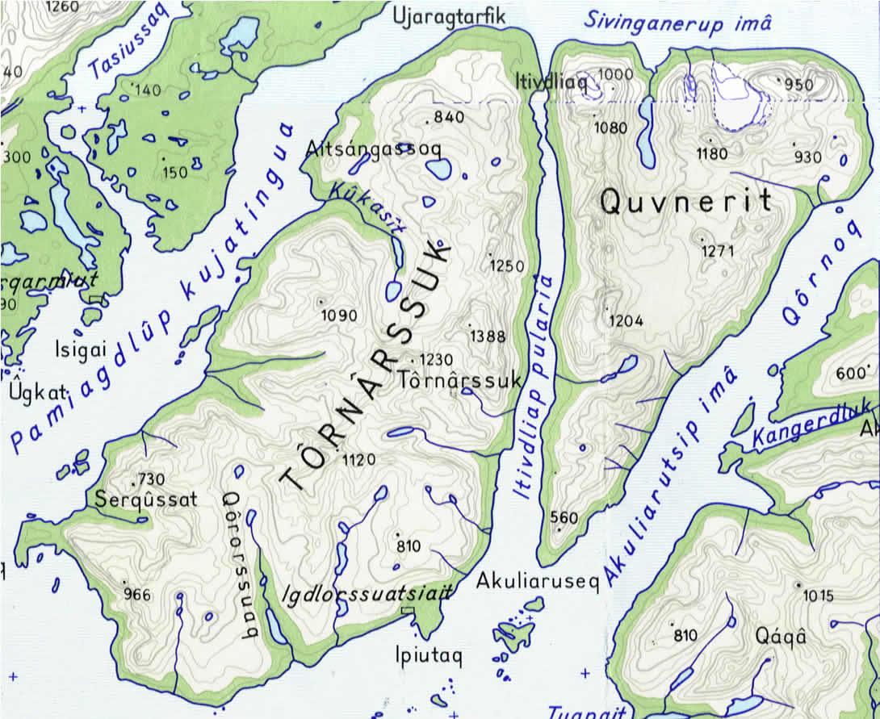
Figure 3. Map of Tornarssuk. (© KMS).

Expedition Objectives.
After establishing a basecamp on the west side of Tornarssuk (intended to be the Kukasit valley), the objectives were to be exploration and establishing of new rock and mountaineering routes of all grades (N of line through point 1120m). Hiking and climbing peaks were also main objectives for the expedition for those of less experience of big walls. It was hoped that first ascents of peaks could be achieved. Close examination of the aerial photographs with the only available ‘map’ show areas of likely steep rock and interesting ridges. Initially, the western and north-western flanks of pt’s 1250, 1388 & 1230m appeared to have potential up the head of the Kukasit valley, with other smaller faces nearer the lakes. Pt 1230m looking the most attractive on the aerial photographs. Access over the 500m col to the next valley south is likely, with establishment of a good route being a target, giving access to the complex of ridges and north facing walls that radiate from point 1120m, for example. North of Kukasit, the two principal sea cliffs could be investigated and we could have checked out the low tide access to Quvnerit at Itivdliaq as points 1080 and 1000m have good steep climbing potential. We were told there is lots of potential along the Itivdliap pularia fjord though it can be cold and windy here, and it really requires a boat. Coast walking is not likely for any distance – distant views give an impression of an almost impenetrable coastline, reinforced by on the spot inspection!
An outline map of northern Tornarssuk is given in Figure 4. This gives the general lie of the land along with the principal lines of exploration of various KMC parties (in yellow), based on observations and photos. Less detail is available, the further away from trodden areas on the map. Very few local names are known.
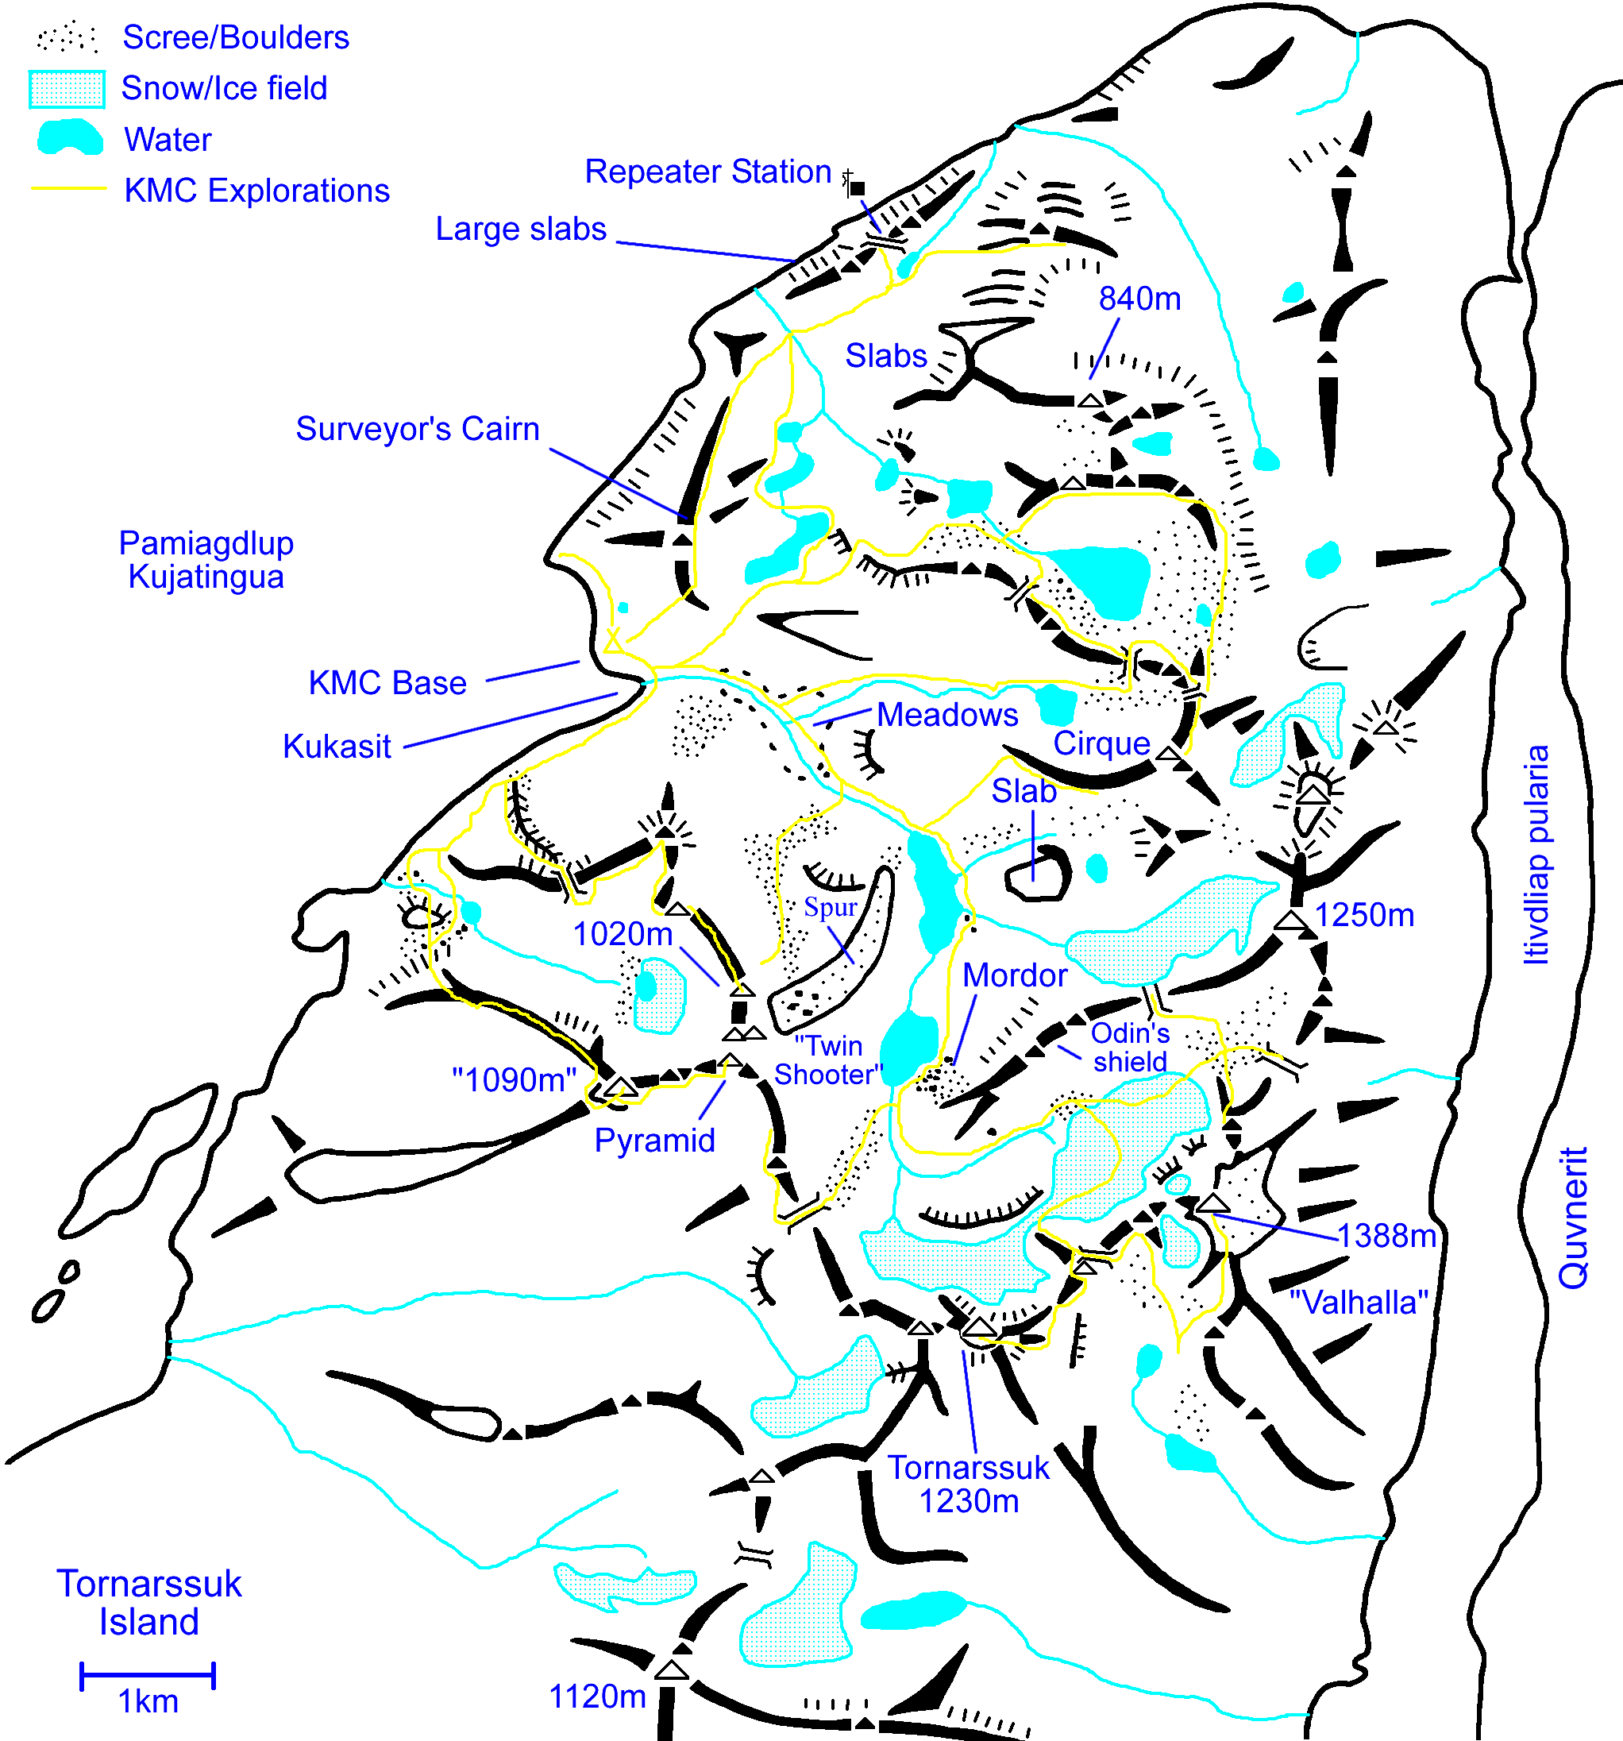
Figure 4. Sketch Map of Tornarssuk, showing Expedition routes.

Maps & Photographs.
The Danish mapping service, Kort & Matrikelstyrelsen (KMS) have the original mapping to the area, but the ‘best’ map is unfortunately only to 1:250,000 scale. Most can be ordered from “www.stanfords.co.uk”.
- Saga 1:250,000 Map, sheet 1. “Qaqortoq-Julianehab”. [Stanfords Cat’ 31154]. Uses the KOM mapping below but has joined the central regions of the three area sheets into one map – the best one to use.
- Greenland K.O.M. Geodaetisk 1:250,000 topographic survey. “Kap Farvel 59 V. 1”. [Stanfords Cat’ 29805]. One of three joining in the vicinity of Pamiagdluk with most of Tornarssuk but it does not have a lot of land on it.
- Greenland K.O.M. Geodaetisk 1:250,000 topographic survey. “Nanortalik 60 V. 2”. [Stanfords Cat’ 7996]. A small part of Tornarssuk.
We also made use of a couple of a couple of scans of the main chart to the area that had been given to us. The local chart was to a larger scale and showed good contour information on the land without the clutter of text.
There are two Aerial photographs to 1:150,000 scale that cover Tornarssuk and Quvnerit, available from the National Geodatabank at KMS in Denmark, as we found after presenting a list of latitude and longitude positions (60° 2’N 44° 24’W, 59° 58.4’N 44° 9’W). Two laminated copies were taken with us. They take practise in interpreting, but they gave strong supportive hints in the form of shadows, and they really came into their own on the island, when one had reference to points actually observed. Tornarssuk is unfortunately on the edge on both, so one is effectively viewing the hills “side on”.

Logistics.
Logistics were simplified this year by making use of our 2004 experience, using virtually the same approach. Thus only the minimum detail is described – those wanting more should look out for a copy of the 2004 KMC expedition to Pamiagdluk report on the KMC website (www.karabiner.org) etc. Having a more reasonable team size also meant bookings were much easier.

Flights to Nanortalik.
We required the trip to be a maximum of 4 weeks off work, but maximising climbing time, so we ignored all the slower ferry type options and went for the direct Air Greenland linkup from Copenhagen to Narsarssuaq in Greenland, with an onward Helicopter link to Nanortalik. Though flights could be booked over the Internet then, we couldn’t readily explore all the available options and would have to pay immediately (a punishing blow to the credit card) so we enquired via Greenland Travel in Ilulissat, Greenland. They were very helpful and found us an itinerary that was nearly ideal. Taking the risk of a return to Copenhagen in a single day from Nanortalik, we gained 20 days on the island for only 19 days off work. No discounts were possible and the tickets were non-refundable - a fact we can confirm! But at least we could pay (by foreign bank transfer) in a two week grace period from mid January, which got extended a further 2 weeks during the decision process.
After the dates were fixed, we needed to get to Copenhagen. Though we could have flown out from Stansted or even Heathrow, we really wanted to avoid the costly and painful exercise of getting to these airports this time! Fortunately more options were found this time with lots more jumping on the budget airline bandwagon – direct flights from Manchester with “Snowflake” (SAS in disguise) were ideal and factoring in the extra travel costs were still cheaper than via Stansted. So by the end of January we had all the travel and accommodation booked for a group of 7.
Day | Activity
Tues 19th July | Snowflake (SAS) Flight SK542 dep. Manchester 19:05 to Copenhagen, arr. 21:55. Overnight Copenhagen Youth Hostel.
Weds 20th July | Air Greenland Flight GL785 dep. 11:00 to Narsarsuaq, arr. 11:40
Weds 20th July | Air Greenland Flight GL391 dep. 15:20 to Nanortalik, arr. 16:30
Weds 20th July | Overnight at Youth Hostel in Nanortalik.
Thu 21st July | Shopping in Nanortalik
Thu 21st July | Boat to Tornarssuk Island (Morning). [~3 hours]. Locate Basecamp.
Fri 22nd July | Fully set up camp, dig latrines, unpack etc.
Sat 23rd July to Tues 9th Aug. | Expedition Activities.
Wed 10th Aug | Tidy up Basecamp, Rubbish disposal, pack.
Thu 11th Aug | Pack Tents. Boat to Nanortalik. Time to be arranged (Early Morning).
Thu 11th Aug | Sort out return Freight. Relax in Nanortalik Youth Hostel.
Fri 12th Aug | Helicopter flight GL390 to Narsarsuaq, dep. 10:05, arr. 11:15
Fri 12th Aug | Air Greenland GL786 to Copenhagen, dep. 13:35, arr. 21:50.
Fri 12th Aug | Overnight in Copenhagen Youth Hostel
Sat 13th Aug | Explore Copenhagen. Overnight Copenhagen Youth Hostel.
Sun 14th Aug | Snowflake flight SK539 to Manchester, dep. 8:20, arr. 09:15
Table 1. Travel itinerary.
Just 10 days before departure, 2 of the original team were forced to drop out through difficulties at work, which was a severe blow and put us below the safety comfort minimum of 6. For some time the expedition was in doubt as the remainder discussed the situation. The weekend before saw another sort of drop out, in that Marylise was not comfortable with the ideal of staying on the island but would make use of the ticket as a ‘tourist’, staying behind in Nanortalik. The expedition was on the verge of being cancelled, but the consensus was “damm it, we’ve come this far, we’ll just go and do what we can”. Always worth asking because we could get a refund of the taxes from the Snowflake flights though nothing came of the Air Greenland query. Air Greenland are very inflexible – we had someone who could take a place at short notice, paying for a new ticket, but even so was dumped on the end of the wait list. Very galling was the sight of empty seats on the flights out and back!

Boat charter.
For the Nanortalik to Tornarssuk leg we prearranged boat hire with Niels (Tourist Officer & Mr ‘Fixit’) at the Nanortalik Tourist office, and confirmed details on arrival. Available is the “Ketil”, a 35ft boat licensed to take 12 people and 1000kg of luggage with a crew of two. It is quite heavily used in the summer, and can end up with more than one run a day as it had on our departure day. The original plan was to have a day spare between the return boat journey and the helicopter flight, but during the spring Niels ended up with a double booking and we had to accept a return on the morning of the day before the flight. Niels assured us we would be picked up! The journey was ~70km and the journey out took almost 3 hours. We had no problems with sea ice at this time of year with an easy, smooth ride via the ‘inland’ route, but with quite a stiff, ‘wetting’ breeze in the open section south of Pamiagdluk. The return journey was far rougher, accounting for a late pickup and a close call in that the crew nearly did not risk leaving harbour.

Accommodation.
En-route we used various types of Youth Hostel – the only realistic choice in Greenland.
We made use of the Danhostel Copenhagen Amager on both outward and return journeys. It’s the largest hostel in Copenhagen with 528 beds in shared rooms, within a sprawling array of halls – very convenient and only 15 minutes taxi ride from the airport, or better, using the very efficient train and Metro system (which runs 24 hours!). We booked in January via the Internet and Email from the UK, but couldn’t make a group booking – it pays to have a YHA card and have a sheet sleeping bag liner though all can be obtained there. The hostel was very busy with the reception usefully staying open past midnight, though the beers (in plastic bottles) stopped flowing at midnight.
There are two ‘hostels’ in Nanortalik at around 200DKr a night each. Niels managed to book “Mathildes” for us. Camping outside is possible though the empty inside was preferred, and there is a kennel like outhouse on the shoreline, which we used for barrel sorting and a storage point for the excess gear (of the absent members). It has a stove, which came in very handy for drying things prior to packing in barrels for the return.

Freighting.
It was necessary to ship out equipment and some food supplies due to the limited flight’s weight allowance (20kg and 8kg hand luggage – and fairly strict with it). Equipment and waste (if sensible) was be freighted back after the trip. Shipment was in a mixture of watertight ‘blue’ 60L or 120L (no handles) barrels, and stout double-walled cardboard (disposable) boxes from Aid-Pack. These held the bulk of the communal kit with an allocation for personal kit. We used Blue Water Shipping again as they have their UK warehouse just round the corner in Bredbury, Manchester. Total shipping time by sea (via Denmark) depends on the service schedule so we made sure they could give us a latest drop off date in Manchester that they could be confident with a final delivery in Nanortalik. This was 7th June, but we fixed on 25th May owing to bank holiday breaks.
After a prolonged packing session in the leader’s flat we had 14 packages, 11 60L drums, 1 120L drum for the main tent and 2 double-walled cardboard boxes. Volume came to 1.34m³, assuming we could treat the volume of a drum as a cylinder. These were tripped to the warehouse in Duncan’s van and back of DB’s car on the 25th and the leader rediscovered his living room floor. Paperwork just consisted of labels and a packing list with the agents dealing with the forms.
The gear arrived in Nanortalik approximately on time, about 10 days before us, and outside the back of the Royal Arctic line terminal for us. Once back in Nanortalik at the end of the expedition, we just had the barrels to repack and note down the contents (We had a pre-prepared pack of labels and plastic sleeves left behind for this). Then the now 12 barrels and first aid kit box were carried by Niels’ very well travelled (considering the amount of road available) truck, to the Royal Arctic line terminal building. With the next ship out not until the end of the month, we had to pay directly the equivalent of £11 as warehouse charges, not too onerous! We just needed the receipt from Niels to set the barrels off on the first leg to Denmark under the same paperwork, and notified BWS the shipment number back in the UK. We didn’t actually get an invoice until the end of September, with the barrels arriving in the UK on the 21st, and found it more than expected.

Expedition Diary.
The Overall expedition dates (UK to UK) were 19th July to 14th August. Here is an account of our experiences and a description of the Kukasit valley features.
Tue 19th July: Met at Manchester Airport at 17:15 and distributed a pile of electronics. Straight forward flight to Copenhagen where it was breezy with broken cloud. Train and Metro to Bella Centre stop then a walk to the hostel and a couple of beers.
Wed 20th July: Up early to catch train, arriving at the airport at 8:45. Stocked up on Alcohol for the trip at the duty free – difficult for those only drinking beer! A cloudy Copenhagen was left on time, with only a partial clearing over Greenland. We landed at Narsarssuaq under clear skies and a little haze, while it was very warm at over 20°C. A long wait for the standard Sikorsky Helicopter which left half a hour late and went via Qaqortoq. Niels met us on arrival and ferried us to the Supermarket for some evening food, and the Hostel. It was the first time we found just how early we would have to leave – 10am, since the Ketil had to return to take a Spanish group (who descended on the hostel area in the night) up Tasermuit fjord at 5pm. With lots to do, we sorted out the Freight barrels, leaving the cancelled members gear behind in the Hostel kennel (apart from the stuff we borrowed). Flies were bad as we wandered round town in the warm evening – even the locals wore head-nets.
Thu 21st July: A very early start to a fine day with the leader dealing with the paperwork with Niels by 7:30. The next shocking news is a proposed 6am pickup on our departure day – more double booking! Fortunately, Niels had bought our gas cylinder for us, and with some items borrowed from the kennel stores, we only had to rush to get the food supplies. With more persuasion from Niels, we were let into the Brugsen at 8-30, before the official opening time, to fill trolleys. We managed to get most things, or do without in the end. With frenetic loading activity up at the old harbour, amazingly we left on time at 10am with all 5 in the boat.
The route out through the inner islands was smooth, but conditions turned choppy on the open sea. The narrows behind Nunarssuaq (labelled as Dan’s island due to his ideas on it) were windy enough to cause the upper deck to be vacated, with a drenching for DW & CP. Oddly though, south of Pamiagdluk, the wind changed direction to a very warm easterly. By now we were getting good views of Tornarssuk as we skirted the islands and headed north up the island’s western coast. The southern end of the island, seen end on, is an impressive cliff. Our landing area was very exposed with the land rising sharply for 10m behind a barrier of boulders, which would hinder boat access to the small beach area by the river mouth. As no one had been landed here before, a cautious approach was required before we were loosely tied up at the head of a chain of boulders, and precariously off-loading barrels and packs by human chain to above tide level. Only a ladder fell in! Marylise was to return to Nanortalik, but nearly was left ashore as we hadn’t made the fact clear to the boat crew.
The 4 survivors hauled the barrels clear of the rising tide, and had lunch. Half an hour later we spotted a boat coming our way – it was the Ketil returning with a forgotten First Aid kit! Ooops!. The now fully equipped castaways spent a good deal of time looking for a good campsite, only for CP to find it 200m right of where we landed, immediately above the sea, but far enough to exhaust one, hauling over the boulders. Persistent Blackfly present into the evening when a warm breeze switched on from the ENE. The mealtime wildlife show consisted of a small whale spouting in the bay ending with the classic disappearing flukes shot. The evening light (to 11pm) was finished off with DOB/CP heading up-valley and DB/DW heading west round the coast – some good crags with 2-5pitch routes on the front face of the hill north of camp, but disturbingly finding a small cairn out on the western point. Also the bluff south of the river had a sweep of slabs and fringe of crags.
Fri 22nd July: Very overcast and warm with Blackfly arriving from all corners of the island. A morning of final sorting out of the camp arrangements and pit digging, but were all heading up the valley by 11am, geared for an exploratory mission. So, to set the scene. Past the initial short, steep rise of the river, the boulder choked valley opened out into a double tiered set of lumpy ‘meadows’, with easy slopes to the north and a complex ridge line to the south of the river. The map has a 1090m height hidden back here. What appeared to be the highest point was dubbed as the “Twin Shooter” (or variously later, “Lobster claw”, “Batman”) due to its double spiked top. Adjacent was a “Pyramid” shaped peak, and to the right, under another top, a series of proud aretes rose out of the lower scree, banded grey with a deep black upper third.
The river rose again round a bluff, and with extensive, rapid boulder hopping across the broad river bed, we arrived at the first alpine lake of the valley, and rested on the slabs of what would become the regular first rest and fly swatting spot. There was a big area of slabs above the north-eastern shore, falling from an upper glaciated basin. A broad shoulder of scree and outcrops rose from the southern side towards Twin Shooter – a possible tedious ascent line. Easy walking around the eastern shore led to a gravelled flood plain with braided streams and solitary, enormous boulders. The valley had turned southwards, and narrowed and an 80m rise led to the top of a rocky bar holding back the higher 2nd lake. A shield barrier of rock to the east (later, “Odin’s Shield”) had some clear deep crack (that means, really wide) and corner systems in the lower half. These were the subject of speculation but all foundered in the broken, loose looking, “can’t see any line” upper half – the source of the boulder field looming on the east shore of the next lake. The western shore was avoided – outcrops on the water’s edge would force one into a long traverse of steep scree, below a toothed ridge falling to an easily accessible col (“South park”) near the head of the valley.
The valley terminated in the golden sands of Tornarssuk and a rest from the rigours of the boulder field. A hidden glacier drops from the left behind a barrier wall (route possibilities here) and emerges as an ice-fall above a rock apron at the end of the valley. It guards access to the huge steep, crack seamed walls of Tornarssuk (1230m) – North facing, with a recessed section below the summit, these always looked dark and forbidding during the trip, particularly with the crowning black band. We toiled up a boulder slope following the main stream back left behind the knife edge ridge of Odin’s Shield, to arrive at the moraine of another ice field under the western face of 1388m (later, “Valhalla”). A scrabble up the gravel brought us to the top of the ice, nearly filling a long trough.
Despite 1388 being the biggest feature, eyes were drawn to its right where astride the ridge sat a dramatic tower. From a seat of dark rock rose a ‘Tooth’ of lighter smooth rock, with a flat rectangular shield of rock held in front. Despite no visible line of ascent, it immediately went high on the list of targets! A deep vertical drain-pipe crack dropped to the glacier from the notch – there are off-widths, and there are off-widths… To the right the snow covered glacier rose to a shoulder and out of sight round what appeared to be the end of the ridge on which the Tooth sat. There was no continuous line to 1388 either, with fore-walls likely to be pinnacles and snow fields to cross to get to the foot of the upper wall – a very complex hill.
With the haze thickening, the group headed north across the fortunately bare ice (no crampons) to the far end, heading for the col north of 1388 on the spine of the island, reached via more boulder hopping, snow fields and scree. The character was immediately different, as the other side, a steep couloir into the fjord, was altogether darker, dirtier and colder, flowering plants were more apparent. A steep, forbidding, pinnacled ridge rose towards 1388 and another, darker one could be seen behind it rising from the fjord. To the north rose point 1250m behind its broken barrier – clearly difficult of access this side. A long, narrow ridge with flanking walls of orange rock dropped from 1250m along the far side of the basin to a col of white rock, to which we glissaded and hopped. The ridge ended abruptly and would be a nightmare to traverse, so heavily pinnacled was it. It continued on the same line into Odin’s Shield.
Though a short drop to a snow covered ice field offered a more direct return, the obvious signs of covered crevasses and a half seen runout into dirty grey ice persuaded us otherwise. Big wind carved snow features under the walls of 1250 to our right and a possible spur at the far end, before the snow turned into a scree basin. The back of the cirque of smaller peaks on the far NW side has a nice little wall on the back of its two main tops – there’s an ‘easy’ looking ridge from the west to start on this cirque. The area beyond to the NW essentially looked like a complex lumpy plateau. So it was back the way we came, back at base by 19:50 with a hint of drizzle. The Black Fly just won’t stop!
Sat 23rd July: Not an early start and a hint of drizzle, but DOB/DW were off to the first lake and a look at the cirque of peaks, taking a direct line from the lower lake outflow to the ridge over boulder fields and easy angled rock. The crest was loose and unsound, curving right to a small summit and narrowing. The way ahead looked very broken and unstable, and led to a vertical face on the near [SW] side of the first main top. Discretion being the better part of valour with a lack of equipment, they retreated. DW suggested following the ridge line down but they were stopped by a band of crags, so they contoured and scrambled down a loose gully, abseiled past a very large chockstone, and returned to the valley floor over more tiring boulder fields.
DB/CP crossed the river above the meadows, plodded up a scree fan, and traversed left along a rising scree terrace, heading for a promising line to 1090m via the central arete and/or gully just left of the 3 main spurs. The groves between were huge on close inspection, with streams and snow patches. They geared up on the scree and just as they were to set off, heard a mysterious rumbling. Looking up, they saw a wet snow avalanche settling just 15m away – it was big enough to be seen on the other side of the valley so the others were wondering if they would see the pair that evening. A patch of snow, on a shelf at the back of the slabby gully to the left of their intended start, had slid down the lubricated slab towards them, before turning down the main drainage. This produced debris fountaining over the scramble start that they were soon inching up, into the safety of an alcove.
Their rib was very steep with prominent overhangs low down, and some way up, which they kept to the right of. The auspicious start, after moving 5m leftwards, was via a chimney with overhanging chockstone to grapple with. Some excellent crack climbing followed, and they were led round the left side of a wall to find it a free-standing pinnacle with the choked Chasm of Doom behind. Time for some time consuming, tricky, outflanking manoeuvres to land them on easy ground, then arriving at the next steep section, seamed with discontinuous, flared cracks at 18:50. Some two pitches above loomed the black rock band, suspiciously rock tripe like, with a more massive block like structure, before this fell back into a ridge. From the flanking spurs, they had to be just short of half way. From here they could see the possibilities of routes onto the spinal ridge of the island south of the Tooth, and at this point Carl could swear he could see some ‘red’ boulders that looked like a group of people on the north west coast. Not being prepared to spend the night out in the dodgy conditions, they bagged it and abseiled off, to return to the tents by 23:15.
Sun 24th July: Another warm night, and partly cloudy morning. Only the Blackfly were happy, with Carl going down with a cold, and DW in the lowest phases of one. General tiredness. DB made the first unsuccessful fishing attempt whilst the others had a sauna in the main tent, when at lunch a southerly breeze brought a bank of sea fog in to envelop the camp, just as in the film, with temperatures plummeting. This sudden change had lots of icebergs rolling over out there somewhere. Late afternoon, DB and Dan went off for some cragging on the slabs west of our tarn, just beyond where one is forced to climb up and across the rock to a terrace. A mixture of crack and slab climbing moves gave an enjoyable 3 pitch E1 with an easy scramble off into the flanking gully on the left. They avoided a hideous overhanging chimney thing, for some much nicer flakes, and could have added more pitches. Plenty of other lines possible here on good granite. Still foggy however, with Carl having amused himself collecting ice from a grounded ‘berg.
Mon 25th July: More low cloud and mist out to sea. No wind and horribly humid. Still, DOB/DB set off with a light rack and rope to investigate a route to 1230m. Occasionally, a bit of a hill could be seen. Arriving at the end of the moraine on the Valhalla glacier, this time bearing crampons, they roped up and trudged across crevassed ice and snow (having to cross just one lateral crevasse) up onto a shoulder (~700m). Here a spur dropped down from the spinal ridge, and they were at the head of the lower barrier wall – the snow continued round into a basin, with the big, big walls of Tornarssuk opposite. The cloud closed in as they continued on, on thin soft snow on ice, into the basin until some large crevasses loomed out of the mist. Deciding on discretion, and as the possible exits were invisible, they retreated to the shoulder for lunch.
The cloud cleared a bit to encourage them to try the spur, which turned out to be easy scrambling ending at a triangular peak. They could see a shattered grey rock ridge leading out to the foot of what had just been named “Odin’s Tooth”, still obliterated in cloud. Rounding the southern side of the triangular peak 20m from the top, they emerged onto the edge of a broad slab running all the way to the ice field where there were the open jaws of crevasses awaiting. A slanting band of shattered rock led them easily, but exposed, diagonally down to a col on the spinal ridge. From here a jagged ridge rose in steps steeply up as the NNE ridge of Tornarssuk. A bit of outflanking on the east plus scrambling back up took them to the next major level at a band of brown rock. At this point the cloud cleared, for a time, to reveal the south face of 1388 and then Odin’s Tooth. The Tooth is steep on all sides with a blunt shoulder out to the east, above easy slopes down to a lake in the bowl below. This side is of reddish rock with no lines obvious from a distance. 1388 looked like it could be a triangular domed plateau with a steep south wall and a long ridge to the east.
Steep black rock rose vertically so they tried a descending flanking move to the east, rounding the tip of a tongue in 200m to pop out into a giant open couloir running the full height of the hollow ridge flank. Straightforward loose rock scrambling brought them to a window looking across the awesome upper black walls of 1230m. The cloud level was rising and falling like demented tidal waves. The summit wasn’t far, but the wall to their left that would have to be climbed, could quite likely be a dead end pinnacle. Just 25m of climbing but on stacked blocks coated in black moss and lichen to a depth of several cm, it was one of the scarier VDiffs around. Better news was the emergence onto a broadening flat ridge, and finding that the highest point, a bit of guesswork in the mist, was only 2-300m away. Dan’s first virgin summit! The top of the cloud was more or less at summit level, thin enough to see they weren’t on a particularly large summit area, while a narrow west ridge went on and down, via a most interesting pinnacle, into the mist. At times it revealed the very tops of big peaks on Pamiagdluk and the mainland above a sea of cloud – ideal conditions for Brocken Spectres! Typical Greenlandic summit ridge – it overhung the face below – it was also covered in Rock Tripe. Sadly, couldn’t see a thing to the south. 17:00 and time to return by the same route, back at base by 21:15, having stashed the gear under a giant overhanging boulder below the Valhalla glacier moraine.
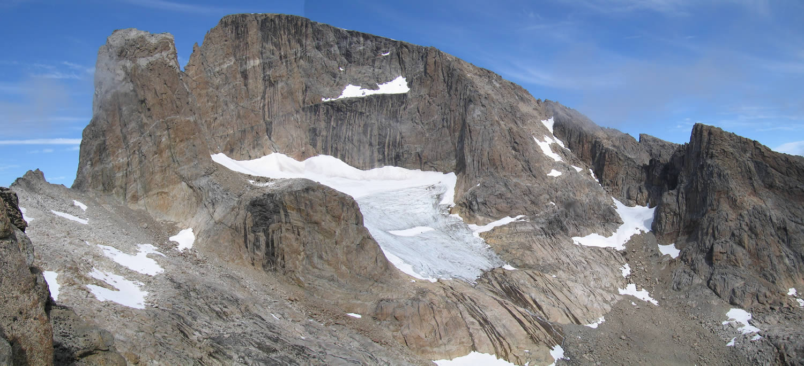
Figure 5. 1388m (“Valhalla”) and “Odin's Tooth” (left) from the south (a montage).
Boredom overcame DW’s base camp lassitude and he explored the area to the N of our camp, climbing N up the hillside to the col between the coastal ridge and the main ridge to the true right of Kukasit valley. The long lake marked on the map is in a bare ice-scoured basin. The outflow N through two smaller lakes is joined by a cascade from higher lakes to the E, and then drops steeply down a large gully to the sea. This gully is bounded on the N by large grey slabs rising from the sea to a ridge. Access may be possible down vegetated ledges on the true right of the gully, but there was no obvious low level traverse line. At a break in angle the rock type changes – the upper third is more reddish. On this ridge he could see what appeared to be a lattice aerial. Pt 840 was not obvious from here. On return, DW followed the coastal ridge, although driven off the top by blackflies, finding a way down a gully to the tarn near base camp.
Tues 26th July: Foreboding start with cloud shrouding the peaks, and a gusty east wind. No activity this morning as the drizzle turned to showers. Tried fishing again but no success – difficult to get into deeper water with the boulder frontage. DB hunted down mushrooms and bilberries, finding plenty of the former within 200m of the tents, and the latter not quite ripe in most cases – needed a bit of rain! Clouds broke in the evening but still the odd light shower.
Wed 27th July: Yet another cloudy day with the high hills hidden and patches of drizzle wandering aimlessly around the upper valley. Dan went up to the hill behind the camp to find quite a large old cairn near the top. Putting this fact together with some aluminium tubing that had been found near base, and a suggestive rectangular pattern of stones found there, we decided this was a surveyor’s cairn because of the good views. Their base would have been in our base camp area (one of the few places to land).
DB/CP set off at 10:30, crossing the river and heading south along the coast for a km to the foot of a prominent scree couloir. The aim was to access the ridge south of base and come back along it to attack 1090m from the west, or at least look at it since no one had seen the elusive summit. A punishing ascent to the ridge at 525m revealed an open valley down the other side, with the map marked 1090m out on a ridge emerging from “Pyramid peak” on the far side. It would be easy to approach from the valley mouth via a spur onto a gentle, open scree ridge. They turned left on an easy boulder ridge leading to a small flat top of red rock at 770m, overlooking base. At the head of the open valley was a moraine dam, holding back a lake with a conical ice field around it. Anyone here would be playing a cosmic game of skittles, as anything let loose on the ridges above (verified when we were on 1090) rolls down the funnelling slopes bound for the lake!
The ridge turned 90° and crossing an open basin of flat stones they were soon on a 905m top. The peaks were playing ‘catch’ with the cloud, as the north end of the island was covered– the white Top in the next col was reached by weaving in and out of a rock tripe covered, narrow ridge. They then dropped down on the south before re-crossing the ridge to a stone chute hard against the red wall of the next castle turret Top (unclimbed). More traversing on the south side of this took them into a gully that was blocked by the underside of a gigantic boulder bridge, so by various tricky scrambling routes they escaped up the right wall onto open slopes. The spur leading north from here was the top of the Arete they’d tried to climb. They crossed a narrow rift across the slopes on a ‘bridge’ and up onto the 1020m summit tor, where across a deep gap loomed the higher top of the “Twin Shooter” with the “Pyramid” beyond.
Down shelves to the north then east to the top of a short overhanging wall – things were getting serious and it was now 16:00. There was no easy way down all the steps to the col a long way below – itself occupied by a big split, cubical block that would have to be circumnavigated, followed by some mucky slabs leading to another bump, and possible notch. Vegetated ledges and black rock steps looked like an unpleasant route to the central open couloir of the “Twin Shooter” that was filled with big, black rocks. It was certain that this section would easily consume a couple of hours, and as much again on a return since there was no sign of an easy onward route, so they turned back while we could without difficulty, and before the cloud dropped again. The big scree couloir was unmitigated murder in descent, everything being mobile, with much ground contact. The breeze picked up as the weather grew more threatening.
Thu 28th July: The rain had started around midnight and continued with some short respites in the morning. Most stayed under cover, but Carl was lured out in a respite for a walk. The rain came on, but Carl stayed out to investigate the possible structure between the twin bumps of the top of the sea-cliff slabs on the NW coast. He returned, soaked, late afternoon with tales of a building housing a TV/Radio/Mobile repeater station, complete with wooden Helipad barely big enough for a helicopter (as long as it lined up with the slats), acres of solar panel and a standby generator. He also noted huge slabs heading for point 840. Not so much of a feeling of wilderness to the island after that, and thereafter we kept seeing people in the mist…
The rain turned very heavy late afternoon and we heard aircraft passing overhead frequently, some with propellers so where were they going? Though actually sheltered from the worst of the north wind, judging by the waves beyond the headland, powerful gusts of wind swirled down the valley falling off the ridge, and the main tent was taking a pounding, with the poles heavily distorted and being pushed to the ground. Dan was feeling the most anxious as he was sleeping in the main tent, so we retired, hoping things held up overnight. Definitely a major gale – one could hear the wind booming around the ridge above base.
Fri 29th July: The tents were still there, since the lowest point of a deep depression had gone over around midnight. The rain had petered out, and the still strong cold wind had swung to the SW with clouds scudding across. Dan had had a fitful night, breathing in tent fabric as the tent alcove flattened from time to time! A morning of repairs, resetting the main tent to improve its resilience, and exercising the solar panel.
By lunch, the skies were still active so DB, DOB & DW went up to the col above camp for a walk, which developed as the day went on. This became known as the Three Tarns Tour. Bypassing the lake on the col, they broke through a barrier wall to the east via a rake, and hence up a grass ramp to the first tarn in a hollow (530m). Then up a boulder field to the next level at 680m holding the larger tarn. To the north was a broad scree ridge bounding the shore, which was typical of the hills northwards. Tiring of the boulder hopping round the south shore, they broke for the ridge and enjoyed an airy scramble east to the north end of a cirque of peaks. A block shaped peak blocks the onward route – probably the best way to the cirque would be round the back (east) from the flat stony area at the head of the 2nd tarn. There were good views of the hilltops of Quvnerit, and glimpses of the two peaks north of 1250m – notable for their sharp northwards facing prows. They descended to the outflow of the 3rd tarn huddled in the cirque, and then the outflow back to the meadows, keeping out of the ravine – a good circuit with no need to wear head-nets for once. Marylise called to say that Nanortalik was getting boring and couldn’t afford to move elsewhere, so would be arriving the following afternoon, and where were we actually…
Sat 30th July: A bright day with all four bound for the head of the valley, splitting at the golden sands. It was very hot and with little shade. DW/DOB took a diagonal line for the South Park col, following rocky outcrops and avoiding the worst of the unstable scree slope typical of this part of the world. They were bound for 1090m. From the boulder-strewn col they contoured around and down slightly to gain a leftwards, slanting rake towards the ridge. After a steep scramble to the ridge, an hour’s scrambling NW over reddish rock led to the first top. Ahead was a broken pinnacled ridge. The distant broad ridge from the Pyramid to pt 1090 looked straightforward apart from one rock step, but the immediate way forward was not obvious, steep and unstable with no bypassing traverse line visible. The way ahead was blocked by a steep wall, that overhung in typical Greenlandic fashion, up to the next pinnacle. It was not possible to go around and the slope down into the bowl on the left seemed long and treacherous so they did not get much further before turning back. Later investigation from the other side revealed a deep overhung breche blocking the route. The facing N slope of pt 1090 was clearly covered with an unstable layer of scree and boulders. There were a number of scars where the debris had slid, revealing the underlying slabs.
DB/CP were bound for 1388, so after retrieving the gear stash scrabbled on to a much barer Valhalla Glacier, heading north. With no crampons, the much reduced snow cover slowed progress, so it was with unusual relief they reached the boulder hopping. However, the snow field above was much reduced, and so were forced onto a traverse on particularly mobile scree, before pulling over the top of a lateral moraine at 740m. They were at the northern end of 1388, just as the west face turned sharp round onto the north side – here because this end offered a high start and there looked like more lines of weakness were available. They hoped to gain the north ridge by a gully or other some way along its flank, reducing the amount of pinnacled ridge to traverse before joining the summit plateau of 1388. From below on the glacier it had looked as if once past the turning of the ridge (then above) it would be fairly easy, and might be a broad ridge. A spur dropped down to them from this turning point, with an open couloir to its left. Though having a steep headwall, there looked to be hidden escapes to the left.
70m of scree took them to ~100m of scrambling following a stream course until a shallow groove was encountered, when they started climbing in big boots with a single 60m rope (saving weight for a ‘scramble’). After 3 pitches they had escaped the gully for a rib on the left to find an impasse above some stacked blocks, so Carl took a tricky descending traverse back into the gully. Still a long way to go, more pitches were climbed up the right side of a snow-field past a balanced block, with much loose rock about. No matter, things looked even looser on a bounding rib to the right and the ‘escapes’ to the left to the sharp pinnacled north ridge, were not, having a red rock, “fossilised dinosaur turd” pinnacle balanced there. Nice views of 1250m opposite and over to Quvnerit as the afternoon wore on and more cloud appeared in the distance. Looking for a way out other than the hard headwall, DB ended up in a notch behind the pinnacle of the right hand rib, as there was a possible traverse line right to the main spur. Altitude was then only 1180m.
Meanwhile, Marylise had arrived on the island, delivered from Augpilagtoq by personal courier speedboat, and had found the camp. A new red mushroom had sprung up! We didn’t see her until late the next morning – with fresh supplies of bread.
Back in the hideaway, Carl had checked the traverse, finding a big chimney system slicing into the head wall, which looked a goer, and might be 2 pitches to the ridge. By then 6pm, being unaware of what was happening behind us, cloud suddenly appeared just above them on the bounding ridges and it instantly got gloomier. In the circumstances, best to start abbing, but it was very slow with one rope and having to avoid disturbing all the loose rock. Fortunately with a bit of down climbing, threads or spikes nearly always came to hand. Sure enough, it started to rain with 3 ab’s to go – in all 11-12 ab’s, with the final diagonal abseil over a now flowing waterfall, took them to a ‘comfortable’ scrambling off point. Retrieved ice axes and off down at 20:15 in the growing dark and rain, the glacier was horrible in the wet – had to keep to the stony areas on the fringes to minimise skating about, and then the melt streams became obstacles. DB will always remember the sound of blindly skittering and tapping ski poles behind him! Leaving gear at the stash boulder at 22:30, and donning head-torches, they battled on with the wind picking up. The Boulder field at the 2nd lake being a desperate struggle in the wet, and then the rounding of the lakes, lichens glowing eerily in the lights. Then after losing the way in the boulders – the rain and rain decided to let us have it while we floundered across the meadows, as we obviously weren’t wet enough. Collapsed in our tents at 00:45 and found it hard to sleep.
Sun 31st July: Wet and windy, though glimpses of the sun. A fester morning, waiting for a chance to dry things. The strong winds eased, though with sharp blasts, and the rain died out. Some camp chores and more resting while Marylise explored the valley to the 2nd lake during a bit of sunshine. The rain returned in the late afternoon, but with less wind. In a dry period we were able to replace a broken fibre-glass pole section of the main tent. Back came the rain for the evening so we consoled ourselves with the 2nd Cheesecake with Bilberry Topping!
Mon 1st Aug: Another dull and damp morning – no point in heading into unknown hills as a) they’re wet, and b) they can’t be seen! Yet another enforced rest day! The tarn was full and had a stream outflow now. DW polished his dry stone walling skills with CP/DOB fishing for vintage icebergs to be accompanied by drinks, CP returning rather wet! Later after the sea fog had rolled in, returning from a fishing for fish attempt, DB/DW spotted they had resorted to lassoing, but 2 tons of ice refused to be beached, rolled over and casually drifted off. The first really cold evening.
Tues 2nd Aug: A fine, sunny morning so though not having a clue as to whether it would last even all day, DB/CP decided to commit to a 2 day high camp and repeat attempt on their 1388 route. Packing small tent plus bivi-bag, a couple of nights food, a second rope and most definitely crampons, they staggered out at 11:45, to arrive at the head of the 2nd lake at 15:30. The last section through the lakeside boulder field was desperately slow with a heavy load – now being known as “Mordor”. A giant boulder at the start of the difficulties was also entitled “the gates of Mordor”, as whatever route you took (and never exactly the same), you always ended up entering or leaving by this boulder. Set up camp at ~200m on an excellent bank of grass under a boulder – last feasible site for a semi-permanent tent, and with no time for a route, spent the time with binoculars. Considerable time was spent studying Odin’s Tooth. On 1388, a big right to left couloir joined the ridge in the area they had been making for, creating a subsidiary ridge that dropped onto our spur, and there was some evidence of snow along the main ridge, which, hopefully was the edge of the plateau. Not appreciated at the time was how the excellent visibility destroyed the sense of depth! They were in the shadow at 17:00 and the temperature dropped sharply enough for the Blackfly to be uncomfortable.
This was DW and DOB’s second attempt on the highest point of the cirque of peaks – slogging up to the W facing cwm below the peaks. Then scrambling up yet another boulder field to the col at the start of the E-W ridge to the N of the cwm, as for the 3 tarns tour. Once across they descended into the 2nd lake bowl looking for easier terrain and after passing under a blocky pinnacle ascended a reasonably straightforward gully. On the ridge they contoured on the east below two subsidiary summits to below the main summit. They were treated to spectacular views of a new peak with an enormous black wall, N of 1250m. This peak is full of access difficulties but some spectacular routes must be available! On this side was an extensive snow field, apparently running down to the fjord – without ice axes they followed the scree filled bergschrund between snow and rock. The rock here was of the reddish, crumbly type. Locating a chimney groove line, Dan muttered his way up for a rope length, pronounced the whole thing fundamentally unsound, and rapped back down. DW suggested exploring northwards to rescue something from the day.
Returning below the 1st subsidiary tower they crossed a col to the N then followed a boulder covered ridge E at approx 900m. This ridge has three minor rocky tops and forms another cwm with a lake (Tarn 2 of 3 tarns tour). Pt 840 is not conspicuous from this side. From the end of the ridge a line S and W took them back to base camp. A bank of cloud just before sunset gave some spectacular lighting conditions on the Tooth and Valhalla – looking good for the next day.
Wed 3rd Aug: A cold clear start on the sands, CP/DB were rapidly, this time with crampons (!), up and across the Valhalla glacier, collecting the gear stash, and arriving at the foot of the shoulder by 10:30. The couloir was in cold shadow and the sudden absence of flies was noted (remaining so all day mercifully)! Also noted was a very recent rock fall on the left side, its cubic metre advance guard perched on the snow metres away at the foot of a long trail of craters in the snow! This time they were serious about the route, and less complacent about the amount of easy ground! Pretty quickly (though could have improved on it), they were back in the notch with 6 pitches (60m and 35m at end) of VS scrambling behind them, having straightened the route out. Skies were wonderfully clear, with indications of a temperature inversion forming.
5m right, a broken grove led into a chimney – jamming up the fins in the back led to a ‘5a’ ‘reach’ for suspect holds exit onto a boulder ledge, (DB should have changed out of big boots!). Up and right was a hole through the arete – with the huge thread consuming many slings, a traverse right led to a corner with a loose exit onto a terrace where the spur on the right of the couloir joined. At long last they could enjoy some warmth from the sun. Directly above was the highest pinnacle where the north ridge swept though an obelisk shaped spire. Carl led off to a window to the east side, hopes high that there would be an easy traverse to the ridge end as they weren’t keen on tackling the razor edge of the pinnacle (and down again). Silence – not good news! The other side of the narrow ridge was a huge deep couloir system coming up from the east and he was looking down and across a wall to a ridge or plateau edge some distance away (this being what we saw from below). The ridge was longer than thought, and looked as if it dropped into a notch (which you can see from below when you know). No way on that side, but a traverse line disappeared round the corner on the right of the pinnacle.
One pitch later, they were forced up to a higher level by a steep wall dropping underneath on the west face, and following a sloping ledge reached a dead end. A short climb up an overhanging block would end on the razor edge, while beyond the ledge an overhanging and overhung wall curved off to the just out of sight ridge. Below was the big SW-NE rift in the mountain, and by hanging out, a deep notch could be made out at its head, with a steep rib out to a table area – there may be a further notch before the true plateau could be joined. No reasonable route could be seen for a day return trip. It was 17:00 and cloud was starting to fill the valleys. Spirit shaken, they retreated, down climbing the last 3 pitches. The first 50m abseil down the chimney resulted in the rope locking up while pulling, and again when the loose end wrapped itself up, compounding the depression. The equipped couloir went somewhat faster. First night stars had been seen, while below was a cloud blanket – so they descended into driving mist at the end of the glacier, returning to the tent at 00:20.
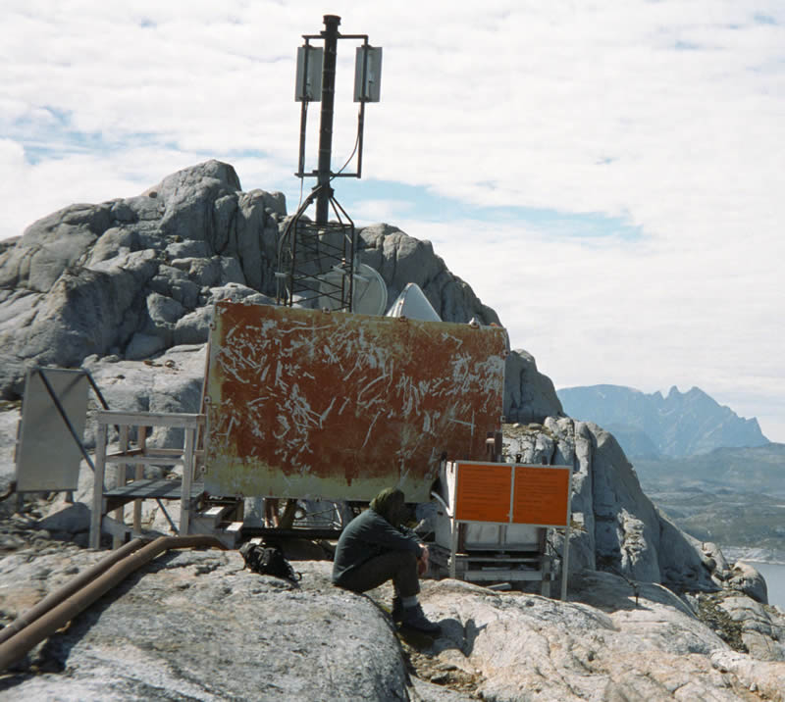
Thu 4th Aug: Though DB/CP had intended a reconnaissance of the Tooth, and conditions were good, the team agreed to return to base leaving virtually everything behind, so they could return in the evening after a rest. At 9-40 everyone was in the main tent, but the others left later, bound for point 840m and the North of the island. DW and DOB explored further northward than DW did on 25 July – the first lake being skirted on the right with one steeper section on slabs. Past the head of the large seaward-heading gully there is a very large area of grey slabs, initially easy, which sweep up towards pt 840. Via a gully, they explored the seaward ridge, on whose western flank great expanses of slab swept down towards the sea. At 2pm they inspected a relay station, which explained the aerial seen earlier. From a small col behind the station, where there was a tarn, a gully led northward and down to the sea. They found a ledge system crossing the extensive rock walls on the true R of the gully but were forced to turn back when it petered out after a few hundred metres. It would have taken too long to descend the gully and the flies were bad.
Figure 6. The Relay Station.
They followed the seaward ridge back towards camp, scrambling to keep to the skyline. DOB passed a well-built cairn, which we presume was left by the survey party. This was not on the highest point of the ridge. From the cairn, pt 840 does appear a distinct peak. DOB and DW returned to camp full of plans to return and climb the upper slabs.
The solar charger was given a good workout while the camp washed, rested etc. A veil of high level cloud drifted in by evening but at 21:00 DB/CP left to return to Advance base with minimal loads. Setting a cracking pace to get through Mordor before complete dark, ‘AB’ was reached in 1hr 10.
Fri 5th Aug: Deep disappointment – it had started to rain gently in the night and by morning DB/CP were trudging up to the Valhalla glacier in drizzle. They could at least look closely at the Tooth… Oddly, the misty conditions were better for seeing the structure of 1388, they had had quite a way to go from Blind Pew (the highest pinnacle on the north ridge), though the ridge from our high point did not drop into the notch as sharply as feared. “Blind” because for a Blind alley, the sound of blind man’s sticks, and the swearing blind… At the end of the moraine, the drizzle turned to rain as the cloud eased its weight onto the hills, so with further activity fruitless, gear was left behind again and they pounded the familiar route back to base. At 14:45 everybody was in the main tent with the rain only dribbling down and clouds around summit level. Only 4 whole days left! Late evening, the winds picked up, blowing down the valley with increasingly wicked blasts – a bad swell on the fjord so we were somewhat sheltered. The pressure was plummeting, we were in for it. A 2nd pole in the main tent snapped – strapped with gaffer tape and loaded with boulders, we could only hope for the best.
Sat 6th Aug: Turned into the worst night by far. Little sleep for anyone, with the winds increasing further and hammer like gusts accompanied by blasts of rain inverting even one Quasar’s poles. At ~1am, in an extra powerful gust, Marylise’s tent was ripped from its moorings and sent rolling with shrieks for help from the occupant. Going to help, the tent was re-sited with effort on softer ground, using every spare peg we had (for some days afterwards we kept finding widely scattered pegs), and vain attempts to patch the rips in the flysheet made. Attention now turned to the main tent, which was being completely flattened in the gusts – most of its poles had sprung out of their pins (helpful), and obviously more sections were cracked. At 3am in another mega-gust DB watched a complete flattening and the steel porch pole being bent 90°. There was no recovery from that, it was a goner, a wildly flapping amoeba with Dan being digested. We hauled Dan out of the rear with sleeping bag, rescued the vital Satellite phone, collapsed all the poles completely, covered the remnants with boulders and left it for better conditions.
By 9am, the wind had eased and it was dry so the morning was spent stripping the main tent and reorganising the camp, everyone losing space in their tents. The leader wasn’t demonstrating good leadership skills under the stress and was fixated on the idea of a group shelter. A shelter for cooking under was constructed in a hole between boulders with some nifty construction by Dan, and by 16:00 it was quite sunny but with a strong gusty breeze. However, the pressure was still dropping, and there was a large bank of cloud to the SW so much of the camp decided to catch up on some sleep. A while later DOB/CP went cragging on the 30m crags above ‘our’ tarn, putting up two routes. A clear evening with the pressure flattening off, and the cloud at a distance, so DB planned on an early morning weather check in preparation for a solo exploration.
Sun 7th Aug: At 3am it was overcast, but at 4-45 there was a hint of sun, so DB steamed up to ‘AB’ finding the small tent miraculously still there, minus a peg or two – thankfully, as the plan was a night or two there. Still dull, but taking some gear from the stash, cramponed southwards up the Valhalla glacier to the snow shoulder. Easy, but bare ice, revealed crevasses to avoid on the right, that we had unknowingly walked over before. Up the ridge for lunch at 11:30 on “Slab Peak”. Essentially dry with a hint of brightness, but with the mainland under cloud – for once Cape Farewell was getting the better weather.
Back at base, DW/DOB explored the coastline southwards looking for a way along to the mouth of the next valley behind the ridge. An ingenious route was found, gaining height towards the slabby area on the headland. The grassy ledge ran out at a rock step. DOB ascended a short crack and traversed a slab to a ledge that ended in a step that seemed too risky to solo. The next highest terrace was explored. DW stood upon a chock-stone, only to have it disappear from under him. Luckily, the hole he fell down was only ~6ft deep and he wasn’t injured. The next highest terrace led to a wall split by a wide crack, which was ascended to a large grassy ledge that ran almost continuously down to sea level on the other side of the headland.
DB trotted along the shattered ridge to the base of the Tooth at 960m for an inspection. Coming up to the junction from the overhanging left (west) was a very steep gully/chimney, so couldn’t descend to the sloping ‘terrace’ under the west face of the tooth, but it would be possible to climb up and traverse left. The smooth, white west face has an angle varying from 75-100° and though there was much loose material looking up the less steep buttress butting the ridge, down to the right the rock was impeccable granite with loads of incredible vertical crack and corner soaring upwards. A scramble up sloping ribs led to the east shoulder, covered in glaring white blocks of alaskite, and on the other side a heavily crevassed glacier filled the basin out to an apron of slabs. The south face of 1388 was a steep, slabby cirque – though easy on snow under the Tooth’s NE face, to the first of several large pinnacles, the steep ridge to 1388 was extremely narrow and no go. The east fore-top of the Tooth overhangs in a Matterhorn like fashion, with a big springboard slab of rock projecting out over the face from the top – “Odin’s diving board”.
Then down under the shoulder to the base of the glaciated slabs, and out to a polished spur at 735m on the eastern side of the circular lake for a viewpoint. An excellent view of “Gargoyle ridge”, the ESE ridge of Tornarssuk, is had from here. A narrowing snow field and couloir headed up round the bends in Valhalla’s east ridge, and out of sight where the east ridge ran into the eastern slopes of 1388. Bounded on the left by an arm of the cirque, it was worth a look. After much loose blocks, and trap dikes in the couloir, DB exited onto scree shelves on the left. Avoided a hollow snow field by traversing up and right, then along to the head of the snow on scree covered slabs and ledges. Now nearly at the head of the couloir and the ending of the long ridge, took a trap dike system up left heading for the cockscomb skyline, fully expecting to be stuck on a narrow ridge. But the scrambling eased into a boulder slope bounded by guiding ribs of rock, as DB emerged onto the domed summit plateau near the head of the right arm of the cirque. Eyeing the cloud drifting into the peaks at the ends of the island, and the obvious signs of precipitation on the mainland, ensured the line of retreat. (follow the cirque, head down on 200° magnetic when the largest islet in the fjord aligns with a prominent dome in the east ridge below, looking for the marking rock ribs to left and right).
Curving to the left over endless stones, inevitably the mist rolled in as DB reached the summit area, robbing him of views, as a selection of highest boulder for the summit was made at 14:25. There was a hint of a roll off in the plateau to a sharp drop where the Blind Pew ridge came in. The little west facing summit cirque was of good, dark rock. After wandering around to attempt to make sense of the plateau structure, DB decided as the camera battery was flat in the cold and it wasn’t going to clear, to head off at 14:40 (typically it cleared in 10mins). The outward route was retraced, from the foot of the couloir at 15:30, cutting across the rocky slope to a little col at 950m north of Slab Peak and down, collecting all of the gear stash in case, to arrive at ‘AB’ by 18:20. It then started to dribble with rain, but DB stayed the night, too tired to battle with Mordor immediately, while base camp experimented with milk powder ‘fireworks’!
Mon 8th Aug: DB was away at 6-30 with most of ‘AB’ kit. It was very still with mist, promising to be a fine day so hopefully there would be some action at base. At 8am nothing stirred, so checked in with Niels. Pickup still on time, and though fine in Nanortalik, the next day was not supposed to be as good. CP decided to just go back to ‘AB’ to pack everything up. DB joined DOB/DW on the trek south along their coastal walk in order to climb 1090m by the way seen earlier. By now we were under a blanket of cloud, a likely temperature inversion. At a boulder choked valley they turned left into new territory but lost DW as he didn’t feel like keeping up. From a bowl they zig-zagged up right (hard route finding) for 100m into the cloud, then over the top of a hillock into a boulder field (should have stayed with the stream until the lake). Got ‘shouted’ at from a fox den somewhere.
Trying to find the hill in the cloud (and marking features for a return), they took a left to right rake through the rocky slope. Here with an unearthly shrieking, a fox joined them, and after a close inspection of these strange creatures, stayed with them – they were obviously weak, and might die on the ascent. After a gully, they emerged at 460m onto steep slopes of vegetated scree, braking into sunlight at ~550m with the splendid sight of the hills wonderfully clear in the still air above the clouds. On up to the start of the broad stony ridge proper, now tired of “Crazy Ed”, the fox howling behind. The long ridge ran into the main mass of 1090m at some spikes some 120m below the summit, so up and right over evil scree to join the south ridge 100m from the summit tor. The tor required some tricky scrambling to reach the summit at only 1020m. Now 13:50.
Figure 7. "Crazy Ed".
At 14:20 they skirted under the eastern side of the tor and off down the north ridge over a Top. North of this had to drop down the western side to rejoin the ridge further on, making the unpleasant discovery of scree on slabs – they were now the bowls in the cosmic skittle game. The ridge terminated in a big drop, so after a scramble down the eastern flank, finally reached the shallow col, and from here, it was a straightforward plod to the summit area of Pyramid Peak. Amid the cluster of black boulders, the summit was a big cheese wedge shaped block – its vertical sides requiring a ‘5b’ boulder problem to get on top. They were about the same height as ‘1090’ – looking down, a beautiful arrow shaped ridge dropping to the col between them and Twin shooter would require climbing, as would the peak itself. Obviously higher, Twin shooter was probably the true 1090m height.
Now 16:50 and though the inversion had retreated to the sea, the sky was turning ominously hazy – best option was to return the way they came at speed, stopping for welcome water at the lake in the valley, quiet this time. Lots of high level cloud coming in by the time they returned to base at 19:15.
Tues 9th Aug: Yes, more rain in the night, but by 9am there were only a few drips, high cloud and a stiff NE breeze. Last real day had to count. DOB/DW set off to the north bound for a look at 840, while DB soon after headed up valley for a close look at 1250m and its peaks northwards. CP, having faith in weather pattern recognition, stayed at base. By the time DB had reached the 1st lake and had started the boulder field climb past the slabs, the wind had picked up and the rain started, knocking the temperatures. DB sat under a boulder for 20minutes as Pamiagdluk disappeared into the grey murk, hoping that it would turn out to be a shower. Simultaneously, elsewhere DOB/DW were doing exactly the same. Still raining so all headed back to base, DB hanging about to pick a large bag of by now big juicy Bilberries as comfort food for the days ahead. All were in tents by 12:30, raining hard as it did all afternoon till 9pm – the expedition was clearly over.
Wed 10th Aug: A grey, but dry, start so things were put out to air and dry. The first barrel was emptied in preparation for packing, while DOB/CP dug fire and refuse pits – then out of pure spite the rain started again and everything had to be thrown in the tent. This forced some hours of barrel packing in the confines of a quasar tent while the rain just kept on coming, pattering out at 20:30. A drenched and thoroughly miserable looking team of DW/DOB moved barrels and gear down to the landing area as they were filled. There were lots of sodden items about… After the last meal, the kitchenware and soaking shelter materials were thrown into the remaining barrels while we prayed for a dry day on the morrow in order to clean and dry things. Now for the burnables – wet burnables – undeterred DW filled the fire pit, emptied half a bottle of fuel in, and struck a match. No problem! Wuumph and it was burning fiercely. With DW and his spade looking every bit the allotment keeper, everything was reduced to a small pile of ash to be neatly buried. Soggy gardeners were locked away in tents by 21:00, in preparation for an early start.
Thu 11th Aug: The pressure had been dropping, and it was still wet at 5am. By 6am we were all huddled under boulders above the landing area, having struck all the tents and piled all the gear above high tide. At 7am the Ketil arrived having left (but nearly didn’t) at 4am. This time with high tide about, washing the boulders of use, after a few attempts the crew resorted to the dinghy for loading. We were on our way by 7:30 with everything shrouded in drizzle, and the sea soon choppy. Having cut through the islands south of Pamiagdluk carefully, and out into the open sea, we hit a big swell and had to slow down – tricky for the helmsman as all the drifting spume in the troughs hid chunks of ice. Arriving at 10:45, with the RAL terminal closing at 16:00, we had to get the freight dried and packed as soon as possible. Fortunately the hostel stove was on and tents and suchlike were soon draped everywhere. A thoroughly disgusting thick mist and drizzle outside. After meeting the deadline, most people just tended to collapse – we didn’t even go to the bar!
Fri 12th Aug: A cold start with the clouds high enough for helicopters to fly under and find Nanortalik. Packed and cleaned hostel leaving a collection of excess food supplies for Niels to find a home, before Niels ferried us to the heliport. Uneventful flight to Narsarssuaq where, after a 2 hour wait, we boarded the plane under brighter skies – the plane taxied out, rolled down the runway, then turned in to park… Off-loading a sick passenger got us into Copenhagen late so we dragged into the Hostel post midnight.
Sat 13th Aug: Day spent wandering the streets of Copenhagen, looking at underwater statues and odd shops.
Sun 14th Aug: A horribly early start, but the Metro and trains were still running, delivering us to the Airport in good time. An anti-climatic flight home to Manchester and a parting of the team – thanks to all for making it a good trip!

Maps and areas of interest.
Names added to these sketch maps of our local area, are just to identify features where no local name is known.
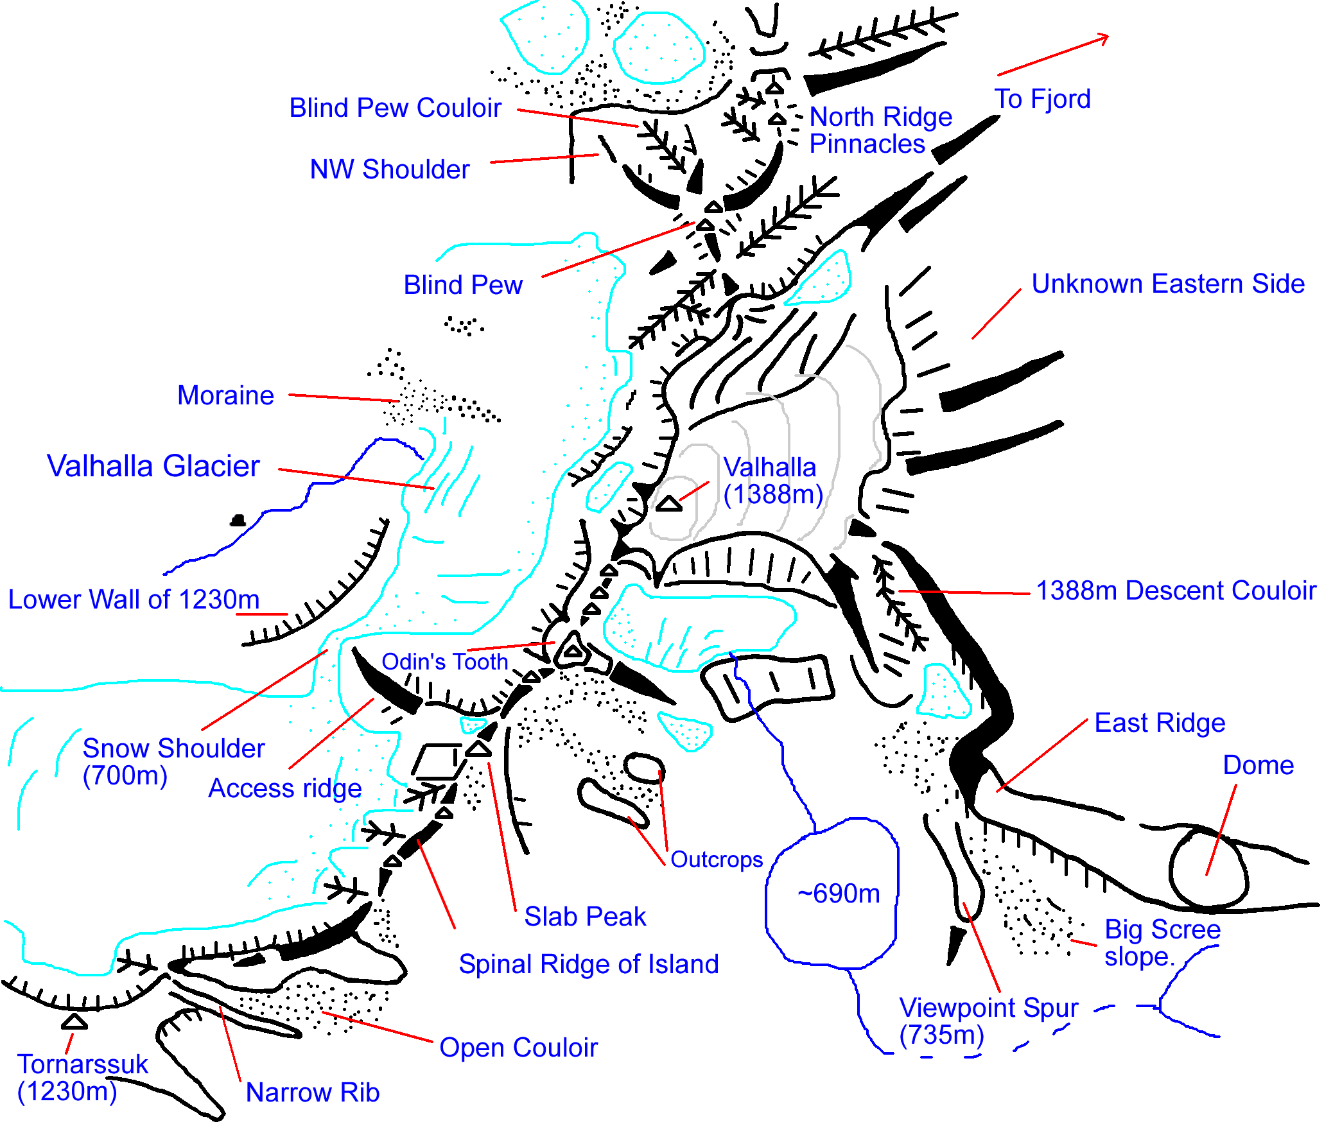
Figure 8. Local Area of 1388m.
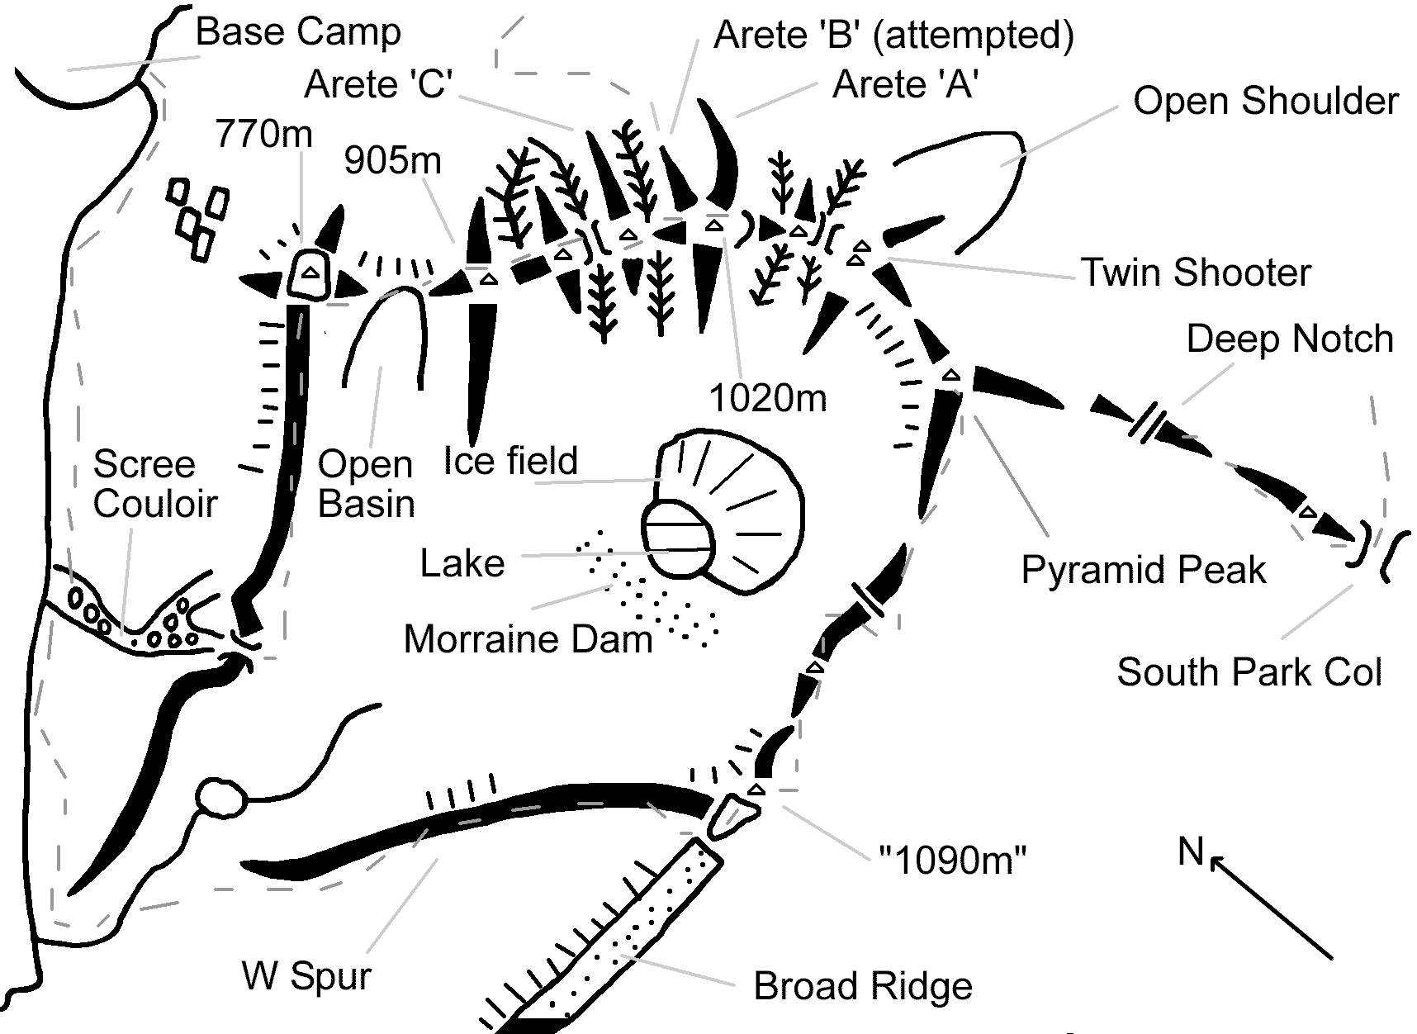
Figure 9. The 1090m area S of base camp.

Conditions.
Here we note the conditions as far as climbing and hill walking activities went on the Northern part of the island.

Climbing and walking.
Much of the rock is very good for climbing being of Granite type or Gneiss. It was generally well weathered on ridges, and well featured, but with quite a lot of fresh looking clean rock about. There were plenty of everything, cracks, large blank slabs, and apparently hold-less walls. The strata were well defined, and features could be traced for kilometres, particularly through pt1388. There were two prominent continuous, parallel horizontal faults slicing through 1388m – fascinating geology. There seemed to be a number of parallel SSW to NNE vertical faults within 1388m and its area.
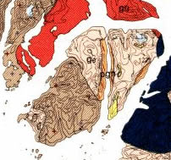There appeared to be three main types of rock regularly encountered; a light grey to white (on fresh exposures) compact, crystalline ‘Dalmatian’ granite rock pocked with weathered garnet that formed most of the lower strata of the hills around the valley. Secondly, a yellowish orange, very crystalline, baked variety of this granite that was heavily weathered, and decomposing to a gritty surface of crystals – bearing large Garnets and lenses of basalt. It could be unsound on a larger scale with apparently sound large features just coming away so was a worrying medium. It could outcrop anywhere, but did form the upper portions of the hills from 1388 North & West, including NW of the rift through 1388m. It weathers into exotic rock formations –so that anywhere one could see crazy pinnacles, you could expect the area to be of this particular rock. The third was highly foliated gneiss, more to the south of 1388, with a much finer grain. The first was excellent, and the last, very good. Loose rock of course could be found anywhere.
Figure 10. Geological map (GEUS).
A geological map (which one can see on the GEUS website) gives useful insight (Figure 10). Key found on full map in Nanortalik Heliport!
- Brown: Southern Tornarssuk, like the bulk of Pamiagdluk is of late Granites, “pyroxene and Garnet bearing Quartz Monzonite of variable composition, with local gneissose foliation”.
- Pink: Northern Tornarssuk, is of early Granites, “Leucocratic Granite, Garnet bearing alaskite (very pale & alkaline) & biotite bearing charnockite”.
- Orange: central fjord shores is of heavily metamorphosed rocks, “pelitic to semi-pelitic Gneiss”.
- Red: Rapakivi Granite.
- Black: Gabbro.
- Yellow: “Meta-Arkoses” with volcanics.
The rock was quick drying in the main, within a few hours, apart from some persistent weeps. It was also quite clean west of the drop into the Itivdliap Pularia except for prominent black bands/strata high up on the hills. On closer inspection this proved to be a thick coating of “Rock Tripe” lichen (with thick black moss and other lichens in broken areas), and not the rock itself which was still good. The stuff obviously prefers some type of rock, this was only somewhat darker and redder. The south of the island has vast areas of these dark walls… As one crosses over the ridge to the fjord shores, just as the geological map indicates, the character of the land changes and the rock becomes more broken, redder and much dirtier – considerably more plants are seen.
Tornarssuk had several significant, permanent ice and snow patches, many as full blown ‘glaciers’ complete with bergshrunds and gaping crevasses. Not much in the way of seracs, but don’t hang about on the slabby aprons below these ice-fields! On arrival, though much of the ‘glaciers’ were ‘dry’, there was still a good covering of snow hiding many of the crevasses, only shrinking after some rain to reveal just what we had crossed unknowingly. Being equipped for glacier crossing is essential to approach many of the higher level faces and peaks, and crampons for crossing the ‘dry’ glaciers in the rain!
As ‘our’ valley was stony and largely barren, it was well drained – indeed we found conditions generally dry underfoot, apart from the ‘meadows’ in the lower valley shortly after rain (very tussocky and riven by streams). Walking anywhere was fairly slow, with just the meadows and lake shore beaches where the walking was comfortable and reliable enough to go at speed. There was a vast amount of boulder hopping (some the size of cars), scree scrambling and moraine scrabbling to do, with one unavoidable area by the second lake becoming known as ‘Mordor’. A new pair of M4 boot soles look like they’ve had a couple of years UK use! Coastal walking is not practicable with steep rock dropping into the water before too long, though we got further than we thought possible heading south.
As far as rock or ice fall went, the area was far quieter than the Alps are, with not many occasions of hearing something go without human help. However, there was evidence of activity when not looking – on attempt 2 on Valhalla (1388m), we noticed a new rock slide just off the side of our route and a 120L barrel sized block of rock sitting on the snow field at the end of a suggestive line of craters… Carl and DB missed being avalanched out of their first route by 15m and 5min, when the snow went from a shelf off to the left, sliding down a lubricated ramp, and overflowing onto the planned start! Pays to be careful.
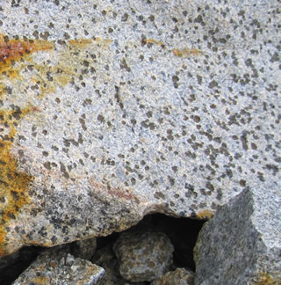
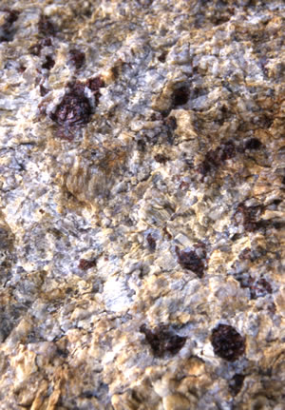
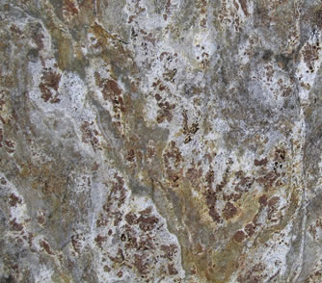
We found the lichen was of a rich and multihued variety, but a certain grey type was viciously slippery if other that absolutely dry. Rock Tripe Lichen was a pain at altitude – forming wide areas of ‘flowers’ of hard, black, cornflake like petals that dug into ones fingertips, and was quite painful on raw fingers as one attempted to find holds underneath. When wet they formed little dark grey oozing sponges…
Figure 11. Some rock types (L-R): Alaskite, Garnet bearing Monzonite & Gneiss.

Weather.
From last year, when we left at the start of a long good spell, to this year arriving at the end of a 4 week period with only 3 days of rain... The weather was generally unsettled with at most 2-3 sunny days in a row, or days of low cloud, but was very mild, only towards the end of the stay becoming cool at night, though nowhere near generating an overnight frost. The southern tip of Greenland does see the wettest weather in Greenland, though it may merely manifest itself as cloud and fog. There were a number of days when the sea to the south was covered in thick sea fog, which would stay much of the day, and there were frequent temperature inversion effects. The weather here can be very localised, generally getting poorer the close to Cape Farewell – Nanortalik seeing little of the winds we had. However, on at least one day, the pattern was reversed with the drier conditions being to the SE.
More importantly, there are strong winds in Greenland – the worst being from a wet NNE direction at Tornarssuk, with a cold SW, mostly dry wind being the next most notable. We had two major nights of storm with some rain that hammered the tents – we were partly sheltered as the “white horses” out beyond the headland indicated, but caught eddies spilling over the ridge and down the valley in big gusts. These would take a day to settle down – often quite sunny but the speed of the clouds whipping over & round the tops discouraged high level activity. The second storm flattened the main tent and overturned a smaller, with occupant! Temperatures were comfortable to hot, with night time temperatures on clear nights usually at the 5-8°C mark. Daytime temperatures ranged from something like 14-21°C, giving shirt sleeve conditions on top of the hills on many of the clear sunny days. A record of the weather is given in 15.3.

Flora & Fauna.
Though in general the island was fairly barren, there were other things to look at, or out for, besides hills.

Insect Life.
One hears more of Mosquitoes and Blackfly in southern Greenland than the Polar Bear. From the previous year‘s experience we didn’t bother with too much insect repellent (having a limited effect on Mosquitoes only) but the essential piece of kit was a head net. In anything but a strong wind or a cold north facing couloir, the Blackfly were so persistent and numerous, they had to be worn during our waking hours outside, including on the very summits. Many are the photo’s that require retouching because of fuzzy blobs! ‘Blackfly’ love eyes, ears, mouths, noses and the inside of spectacle glass – aargh! The chief danger (they don’t bite so the swarming has to be a legacy reaction) of Blackfly is insanity or being distracted. Even in a wind they will try to get at you, but there’s a certain pleasure in watching a black speck zipping toward, and past you, struggling desperately…
The distribution of mosquito is not universal and in our valley they were not notably numerous. They tended to be solitary and mainly operate in the evenings and night (morning killing sprees left coloured remains). They were also large and slow to bite, and most did not get much reaction from the bite. Better, the DEET and other repellents actually seemed to keep most of them off if applied – but keeping all unattended surfaces covered up was the best defence. They tend to stay low in the ground – Carl’s ankles donating the most blood after a rash afternoon of sun bathing!

Flora.
Some us had a passing interest in plants, not least for the prospect of foraging, so finding a scarcity of flora in our valley was disappointing. The lack of flowers was perhaps partly down to the preceding long dry spell. so we packed a useful slim volume on the flowering plants of Greenland. Being so rocky there was no aromatic “herb slope” vegetation, only an enrichment in a few wet flushes. The meadows and camp tarn-side offered the greatest green covering, while the hills only gained significant alpine plants on the eastern side of the island’s watershed. All of the ‘trees’ are prostrate, with dwarf Birch and Juniper dominating, with a little Willow.
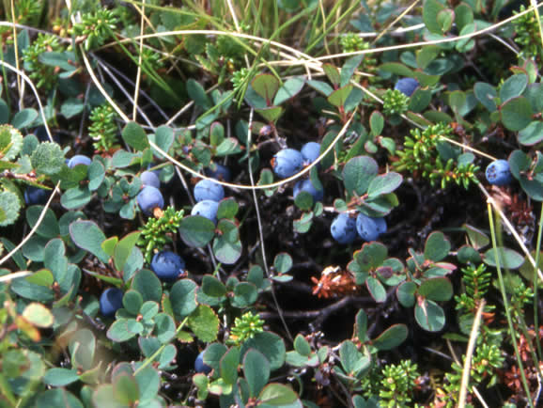
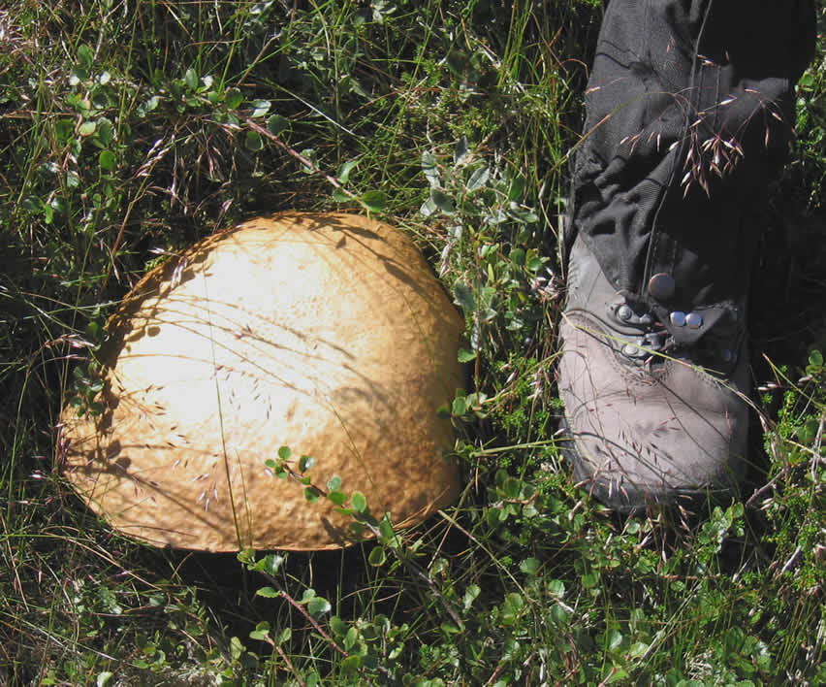
The main ground cover consisted of Crowberry, Birch, Reindeer Lichen (feathery grey – powdery when dry), Bilberry and some grasses. Frequent clumps of Yellow-green Lichen ‘glowed’ by LED torchlight, with an uncanny resemblance to patches of snow in the dark. The lakeside flats were carpeted with the national flower, the Broad leaf Rosebay Willowherb, with Arctic Cottongrass. Other flowering, or just finished, plants included Dandelion, Hawkweed, Harebell, Angelica, Roseroot, Saxifrages, Thyme, Red Alpine Campion, and many more. There were rich communities in the gullies near to the Radio station.
Figure 13. Funghi – food for the Masses!
Figure 12: Bilberries – food for the Gods.
There were a number of edible plants, in theory, but after experimentation weren’t as tasty as made out to be. Rock Tripe has been used as a survival food with 1/3 more carbohydrates than an equivalent amount of honey but we weren’t in a survival situation – lichens have to be boiled for ages to remove the acids! Crowberries are tasteless, but the Bilberries came into delicious condition after the first rains. Several types of edible mushroom grow in Greenland, however there are poisonous funghi and previous experience helped. Two varieties of ‘Boletus’ were found in number, in very large numbers in the Mushroom fields of Tornarssuk and growing to incredible dinner-plate size. With this bounty, we became jaded and the dried mushroom supplies largely returned to the UK! The main was a smooth, dry, tan coloured capped Boletus having a cream to white tubular structured under cap and scaled stem, varying from 5 to 30cm in diameter – identified as a “Birch Scaberstalk” (a member of Leccinum scabrum). The second ‘Leccinum’ was similar, except its cap split in the early stages into a chunky rectangular pattern. Best found in areas of Birch, as they are mycorrhizal with it.

Fauna.
There is an abundance of fish in Arctic waters, many of which should be easy to catch, so the expedition kit included a fishing rod and basic lure fishing kit for some alternative entertainment. However, all our efforts were in vain, with only one of “the one that got away” stories to tell, so the underwater terrain was not good for fish. Perhaps the frequent visits of a seal had something to do with it! A small whale visited the bay on the first night too.
The area was not especially rich in Birdlife though it was quite bold. Especially cheeky were the Snow Buntings. There were some inquisitive Larks and other unidentifiable brown birds. There were a number of gulls, Black Guillemots, Ravens, Ptarmigan with young, and a solitary Whooper Swan.
The only land mammal we saw was the Arctic Fox, a pale or patchy chocolate brown in this part of the world. It was some time before they paid a visit – a Vixen with 3 cubs had a den on the other side of our little bay. Clearly they saw few humans as they came close – you could be doing the washing up with a fox digging a hole for something odorous (but not any of our waste!) unconcernedly 5m away! They weren’t much trouble provided we kept food tidied away and the lids on the rubbish barrels, and they showed their disdain by leaving deposits on the grease trap. The weirdest fox experience was on the ascent of 1090m, being startled by some hideous screeching and howling in the mist, for a fox to emerge from it and keep us very close company, trotting ahead, frequently stopping for us to catch up. It pursued us up the gully, and out on the open slopes still howling, and it was not until we were most of the way up the barren ridge that we realised with relief that our pursuer was heading off for another valley.

Emergency & Contingency Handling.
We also laid plans for any emergency or situation that occurred on the Island, or at home.

Communications.
As the expedition would be completely isolated on the island and well off any regular shipping routes, it was necessary to have a means of communication in an emergency. Indeed, no boats were seen passing us, though larger vessels could be seen from the heights away off near Augpilagtoq, and a cruise ship that negotiated the sound north of Quvnerit. We took a Satellite phone (Irridium) rented from Mobell UK, with a call charge of £1.85 per min, so there weren’t many calls home! A phone could be hired from Niels in Nanortalik, and would be a bit cheaper. However, the UK hire included the full charging option accessories – mainly solar, and DB wanted to check the whole system out in the UK to be certain we’d always have an operating communications system while there. It was switched on at fixed times in the day to pick up vital calls from home, and we easily kept the batteries topped up with the solar panel.
Two mobile phones were a feature of our “Communication Plan”, but we left them in a box in Niels’ safe with all our other valuables of no use on the Island. Thus we couldn’t tell whether they might actually have worked on the island! To our surprise we found a Radio/TV and Mobile phone repeater station on the NW coast of the island, part of the line of sight communications chain between Nanortalik and Augpilatoq, complete with helipad. It did raise the possibility of other emergency communication schemes, such as breaking in and hitting the “off” switch, then waiting for someone to turn up, to “smoke signals” with the microwave aerials (with the smoke from cooking flesh…).
We also took 4 European “PMR446” small walkie-talkies along, but need not have bothered as on the few opportunities for use from on Valhalla, even though Base could be seen, one way communication was the best that we achieved. A member of the club suggested a Marine band radio and loaned us one for the trip, but as no boats passed the airwaves were silent. It could have been used to talk (in Danish!) to the ‘Ketil’… We also had 18 flares and launchers, since we had bought them in Nanortalik last year, but they stayed in the barrel as there were too few of us to look out for them.

Communication plans.
We found a volunteer, plus backup, for the position of Home Contact who could relay messages and information via the satellite phone link using agreed communication periods, and act as a central contact point for information on the expedition progress passing news onto the expedition website. Most importantly, if there had been an accident, they would be able to supply information on the members of the expedition, since next of kin details were left with them, and may be able contact the appropriate authorities. We designed a plan of contact procedures for different phases of the expedition and distributed it to relatives and friends at home. We would switch the phone on morning and evening for an hour, and there were set points in the diary by which we had to have reported home. There were procedures should a call not be made, or be unanswered, but thankfully we did not have to use them.

Crisis Management.
Between the group we performed a general risk assessment, to ensure that everybody was aware of the various hazards and knew what measures we would take to reduce the severity. This focused our minds on the safety equipment and training measures. We felt that all team members should be made aware of at least the basics of self rescue and useful techniques, whether or not they had any prior practise, and so we arranged a very long day’s training course based on our Wales hut with a local guide, Dave Kenyon.
It was decided to ensure that everybody had had a good level of wilderness area First Aid training. We could not expect to be able to immediately evacuate a casualty though the nearest medical facility was the small hospital in Nanortalik. A course run by staff of “Adventure Lifesigns” at our hut was very good, with the scenarios being particularly useful, and this gave us the confidence that we could stabilise a casualty until they were in a medical facility. We constructed a base camp “advanced aid” kit, with a small mobile kit. This included Large size Army dressings, blow up splints, various bandages, dressings and plasters, the miracle “Quik Clot” and burn dressings. An emergency dental kit also went in, though no one was keen on the thought of using it. Everybody took their own First Aid kit, with their own personal supplies, and this ensured that any pair in the field would have at least one useful First Aid kit with them. A short Medical history form, including any serious allergies, was completed by all, copies being kept with the base camp kit, and our Home Contact.
We were lucky not to have any major incidents on the trip. However, there were plenty of grazes and bruises due to falling over on the unstable terrain, and a number of paper-like cuts were received from tiny crystals projecting from the rock. Completely abraded and splitting finger-tips were quite a problem as the rock is unbelievably abrasive – even brushing against the rock had a noticeable effect.

Insurance & Permits.
No permits were required for this area by the Danish authorities, and we did check with the Danish Polar Centre that Search and Rescue funds were not required for this area just 70km from the Nanortalik Heliport and Hospital. We could use standard BMC insurance with a reasonable level of cover. South Greenland falls within level 5, “Alpine and Ski” as we were near habitation on the coast, and couldn’t be said to be in a ‘remote’ area. Insurance has not been included in the expedition finances as people had different needs.

Equipment.
Most of the equipment we took was shipped in the freight and was packed for a team of seven, so we had excess. Check with Niels – the YH ‘kennel’ is a store for many items that expeditions and visitors have left behind, including gas cylinders and so on, and you may be able to borrow something rather than buy specially. We had another blue barrel (from many) to cart food with, plus bowls.

Camping.
For camping we took 4 two man tents, mostly Quasars or Trango 2’s, these were singly occupied while the main tent was intact and these stayed at base. Flat vegetated spaces were at a premium. We also had a lightweight, two person tent, that became an advance base camp at the head of the valley with the support of bivvy bags. We saw the need for somewhere to cook and gather so took the KMC’s “Outwell Hartford XL” from the previous year. We only just found somewhere near flat enough to erect this massive structure, which was a big success while it lasted. All of the tents were put to the test, with some lusty gales but only one small tent suffered from rips to the flysheet, having been ripped from inadequate moorings and sent rolling, with Marylise inside! The main tent suffered with a fractured fibre-glass pole in the first of the big storms, and a couple of small rips in the flysheet, but on the second virtually every pole was fractured as the entire structure completely flattened in the gusts. Thereafter we cooked in a shelter in the rocks covered by tarps.

Stoves & Cooking.
We took out in the freight 3 liquid fuel stoves and bottles from MSR etc. These were for teams to cook on when away from base and as a fall back should there have been a problem with the mess tent cooker. Fuel was a Cleaner product (Naptha) labelled as “Rense Benzin” in 0.5L green plastic bottles. We only used a litre of the 5 we estimated due to just 3 nights away. For cooking at base we had a Double gas ring burner from the KMC stash, plus its own SRG regulator (bought in Nanortalik). The town uses 11kg Propane/Butane BP Gas cylinders and we bought 1. The stove was a great success and despite heavy use, plenty of gas was left.
We had everyone supply their own plate, mug and cutlery for ‘exclusive’ personal use, and supply a light panset for two for each of the petrol stoves. Most of these were freighted with a communal collection of medium pans, frying pan, teapot, kettle, and a pressure cooker (as a large pan). With knives, funnels, grater, peelers, fish slice, scissors, ladles and spoons we were sufficiently equipped to cook quite sophisticated meals (comfort food on the grim days).

Electronics.
In addition to the Satellite phone, we had a smattering of other electronics as well, such as the radios, and a GPS unit to fix locations. A watch type altimeter and an old mechanical one were both lighter to carry and more accurate (if reset every day), for height measurement, and the graph plot on the former was excellent for tracing the progress of the deep depressions. Amongst the group there were torches (seeing little use with the short ‘dark’ hours) personal radios/players as well as digital cameras. So we had a communal box of AA and AAA batteries with a similar stock of rechargeable cells, and returned all discharged batteries (~12!) to the UK. We had a flexible 11W solar panel with us, whose main purpose was to top up the Satellite phone, but with a solar powered, multi-function, battery charger built at work, also did a good job of recharging camera batteries.

Climbing kit.
The idea was that there should be 2-3 full racks brought out to equip a full set of teams, with most personal climbing gear taken in our luggage. We settled on a standard of 60m 8.5mm rope and shipped all of them too – with the cancellations, there was a surplus of rope. The communal equipment freighted out included a set of spares or so, in case of loss to racks or harness & helmet (essential kit item!), and some rarer items of kit, like large cams – this ended up being used to tie down our shelter in the main. No bolts were taken but a few, unused pegs. A whole bunch of tat plus 120m of 6mm cord were taken and we got through ~60m in rigging abseils, but we only needed to leave nylon behind. Nothing needed to be rigged as the 50m of Static rope that ended up on the island stayed in the barrel. There was little need of chalk with the state of the rock!
As to our Ice gear, we decided a minimum of 5 ‘walking’ ice axes (1 spare) and 4 pairs of lightweight crampons would be enough to go around as not everybody would need to progress on snow at once. No ice climbing as such was seriously expected (ice screws etc. weren’t taken). Both items were vital.

Tools & Other Equipment.
We took some basic tools since we wanted to be able to repair equipment and to have the means to put together some form of shelter with some 3x2m tarpaulins. Some scrap sheets of marine ply left lying at the hostel were borrowed as excellent tables/benches & walkways! We included a pair of essential Army folding shovels and a normal handled shovel that Niels loaned us, which together with a jemmy bar and a lot of effort were the vital tools in latrine construction. Finally there were several rolls of indispensable Gaffer tape, used on repairs like flysheets and groundsheets.
As miscellaneous equipment, we had; Books – plants, birds and mushroom identification paperbacks etc., books on the Arctic, and paperbacks. We had a selection of pens and notebooks for a daily log of plans, and records of their days as base material for this report. Other items of notes were, spare tent poles and pegs – the latter were gradually all used to pin every possible point down as pegs were sent flying over long distances. Binoculars were very handy, and a supply of foam seats eased the pressure sores. Ortlieb map cases protected the phone and other electronics. Citronella candles warded off the mosquitoes in the main tent, though the other repellent materials were unused. Most other items saw little use, certainly no one could be drawn to the supply of games materials!

Food & Shopping.
Having a good supply of food was bound to be an interesting task, particularly with the diversity of likes and allergies – one being Vegan with complications, though the rest were generally omnivorous except for one non-fish eater. We decided we should ship all our hill food and bivi style food out, a collection of basics that we wanted to be sure of, and a number of ‘luxury’ items including herbs and spices to vary what could turn monotonous. After a survey was conducted, a list of suggested food supplies and quantities for 7 was drawn up including only items of significant interest. If anyone wanted something in particular and it wasn’t on the general wish list, they’d have to pack it into their own freight allocation. We had to plan for ~22 days on the island, including a two day buffer in case the boat couldn’t pick us up.

UK Shopping.
A lot of our ‘bulk’ supplies came from the nearby Unicorn Grocery in Manchester (good herbs and spices & organics), with the rest coming from a number of odd visits to various supermarkets. Our Vegan packed her own barrel of ‘exotic’ foodstuffs for her own safety. Without giving a full list, of note;
- Teabags – 75% standard, Darjeeling, and Green tea. Just had to make use of the 3 for 2 offer!
- Dried Fruit, nuts and Bombay Mix. Trail mix ingredients were brought in bulk bags for decanting.
- Muesli, Crunchy mix, and Porridge oats (Mistake – remember washing up!).
- Dried Black Eyed Beans, Chick Peas, Green Lentils, Basmati rice and Cous-Cous.
- 3L Olive oil can! – smallest in shop.
- Cheesecake packets – went down well with Bilberry topping.
- Cereal bars - ~160 of a wide range of types thrown into a barrel to eat whenever. (Became tired of them).
- 125g Cookie bars (vegan) from Unicorn. Not appreciated this time round!
- Duty Free Alcohol in Copenhagen Airport, but watch the limit – it is seriously expensive in Nanortalik.
The loss of two members meant we were drastically oversupplied on the island so much came back to the UK to share out.

Greenland Shopping.
Once we packed the UK supplies into the barrels, we looked at the remainder and formulated a generic shopping list for Greenland – only to be torn up and redone a day before leaving! The list consisted mostly of ‘fresh’ foods, cans and soft drinks. There are two Supermarkets in Nanortalik, the Brugsen, with a bakery and payphone in the entrance, and the Pilersuisoq. We had an hour to do our shopping before our boat left so Niels generously loaned us his credit card and store account, and negotiated for us to fill trolleys before the Brugsen was open, thus gaining a march on the Spanish Team who were going out in the afternoon. It is surprising how big a range of goods are available, and the variety of fruit and Veg’ (though not always in the best of condition).

Environmental Practice.
The BMC and MEF recommend that each expedition establish a clean Environmental and Waste management policy. A set of guidelines following on from our 2004 expedition, were posted in the expedition factsheet, and their basis can be found in our 2004 KMC expedition report. The Guidelines could only be based on the best guesses on the nature of our area, so had to modify them to suit what we found. Nanortalik has a waste disposal site, but no recycling facilities that we know of. We could not ‘overload’ this site with rubbish we brought in.
So after the good intentions… Being in a narrow valley, with mostly scree underfoot, we didn’t get a lot of choice in the campsite and the landing itself on a boulder slope was interesting enough. We weren’t about to wade across the river with 14 heavy packages, so our area was the flattest area within reach of the landing (150m away). It was on a well drained shelf 10m above sea level on the north side of the shallow bay, being bare gravel on the east end and a crowberry/grass/lichen mix towards the west. The shelf eventually encompassed a small tarn, stagnant on arrival, so the nearest water was a long 200m haul east to the river mouth. Water had to be frequently collected in 10L water bags, none of which survived the trip due to shoddy construction. It at least meant that we wouldn’t contaminate our water supply. A blue barrel sunk into the river (and tied there!) was our fridge.
The vegetation is not as tough as it appeared. After only a few footsteps in the same area of the main tent entrance, the Crowberry turned brown, dropped its leaves and looked dead. Surprisingly the areas under the groundsheet and the small tents were largely unaffected. Since the bulk of the area was stony we created little trampling.
The washing area was just downhill of the main tent, on the edge of the scree drop-off into the sea. A Soakaway and grease trap was built in a well drained area of grit by digging a pit, filling with layers of stones, gravel and vegetation before covering with some net curtain material to catch the bigger stuff. It worked well, being back filled at the end of the trip, burning the curtain. All washing, with biodegradable washing up liquid, of dishes etc. was done over this. For clothes washing we collected (very) cold water from the river in bowls and poured the used water onto the scree slope instead. Biodegradable Fabric Wash does an excellent job.
Text book ideas of pit latrines don’t apply – finding soil, let alone anywhere we could dig more than 10cm in a sheltered spot was hard enough. Some of the boulders eventually yielded a softer patch of grit in the lee, where we could get as much as 30-40cm deep in small pits. Despite Dave W practising his dry stone walling technique, these were quite exposed sites and we got through 3 of them. All were on the edge of the drop-off. Used toilet paper (6 Greenland rolls) was burnt there and then. A red ‘flag’ on a tent pole indicated occupancy. They were all filled in, first with soil then the boulders to restore the area. The drop-off slope was allocated as the liquid waste disposal area.
Blue barrels lined with bin liners were used to store the different types of waste; plastics, paper and flammable waste, metals (foil and crushed, washed tins), glass, and biodegradable waste (food scraps, teabags…). We dug pits in the gravel, literally down to bedrock, to dispose of the bio-waste barrel contents back filling and relaying boulders. The fox did not dig them up (while we were still there!). The flammable waste, together with anything else that could be burnt cleanly and efficiently, went on a bonfire on the last night. A firepit was dug in the gravel. Now the last day of packing was a nightmare, with rain, rain and more rain, right through to the next morning so Dave W, the “gardener”, rose to the challenge with a bottle or two of fuel. The waste was quickly reduced to a little ash, which was extinguished before a neat backfill of the pit leaving it nice and tidy. A final sweep of the site on the morning of departure, removing the site of hold down boulders showed we had done a good job (though who knows what had blown away to join the small amount of sea borne waste on the shore).
The segregated waste was brought back to Nanortalik in bin-liners to drop in the waste there. We might have returned some to the UK, but the return freight came to more than we anticipated and there were no spare barrels. Excess food etc. Half-used items and unwanted kitchen goods were donated to the Youth Hostel or its store ‘kennel’. Excess, mainly Greenland bought, food in good condition like cans, Niels can find a welcome home for it at a shelter for the town’s needy.

Conclusion.
Much of the planning actually worked for us - nobody starved, or went looking for a corner shop. We were too weak a group and the weather too unstable to make a large impression on our original list of objectives. Not expecting weather to last, we made most forays from base resulting in long days. We should have set up a bigger advance base sooner but with the seeming unlikelihood of a succeeding day of good weather, we could not be enthusiastic. Any sort of weather forecast might have helped! We made good use of what we had though, heading off as long as it wasn’t raining or blowing a gale, even if it did mean turning back later (actually not that often). We were desperate to complete something in the last days but these were definite turnbacks! The conditions favoured single day mountaineering routes rather than long rock routes.
Most importantly, everyone returned safe and well, and enjoyed the experience, though the leader apologises for poor leadership skills on the island when hoping to enjoy the fruits of before & after labours. A chance to stand on virgin terrain and climb without being blinkered by guidebooks. Some interesting moments were had and the scenery is stunning. Some wish to return one day and yes, we have left plenty to do even in the same valley without a need to head south over the col to the next valley system. And there should be plenty of pictures for the KMC slideshow and website!

What’s left to do?
Taking just the immediate surrounds of the Kukasit valley, there are still some peaks and ridge traverses to be done. Point 1250m needs an ascent, but not a traverse of its cockscomb ridge unless one is incurably keen on rotting pinnacles. There is a possible line to a shoulder on the north end of the west, face, traversing in and climbing direct to ones choice of the summit for a few pitches. Its eastern side is likely to be in the band of dirty rock, though the NE flank could be steep. A peak of >1000m just north is separated by a big drop – though having a dome of a top, it is steep sided (very much so on the northern end). Finding a route to it will be a problem in complex, glaciated terrain – and note, it is black. A lower peak even further north has similar characteristics with an even bigger black wall, but even more difficult to get to. These are the prominent peaks in M. Wyser’s picture of the north of the island.
The Twin Shooter/Lobster claw remains to be done, confirming if it actually is the highest point. Possibly could be attacked up scree spur from between the two lakes, but could be made interesting by a determined attack on the SE ridge, or via a route on some of the aretes on the south side of the Kukasit. The cirque of 900m+ peaks NE of the first lake has a manageable (?) amount of pinnacle work for a traverse though on poor rock. Odin’s shield as a traverse could be interesting, and there are some powerful crack and corner lines in the lower half of the front face. A big sweep of slabs left of the Shield will give several pitches but not if rain is around.
Going around the head of the valley, first off is the subsidiary peak to the south of Tornarssuk (1230m). It is separated from Tornarssuk by a big notch, and it has a ridge and slab line from the west via the “South Park” Col. The north wall of Tornarssuk is big and impressive, but will be cold and it starts from a glacier – there is a big band of black immediately below the summit. Below on the wall under the glacier, there look to be a few climbs. North again, is the most eye catching target of Odin’s Tooth (~1100m) with accessible south and east sides seamed with lines on excellent rock. The west face could be reached by traversing in, and is steep, 70-100°, with a challenge of a smooth grey shield of rock. Due to the length of approach, a camp by the lake below would help. The complex front face of Valhalla could be interesting but the riven nature gives false summits.
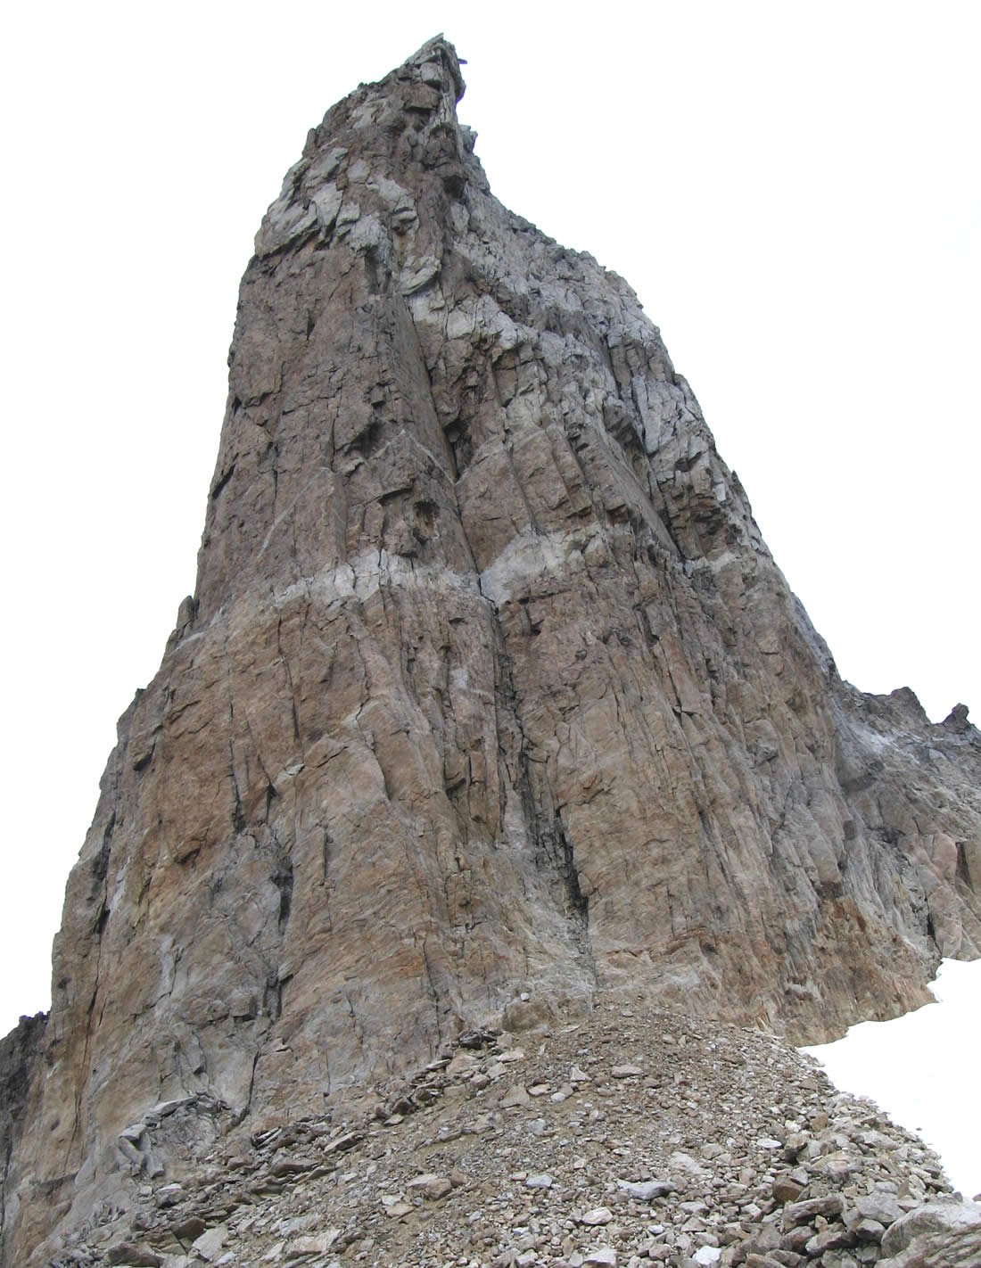
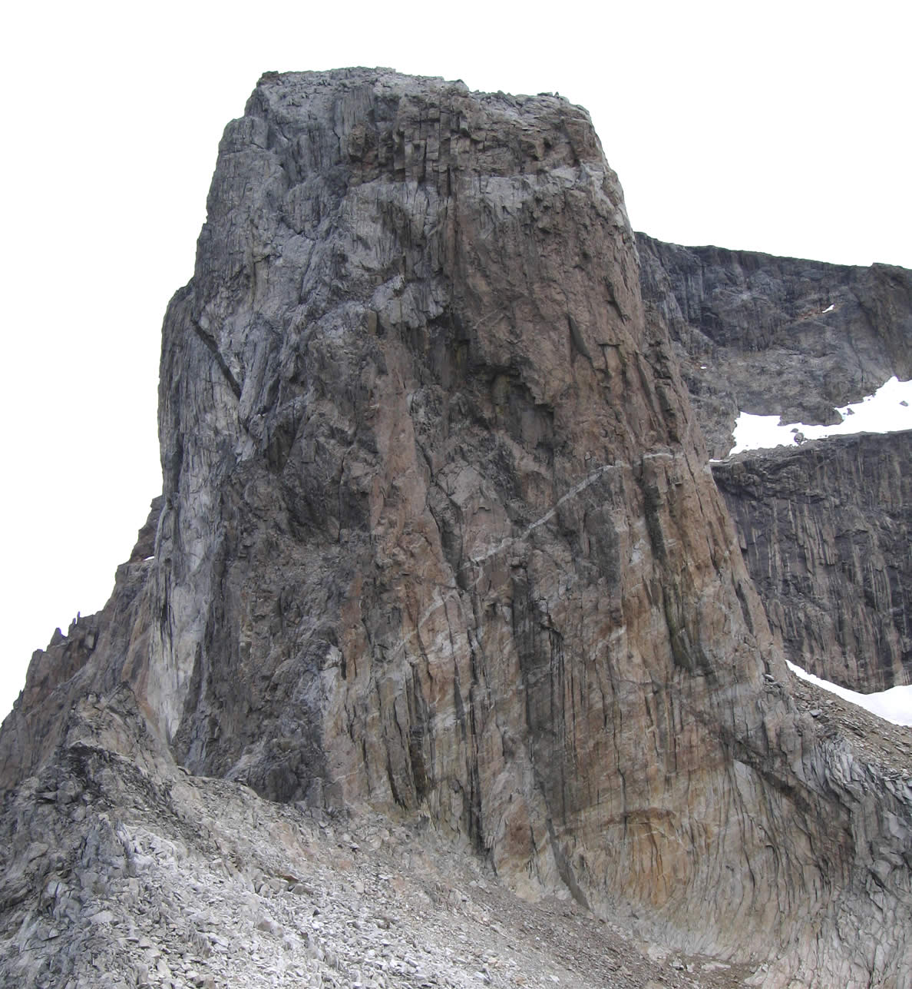
Further afield, there are some big slabby Sea Cliffs below the Radio station, with a possible descent down a gully. These are dwarfed by the huge, easy (?) angled slabs sweeping to the summit of 840m from the NW. Complex rocky terrain makes exploration further N tricky, but the lower peaks here tend to be easy piles of scree with rocky tors. Plenty of short fierce crack climbs heading down the south coast from base, but to go much further afield would mean crossing the “south park” col into the valley system south where there are big ridge systems to the summit of 1120m and glaciers below their flanks. The far south of the island has a plateau like structure with steep walls and it all looks rather grey down there with lots of black bands and expanses of grey rock. The far south drops abruptly into the sea from ~700m. There’s plenty more and will give routes over a wide range of grades.
Figure 15. Odin's Tooth from the South.
Figure 14. Odin's Tooth from the East.

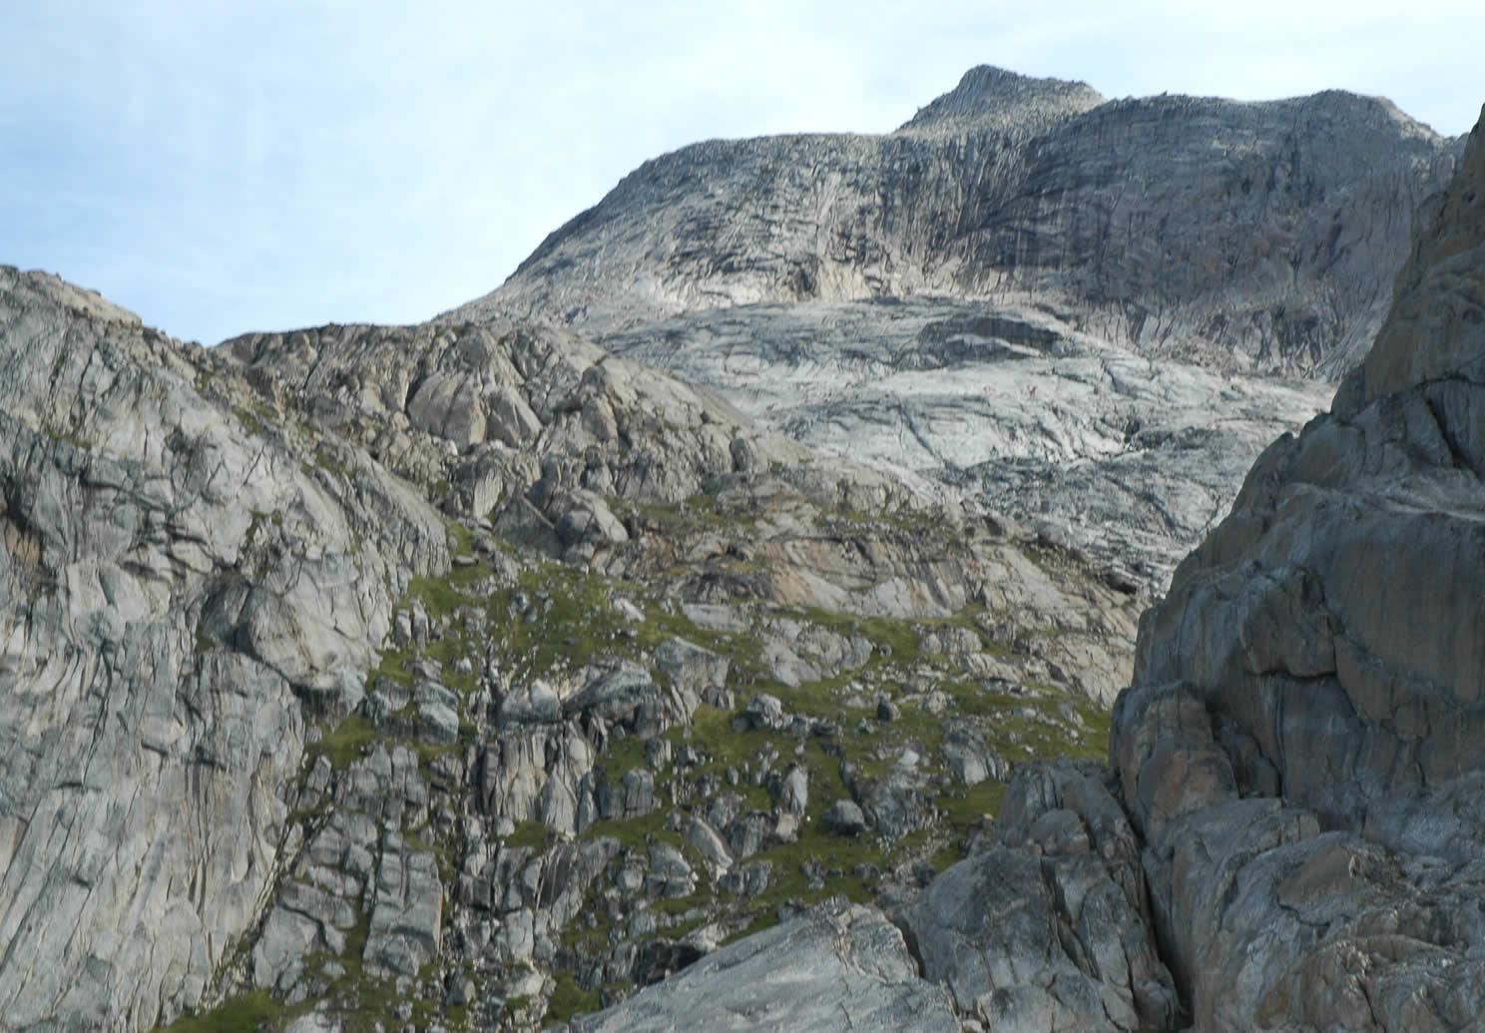
Figure 16. The Slabs on the NW side of 840m from the lakes outflow.

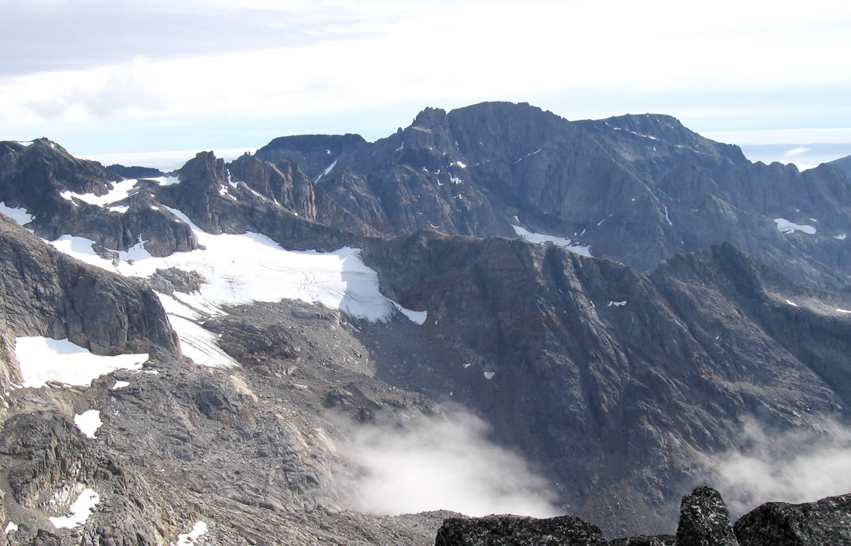
Figure 17. 1120m from the north ('1090m').
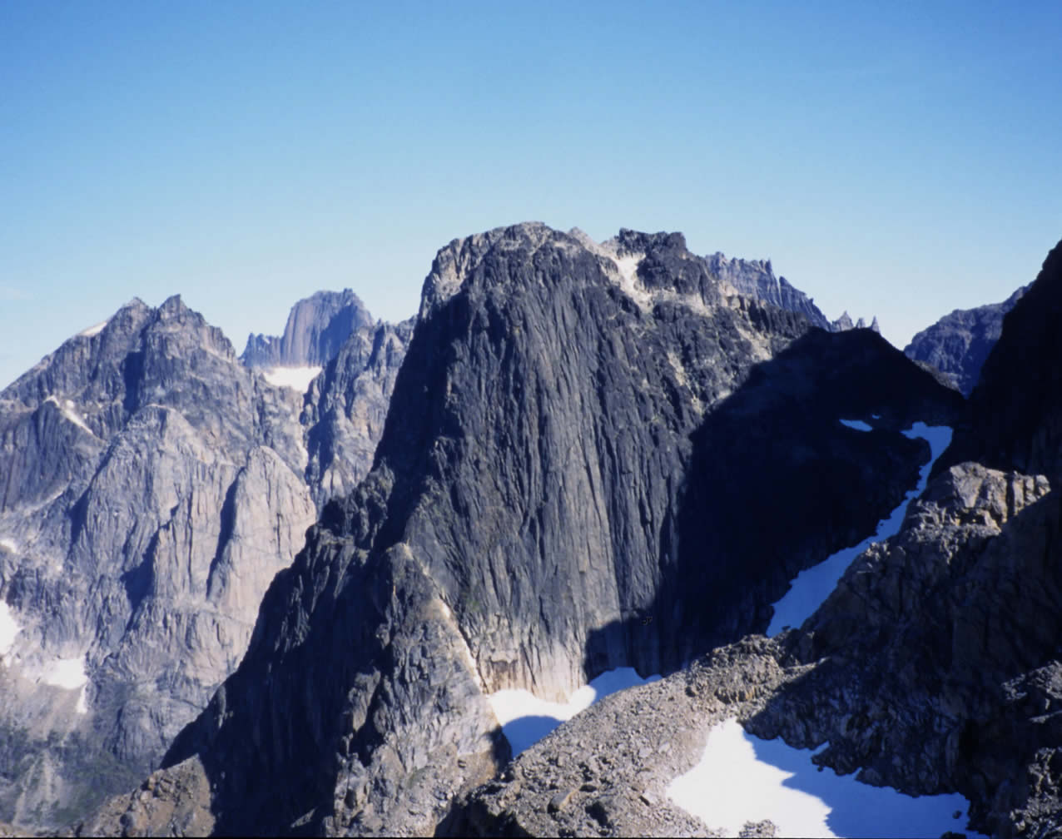
Figure 18. The 'hidden' north-west facing Black walls of the 2nd peak north of 1250m.

Acknowledgements.
All the expedition members would like to thank the following for their contributions towards the financing and success of the expedition.
- The Mount Everest Foundation for their Approval of the expedition.
- The UK Sports Council and BMC for financial Support.
- The Gino Watkins Memorial Fund for financial Support.
- The Karabiner Mountaineering club for financial and moral support.
- Norcott Technologies for electronics support (solar panel) and provision of “office facilities” for the leader.
- Unicorn Grocery, Manchester for groceries. (www.unicorn-grocery.co.uk).
And of the others who gave of their advice and assistance;
- Niels Taekker Jepson of the Nanortalik Tourist Office, the “Mr. Fixit” to whom nothing was too much trouble.
- Michi Wyser of the 2004 Expedition to Quvnerit, for lots of advice, encouragement and some initial pictures of the area.
- Dave Shotton for waiting by the phone, acting as our Home Contact, and posting expedition progress on the club website www.karabiner.org.
- Roger D for advice on radios and acting as a backup Home Contact.
- Duncan Lee for use of his van.
- Dave Kenyon for going that bit further on our self-rescue training course.
- David Carraher of the 2004 Irish Kayak team for copies of charts and information.

- The compilers of this report and the members of the expedition agree that any or all of this report may be copied for the purposes of private research.

Appendices.

Routes.
Route Name | Grade | Length | Climbers | Where | Date
Arete ‘B’ route.  (Central Arete of 3 main features). | HVS/E1 5a/A0,5a/b,4c,5b,4a  (1/3 of spur only) | 260m | CP, DB | North face Arete complex of Twin Shooter. | 23/7
Dan ‘s route | E1 4c,5b,5a | 130m | DOB, DB | S Face Camp Hill | 24/7
Tornarssuk North ridge and East Couloir. | PD+ (25m VD [very dirty]) | 500m (from snow shoulder) | DOB, DB | Tornarssuk 1230m | 25/7
Twin Shooter West ridge.  (1020m peak reached). | PD (steps of 4a) | 1000m/2km | CP, DB | Ridge line S of base | 27/7
Twin Shooter East ridge via South Park Col | PD? | ~300m/1km from col | DOB, DW | Ridge line SE of 2nd lake | 30/7
Blind Pew. (Pinnacle skirted in attempts on 1388m) | VS scrambling - 10 pitches to 5a ( 5a pitch – HVS?). | ~450m vertical. | CP, DB | Valhalla NW spur | 30/7  3/8
We’re going to Mars | E1 5b | 30m | CP, DOB | Crag above base camp tarn | 6/8
Un-named | HS | 30m | DOB, CP | Crag above base camp tarn | 6/8
Valhalla (1388m) via SE couloir. | F+ scrambling. | 680m vertical | DB | Vallhalla SE side | 7/8
Pt1090 SW Spur & Pyramid Peak | PD+ 5b boulder problem for Pyramid | 1000m/2.5 km | DOB, DB | 1090 Massif | 8/8

Topos & pictures.
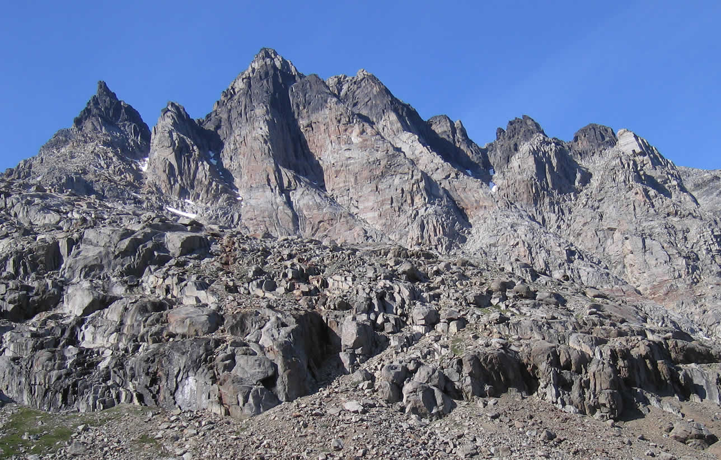
Figure 19. The Aretes of the "Twin Shooter" ridge.
Taken from the foot of the first lake in the Kukasit valley, a route was attempted on Arete ‘B’, the rib just to the right of the highest point on the skyline (1020m). The “chasm of doom” is in the shadow at the head of the steep lower section.
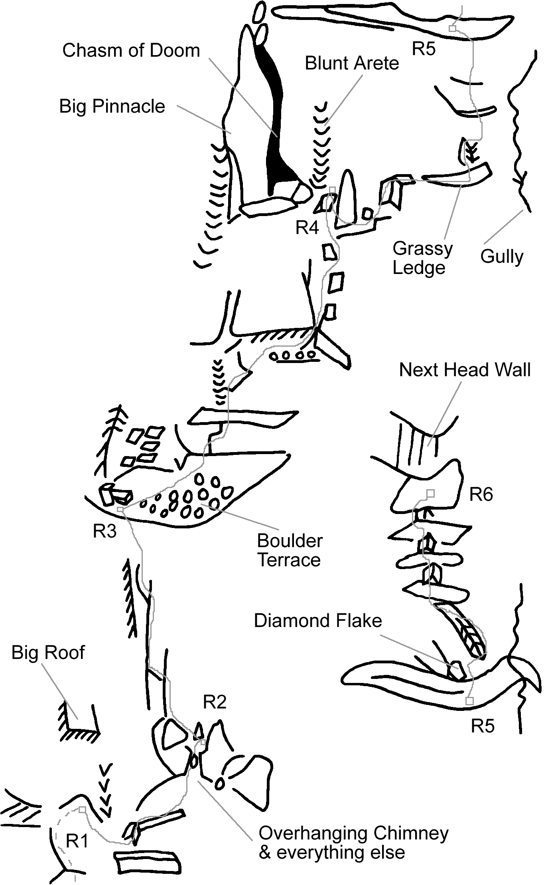
Figure 20. Arete 'B' Route.
Start at foot of spur, below a big roof, and just to the right of a sloping shelf from the gully right – check out the snow!

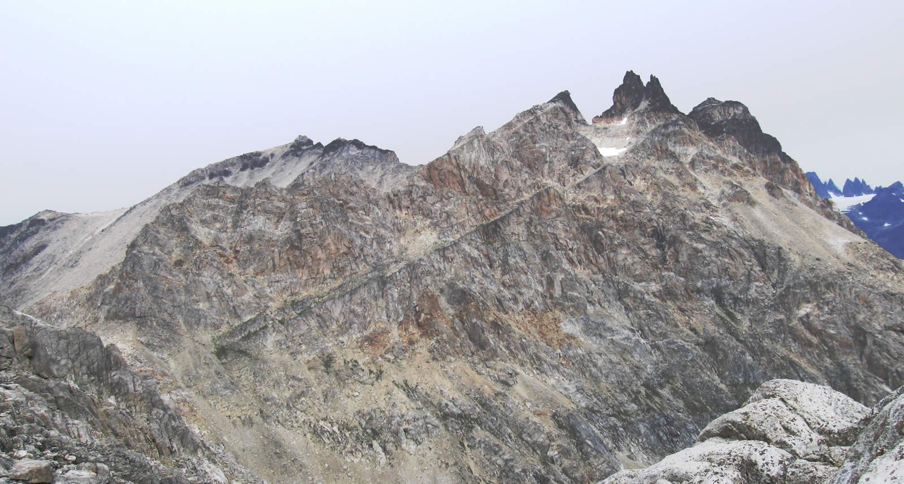
Figure 21. The SE ridge to the "Twin Shooter", and '1090m' on the ridge behind.
Taken from the snow shoulder on the Valhalla Glacier, the col is just hidden on the left. A route followed this ridge L-R to the first deep breche (where the southern ridge out to ‘1090m’ behind can be seen. Pyramid Peak is the black tip to the left of the “Twin shooter”/etc, in the middle right, and 1020m the next right of Twin Shooter.
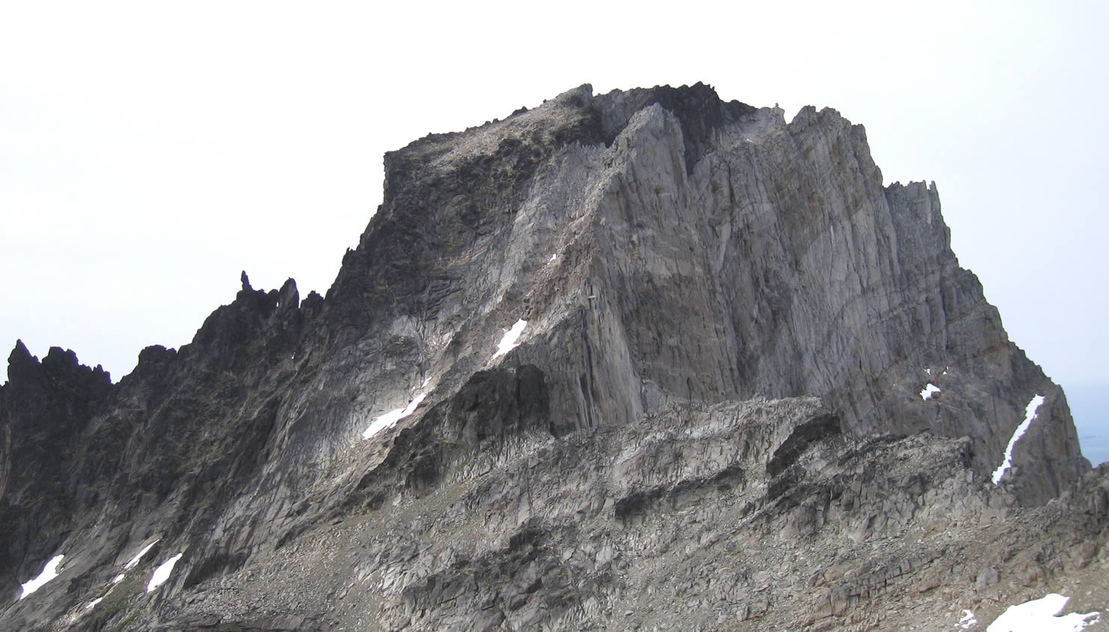
Figure 22. Tornarssuk (1230m) from the NE (Odin's Tooth shoulder).
The summit is the highest ‘black’ point. The ascent route alternatively followed and skirted the ridge from off the right of the picture, and round the foot of the first black coloured rock into a long grey couloir (via the first snow patch) to a notch in the ridge. A short black wall to the sloping summit ‘plateau’ was taken on the left. Gargoyle ridge runs off the left of the picture.
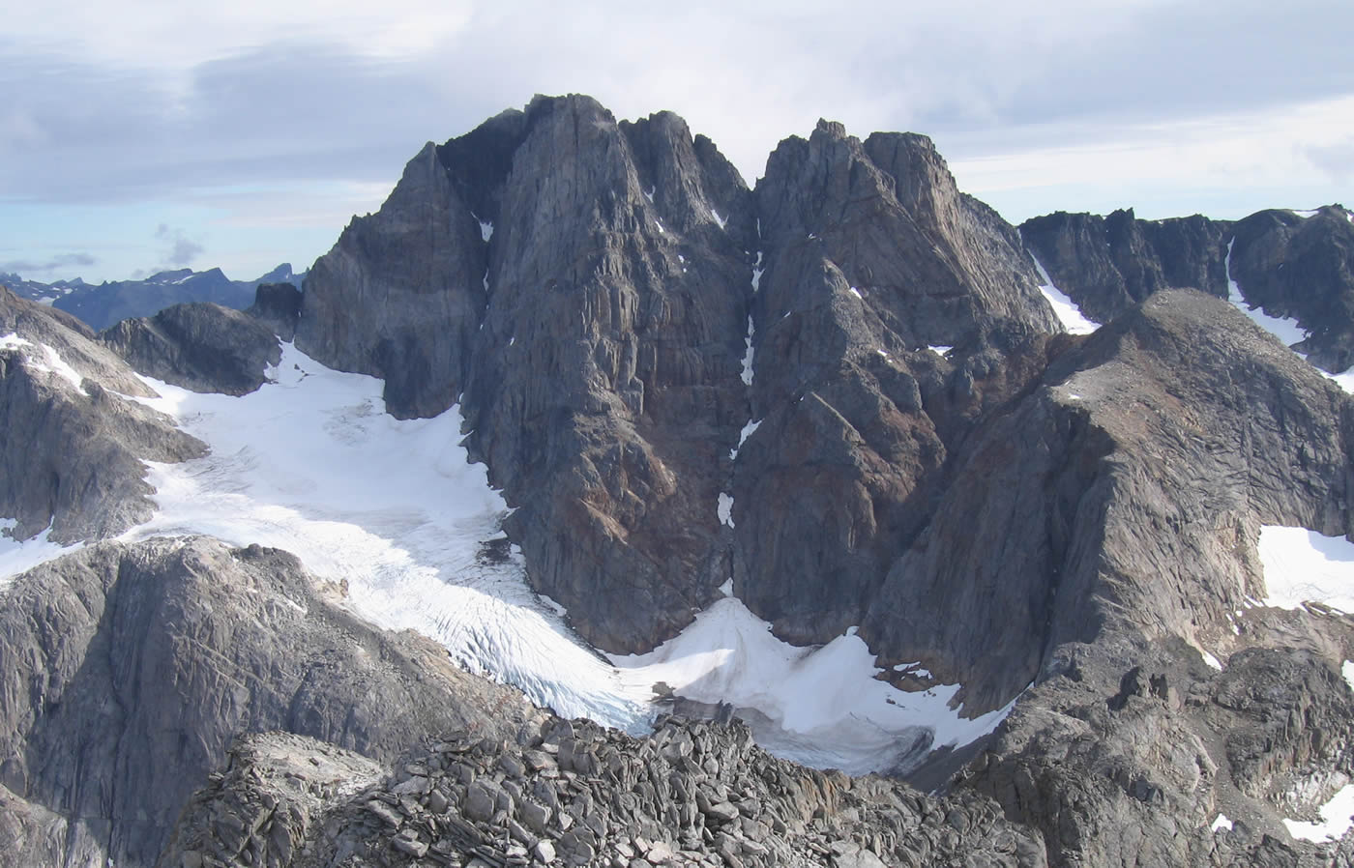
Figure 23. Tornarssuk from the NW (Pyramid Peak).
Access route takes the grey spur on the extreme left, to follow the spinal ridge round the head of the ice field. The ‘top’ on the right was not attempted.
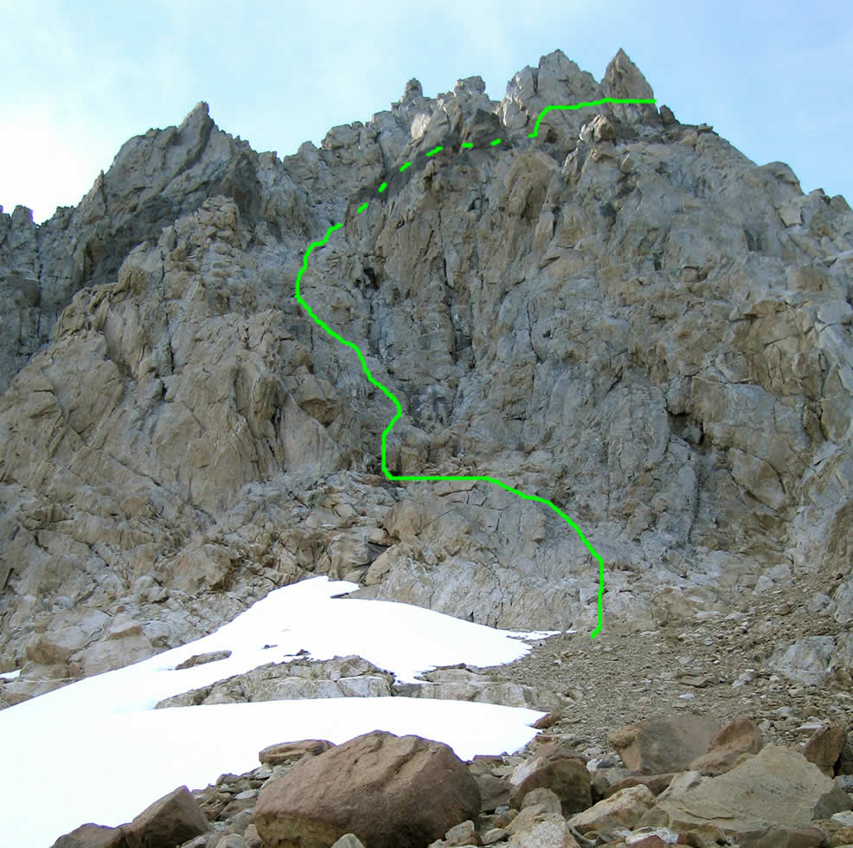
Figure 24. Line of the Blind Pew couloir route on the northern end of 1388m.

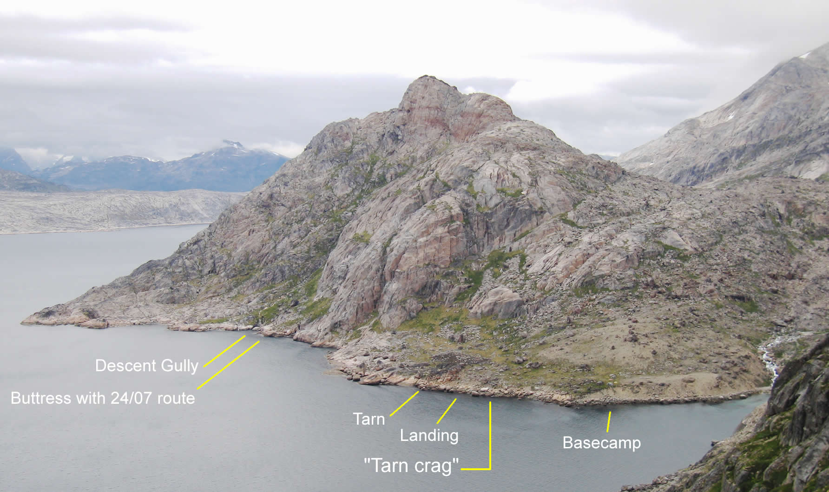
Figure 25. The Base camp hill from the south.
Two routes were climbed on the “Tarn crag”. “We’re going to Mars” taking a prominent ‘S’-shaped crack in the steep slab, and ‘Un-named’ following a wide right-hand corner crack to the left of the previous route.
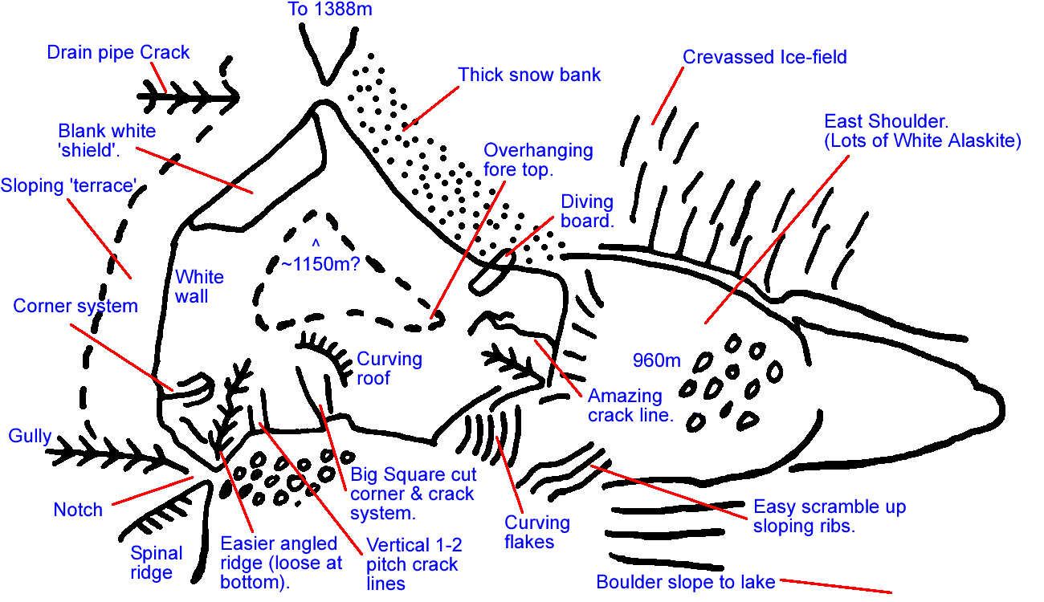
Figure 26. Estimated plan view of Odin's Tooth.

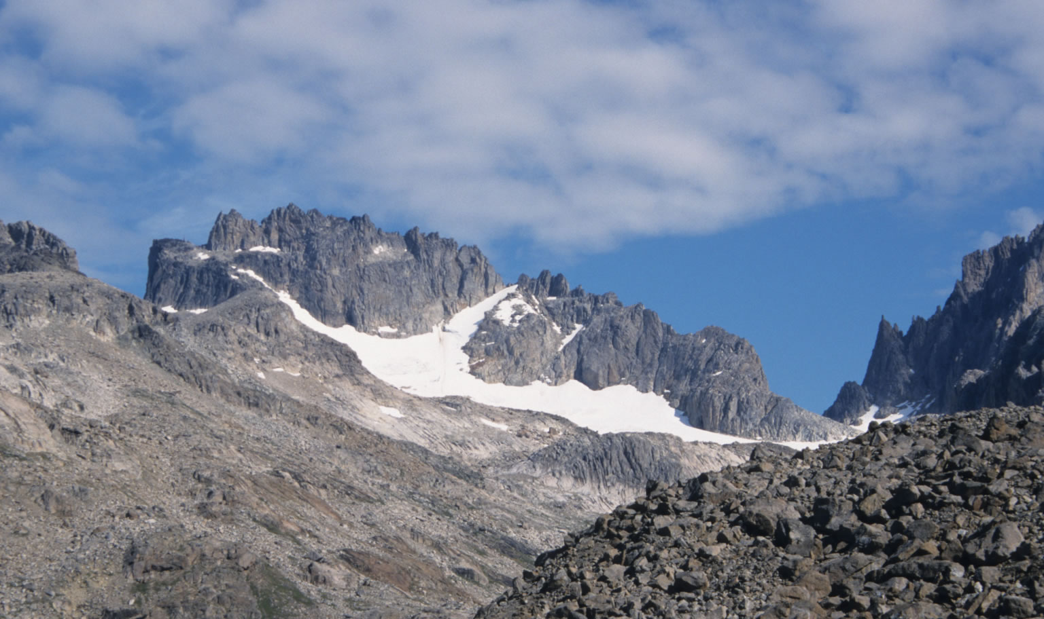
Figure 27. 1250m seen from the basecamp area.

Weather record.
Greenland’s weather for 3 weeks…
Date | AM | PM | Evening | Comment
20th July |  |  | → | Arrived on a warm Sunny day. (Wednesday)
21st July |  |  |  | Another fine day for a boat journey.
22nd July |  |  |  | Warm and overcast.
23rd July |  |  | ⋅ | Cloud and drizzle broke by end of day, warm.
24th July |  |  | FOG | No wind & warm. Cold in fog.
25th July |  |  |  | Misty start. Very humid and warm.
26th July |  Г |  Г | ➢ Г | Peaks shrouded in cloud. First gusty E wind.
27th July |  |  |  | Another cloudy day, very mild, spots of drizzle.
28th July |  |  F |  Е | Day built up to first night of storm. (N gale).
29th July |  Е |  F |  F | Winds easing.
30th July |  |  |  | High cloud presaging a front.
31st July |  Е | ➢ F |  Г | Wet and windy.
1st Aug |  | ⋅ |  FOG | Dull day – with bank of cold fog.
2nd Aug |  Г |  Г | → Г | First Good day even with breeze.
3rd Aug | mist |  |  | Bank of very low cloud swept in.
4th Aug |  |  |  | Hazy.
5th Aug |  |  Г |  Е | Drizzle, then buildup to 2nd storm over night.
6th Aug |  Е |  F |  Г | A day for recovery.
7th Aug |  |  |  | Generally overcast or hazy.
8th Aug |  |  |  | Temperature inversion.
9th Aug |  Г |  F |  Г | High Cloud
10th Aug |  |  |  | Rain and more rain
11th Aug |  |  |  | Dreich day
12th Aug |  |  |  | Brightening up as we left.

Finances.
The final ‘detailed’ accounts of the expedition are given below.
Income |  | Expenditure
MEF Grant [Approval only] | £0.00 | Airfares | £4,673.41
BMC Grant | £800.00 | Boat Charter | £1,442.30
KMC Donation | £200.00 | Other Travel expenses | £21.15
Gino Watkins Fund | £500.00 | Accommodation (Youth Hostels) | £385.10
Contributions, to expenses incurred, by cancelled members | £435.06 | Food Supplies in UK | £581.13
Members (5) payments to costs. | £7,721.42 | Food Supplies in Greenland | £454.00
Average UK personal contribution = | £1,544.28 | Fuel Supplies (Gas) | £42.31
 |  | Tools, kitchenware, & hardware supplies | £42.98
 |  | Climbing Equipment | £65.47
 |  | First Aid Supplies | £46.54
 |  | Satellite phone rental & calls | £469.96
 |  | Expedition Research & reporting costs. | £51.10
 |  | Drums & packing materials | £1.47
 |  | Freighting Costs (return) | £761.16
 |  | Pre-expedition training | £550.00
 |  | Other Equipment & expenses | £68.40
Total Income | £9,656.48 | Total Expenditure | £9,656.48

The final calculations were for the 5 members who went to Greenland. The flight and training costs of the two cancellations were removed and charged to them directly so are not shown here. Because by the time of cancellation a large amount of food, and some equipment, had been bought on the basis of seven going, they were ‘asked’ to contribute a 1/7 share towards the committed expenses. These were; Food bought in the UK, Freighting costs, bank charges, climbing equipment, First Aid supplies and general supplies.

Bibliography.
A number of books gave useful, not necessarily climbing related, information on the character of Greenland, etc.
- The lonely Planet Guide “Iceland, Greenland and the Faroe Islands”. Graeme Cornwallis & Deanna Swaney. ISBN 0-86442-686-0. Recommended.
- The Lonely Planet Guide “The Arctic”. Deanna Swaney. Covers North of the Arctic circle but has a useful supplement on Nature in the Arctic.
- Greenland Tourism brochures for Greenland and Southern Greenland. Available online (PDF) from www.greenland-guide.gl.
- A Tourist guide to the Nanortalik area is available from the Nanortalik tourist office on www.nanortalik.gl.
- “The Arctic, A guide to Coastal Wildlife (field guide)”. Tony Soper, Dan Powell. Good for identifying whales if near the open sea.
- “The Arctic and its wildlife”. Brian Sage. Flora and Fauna.
- “A Naturalist’s Guide to the Arctic”. E.C. Pielou. ISBN 0226668142. Arctic landscape features as well as flora and fauna. Very good.
- “Greenlandic for Travellers”. Birgitte Hertling. ISBN 8755809804. Two dialects in Greenlandic – a phrasebook, that may supplement a Danish phrasebook. Might help understand feature names.
- “Flowers of Greenland”. Feilburg, Fredskild & Holt. ISBN 8799713071. Bilingual. Essential and easy to use book for identification of plants in Greenland.
- Mushrooms: Dorling Kindersley Handbooks. Thomas Læss∅e. ISBN 0-7513-2727-4. Clear pictures.
- Mushrooms: Peterson Field Guides. Kent McKnight & Vera McKnight. ISBN 0-395-919900. Good range – North American based.
- The Lonely Planet Guide “Denmark”. Glenda Bendure & Ned Friary. ISBN 1-74059-075-9. Useful information for transit through Copenhagen.
- Royal Geographical Society “Expedition Handbook”. Ed. Shane Winser. ISBN 1-86197-0447. Useful reference text for planning expeditions.
- Royal Geographical Society “Expedition Medicine”. Ed. David Warrel & Sarah Anderson. ISBN 1-86197-4345.

Websites & Contacts.
Adventure Lifesigns. http://www.adventurelifesigns.co.uk. Will run in-house or residential First Aid Courses, and supply First Aid Kit items.
Air Iceland: www.airiceland.is.
Air Greenland: www.airgreenland.com.
Arctic Umiaq Line (Ferries in Greenland): www.aul.gl.
Blue Water Shipping: General Freight firm who arranged our freight: www.bws.dk.
Contacts: Richard Dunning. Rdunning@bws.dk (0161 406 3380).
The BMC: www.thebmc.co.uk. Contact for Insurance.
Customs and Excise (UK) – essential source of notices and forms: www.hmce.gov.uk.
Danish Polar Centre: www.dpc.dk.
Contact: Poul Henrik Srensen. phs@dpc.dk for expedition approval.
The Danish Polar Centre has a section on mounting expeditions to Greenland, with many fascinating pages.
Danish Youth Hostel Association: www.danhostel.dk.
Greenland Geological survey: www.geus.dk.
Greenland Tourist information: www.greenland.com.
Greenland Travel: www.greenland-travel.dk.
Contact: Mr. Espen Andersen. ea@grb.gl. Arranged our travel – very helpful.
Iceland Express: www.Iceland-express.com. Cheap flights to Iceland.
Kort & Matrikelstyrelsen (National Geodatabank, Miljφministeriet, Kort & Matrikelstyrelsen, Rentemestervej 8, DK2400, Copenhagen NV): www.kms.dk. For mapping of Greenland and Aerial Photos.
Contact: Nina Skaaning. nks@kms.dk.
Mobell Communications Ltd (satellite phone hire): www.mobell.com.
Mount Everest Foundation: www.mef.org.uk.
Nanortalik Tourist office: “www.nanortalik.gl”.
Contact: Niels Taekker Jepsen. nanortalik@greennet.gl.
PO Box 43, 3922 Nanortalik, Greenland. 299 613633. He’s the local tourist officer with a lot of knowledge and contacts. Has “fingers in every pie” and travels a lot. Very helpful indeed.
NHBS Ltd, Totnes Devon. www.nhbs.com for general & specialist Science, Natural History and Travel Books (Our Greenland book supplier).
Royal Geographical Society: www.rgs.org. Source of Expedition planning books and online articles. Index of past expeditions.
Scott Polar Institute (for Gino Watkins): www.spri.cam.ac.uk/about/funding/ginowatkins.
Snowflake – SAS budget airline: www.flysnowflake.com.
“Topas” – Travel agent in Copenhagen, partner with Arctic Experience, who can also book flights: www.topas.dk.

Picture credits:
Pictures from the team members, specifically; Figure 6 - Dave W, Figure 16 - Marylise, Figure 18 – Dan, with the remainder the editor.

