Karabiner Mountaineering Club
60th Anniversary Expedition.
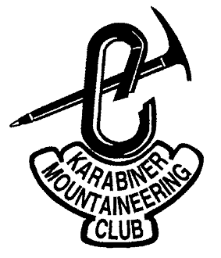

Pamiagdluk Island, South Greenland.

8th July to 8th August 2004.

MEF Reference 04/20.

Final Report.

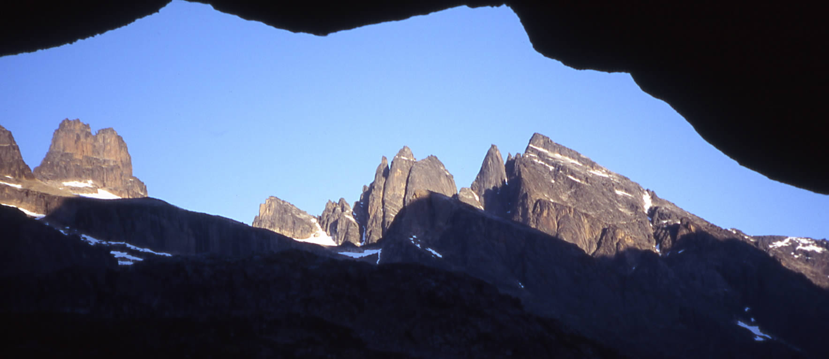

Edited by: David Bone. [Rev 1.0 13/10/04]
Flat 7
6 Chatham Grove
Withington
Manchester
M20 1HS
United Kingdom.
Tel: +44 (0) 161 434 2717 (Evening)
Tel: +44 (0) 1925 247600 (Day)
Fax: +44 (0) 1925 247610
E-mail: dbone@norcott.co.uk. Website: www.karabiner.org.
Summary

This is the final report of the Karabiner Mountaineering Club’s 2004 Expedition to the island of Pamiagdluk, Southern Greenland, near Cape Farewell. A mixed team of 12 headed out by plane, helicopter and boat to near the head of Kangerdluarssuk fjord, deep in the heart of Pamiagdluk, an area not previously recorded as having a climbing team visit. The team had a mixed bag of weather, but with fine spells at the start and end, and managed to put up on few new lengthy new rock routes on the western side of the fjord, do much cragging, and some likely first ascents of various peaks. The expedition was considered a success, and many had their first experience of an expedition.

Contents:
1 Introduction. 4
2 Expedition Members: 4
3 Research. 5
3.1 Choices of area. 5
3.2 Pamiagdluk history. 6
3.3 Expedition Objectives. 6
3.4 Maps & Photographs. 7
3.5 Later information. 8
4 Logistics. 8
4.1 Flights to Nanortalik. 8
4.2 Travel to Denmark. 9
4.3 Boat charter. 9
4.4 Accommodation. 9
4.5 Freighting. 10
4.5.1 Customs & Excise Documents. 10
4.6 Lessons learnt. 11
5 Expedition Diary. 11
5.1 Maps and areas of interest. 20
6 Conditions. 22
6.1 Climbing and walking. 22
6.2 Hazards. 22
6.3 Weather. 23
7 Flora & Fauna. 23
7.1 Insect Life. 23
7.2 Flora. 23
7.3 Fishing. 24
7.4 Birds and mammals. 25
8 Emergency & Contingency Handling. 25
8.1 Communications. 25
8.2 Communication plans. 25
8.3 Crisis Management Planning. 26
8.4 Medical & First Aid. 26
8.5 Insurance & Permits. 26
8.6 Accidents. 27
8.7 Lessons learnt. 27
9 Equipment. 27
9.1 Camping. 27
9.2 Stoves & Fuel. 27
9.3 Kitchenware. 28
9.4 Electronics. 28
9.5 Tools & building materials. 28
9.6 Climbing kit. 28
9.7 Other Equipment. 29
9.8 Lessons learnt. 29
10 Food & Shopping. 29
10.1 UK Shopping. 30
10.2 What and where to buy in Greenland. 30
10.3 Lessons learnt. 30
11 Environmental Practice. 31
11.1 Great Plans. 31
11.2 … go astray – actual practice. 32
11.3 Disposal in Nanortalik. 33
11.4 Lessons learnt. 33
12 Conclusion. 33
13 Acknowledgements. 35
14 Appendices. 36
14.1 Routes. 36
14.2 Topos & pictures. 37
The Baron area. 37
14.2.2 Black Fly Buttress. 39
14.2.3 Fat City Buttress. 40
14.2.4 “Bone Machine Buttress” (‘A’ Buttress). 40
14.2.5 Point 1300m Area. 41
14.2.6 Punta Cosulich. 42
14.2.7 Mingy Midge Ridge. 43
Kangerlussuaq amusements. 43
14.3 Weather record. 44
14.4 Finances. 45
14.5 Risk assessment. 46
14.6 Bibliography. 47
14.7 Websites & Contacts. 47

Title Page: The Twin Towers in the view from the Bar boulder.

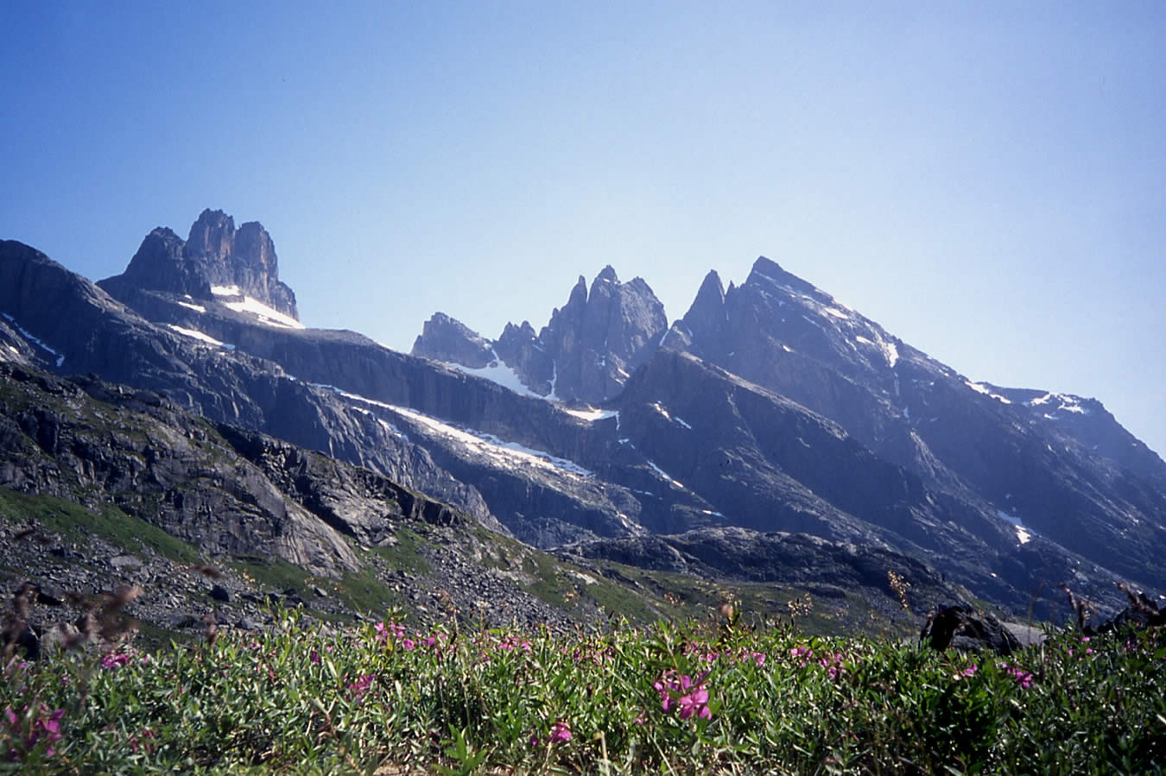
Figure 1. Twin Towers and the SE of Pamiagdluk from above base camp.

Introduction.
The expedition began as an idea amongst a small, slightly inebriated core group in November 2003 with the thought that, as 2004 was the 60th anniversary of the KMC, something special should be done to mark the occasion. As there had been an expedition to East Greenland in 1994, it seemed appropriate to run an expedition to somewhere in Greenland, and open it out to all members of the club and immediate friends, so all could gain expedition experience. With Greenland being the world’s largest island, the question was ‘where’. We duly consulted with the Club’s Greenland guru, Jim Gregson, who gave us essentially two choices – the sunny, snow clad hills of Eastern Greenland, or the ‘wet’ non-snow covered peaks of Southern Greenland. His photos of blue skies and snow looked brilliant but in the end we opted for the rock of the South. We all preferred primarily rock climbing, with but one of us being keen on skiing, we wanted it to be open to as wide a group as possible, and there was the factor of the prospect of hiring Twin Otter planes sending frissons of anxiety through our bank managers. Thus, with the admonition “it’ll rain all the time!” ringing in our ears, we set out to research climbing at the southern tip of Greenland. This is the story of the preparation and of the successful execution of the expedition.

Expedition Members:
With the exception of our two Czech friends, all of the team are based in the Manchester area. The expedition grew well beyond the 6-8 tops we thought could get away, with the final pair begging to be allowed in towards the end of January. Indeed, there could have been more but we called a halt at 12 since that was the maximum capacity of the boat.
Rob Allen, age: 48, Occupation: Metallurgist, British.
Rob has been climbing for approximately 13 years and has climbed extensively in the UK as well as France, Spain and Morocco, Leading up to E2/F6b. He has winter experience in Scotland and multi-pitch rock routes include: Chibania F6b (6 pitches) and Voie original (variant) F6b (11 pitches) - both in the Todra gorge, Morocco.
Helena Bestova, Age: 42, Czech.
Helena has 17 years of climbing experience and has climbed in the Swiss and French Alps, Dolomites, US -Desert and Red rocks by Las Vegas.
Dave Bone. Age: 43, occupation: Electronic Engineer. British. Expedition co-ordinator.
Dave graduated into climbing in 1989 from hill walking in UK, Europe and Tasmania. Since then he has climbed to E2 in throughout UK, Europe. USA & Canada. He has been winter/ice climbing in the UK and Alps, and has had a number of Alpine seasons with mixed and long rock routes plus some solo peak bagging. Dave has organized a group expedition to the Caucasus, with attempts on peaks in the Elbrus region (including Elbrus). Took part in a guided expedition to the Gangotri region of the Indian Himalayas, reaching 5900m on attempts on Peaks and mixed routes.
Steve Cheslett. Age: 41. Occupation: Physiotherapist, British. Expedition Medical co-ordinator.
Has been climbing since 16, mountaineering throughout UK in summer with Scottish Winter experience up to Grade 3 Ice, 2 weeks Alpine Experience in Chamonix. Has climbed to E4 traditional / 7B French Sport / B7 Bouldering, throughout UK , France, Spain, Italy, Czechoslovakia, Switzerland, Squamish Canada, Hueco Tanks Texas, Colorado and Thailand.
Ian Heginbotham, age: 28, occupation: Industrial rope access, British. Expedition lead climber.
Ian has been climbing for 15 years and has lead up to E4 in the UK and 5.11c in the states. He has climbed extensively throughout the UK including numerous winter trips to Scotland. In 1999 he spent a month climbing in Australia and in 2000 he travelled and climbed throughout Western Europe. Ian has also spent a few seasons in Yosemite, completing such routes as… Lost arrow spire, Braille book and the shield.
Duncan Lee, age: 37, occupation: Decorator. British. Expedition Climbing director.
Duncan has been rock climbing for over 25 years and has climbed extensively throughout the UK and Europe as well as in the USA (Zion, Yosemite and The Black Canyon of the Gunnison), Morocco and Madagascar. Other experience include numerous Scottish Winters, Alpine summers and on site new routing on rock in the UK, USA, Spain and Madagascar (Malagasy Maroto 300m "Easy E4" and Karma Chameleon 330m "Hard E4.").
Alois Metelko, age: 46, Occupation: IT Technician. British.
Al has been climbing for over 15 years and has lead up to E2/E3 rock and 5/6 Scottish. He has been on many trips to the Alps in winter and summer and has also visited the USA, Canada and India.
Anna Neubert, age: 28, occupation: medical student, British. Expedition entertainment officer.
Anna started climbing regularly 2 years ago. She is currently leading HS and seconding VS. She has climbed in Chamonix, Isle of Skye, Peak District, Lake District and other UK sites. Anna’s passion is any outdoor pursuits and group adventures. She has had the pleasure of teaching sailing, windsurfing and canoeing for 4 summer seasons, spending a winter skiing in Switzerland and traveling around the world for 5 months.
Karel Prochazka, age: 52, occupation: Retired physician, Czech. Expedition medical advisor.
Karel has 37 years of climbing experience. He has climbed in Himalayas, Pamir, and Caucasus, US - all over, NW Territories in Canada, Morocco, French and Swiss Alps… The list goes on!
Julie O'Regan. Age: 29. Occupation: Trainee Teacher, British.
Has been climbing for about two years and currently leads V Diff and second E1 on a good day. Climbs regularly in the Peak, Wales and the Lakes. Has also climbed in Australia and Spain and completed a 10 day technical mountaineering course based at Mount Cook in New Zealand, following this with a Victorian Climbing Club trip to the Mount Cook and Mount Aspiring ranges. Has also trekked in the Indian Himalayas, reaching 5,100m and completed Tasmania's Overland Track in winter.
Scott Sadler. Age: 26, Occupation: Police community support officer, British.
Scott started hill walking in 1994 and quickly progressed into mountaineering. He has been rock climbing for over 5 years and has lead up to E4. He has climbed in the French Alps (rock routes and solo peak bagging), Spain and North East US, as well as throughout the UK. In 1999 he took part in a guided expedition to Mera peak in the Himalayas, reaching 6100m but having to turn back due to bad weather. He has had numerous Scottish winter trips and has also spent 3 months ice climbing in New Hampshire, US.
Jennifer Varley. Age: 26. Occupation: Accelerator Physicist, British. Expedition quartermaster.
Has been rock climbing for 2 1/2 years, mostly on gritstone in the Peak District, but also Wales (multi-pitch routes at Gogarth, Pembroke, Llanberis Pass) and the Lake District. Leads routes up to VS, and second up to 5b. Has been a keen hiker since about the age of five, and explored many parts of Britain by foot, especially the Peak District and Lake District, as well as hiking in Canada (Rocky Mountains), US (Grand Canyon, California), New Zealand (all over) and Australia (Blue Mountains) during a year-long solo backpacking trip around the world.

Research.
We looked at the usual sources such as High, American Alpine Club, DAV Panorama, old magazines and journals, the BMC library etc. and we did an extensive trawl on the Internet looking for any names and alternative spellings, and in different languages, in the area. And most importantly we tried talking to people.

Choices of area.
The gateway to Southern Greenland is the town of Nanortalik. The general area is shown in Figure 2. As Greenland was new to all of us, and we had to satisfy a range of experience, abilities and interests, ideally we wanted to leave everybody with an idea of what the area would offer them. There were a number of expeditions to the area of the mainland east of Nanortalik, and to some parts of the larger islands further east in the 90’s, but with plenty of gaps left, this looked like the way to go. Research concentrated on the Torsukkatok Spires (or Torssuqaatoq) to the south west of the settlement of Aappilattoq, and the neighbouring island of Pamiagdluk. Activity on Pamiagdluk picked up post 2000, so there was knowledge of the conditions on the island, but there was an intriguing gap in the middle of the island, with just a few photographs giving tantalising glimpses of features that might be in the area. That was enough reason to look in depth. There has been an increasing trend to not report activities, so we cannot claim to have traced a full account though.
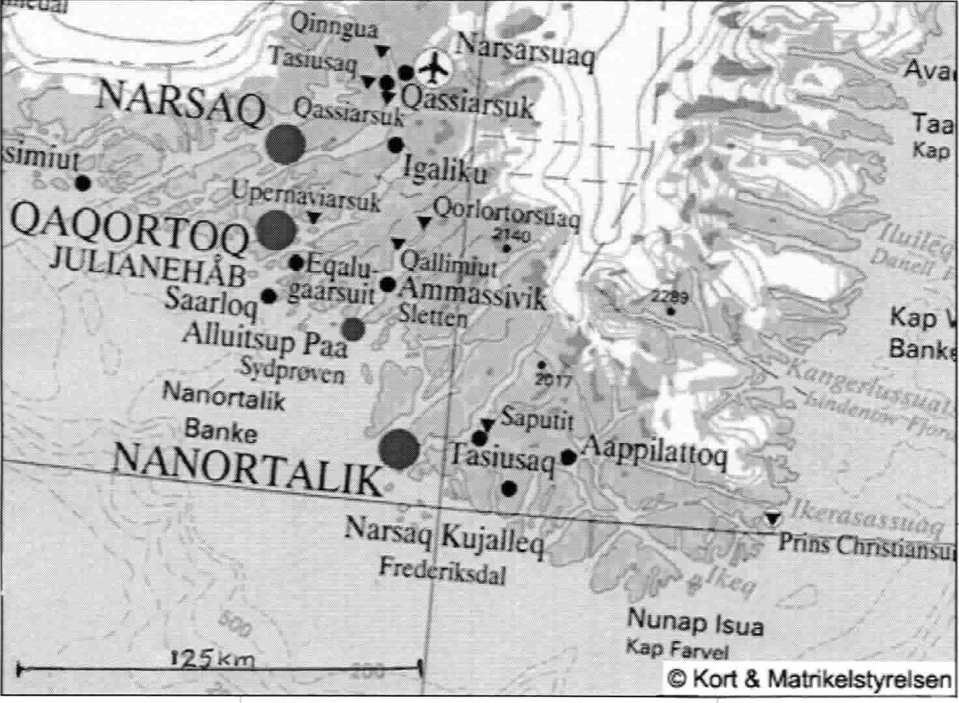
Pamiagdluk
Figure 2. Southern Greenland general area map.

Pamiagdluk history.
In looking into the history of climbing on Pamiagdluk, we found the earliest useful reference was in 1975, and then a dearth of information until the 90’s. Some records have to be missing and we couldn’t really find much other than British and German records. The 1975 St. Andrews team (no details) had bagged some peaks in the NW corner as well as the largest peaks in the NE sector. Big Wall climbing started with the Germans in the mid-nineties (there’s some confusion about the start date) who came in via the NE coast and put up a number of routes in the area bounded by Naujarssuit, the “Twin Pillars”/”Twin towers” (1373m) and “French Bird Peak”. Also a couple of very long routes were put up on the walls above the NW side of the valley (“Antonio valley”) dissecting the island from N to S, in 2001(HMS 241, DAV Panorama 6/2001).
In 2000 the “Thumbnail” expedition had their base camp on the western coast of the island, restarting British interest in the area. Also in 2001 to the same base area was the “Baroness Expedition” (HMS 241, MEF 01/47, etc.), which did a number of hard routes on the Baroness wall nearby. Since then there have been other visits to this small area on the west, such as the 2003 British-Australian Torssukatak Spires expedition (MEF 03/22) which climbed on two ‘new’ peaks as well, the ‘Butler’ and the ‘Mark’.
This left us the Kangerdluarssuk fjord with no recorded visit and fresh approaches from its shores as the most glaring gap. The island layout is shown in Figure 3.
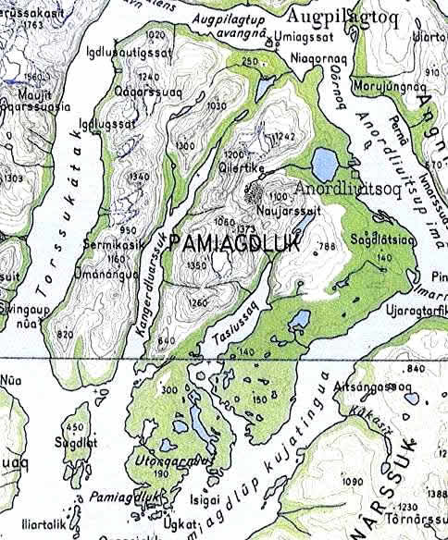
Figure 3. Map of Pamiagdluk. (© Saga Maps).

Expedition Objectives.
Our objectives were to explore, and establish new rock and mountaineering routes of all grades on the western side of Kangerdluarssuk Fjord, Pamiagdluk Island. Interesting looking climbing targets looked like the steep SW facing wall of point 1300m close to the proposed camp. The Baron from the East was a possibility. The peaks of Sermikasik and Umanangua, etc. south of the Baron should be first ascents. There ought to be potential for new routes all round the 1300m-1030m massif. The Qaqarssuaq massif could be explored from the south for routes. And nothing had been recorded heading up from the eastern side of the fjord, though there was greater doubt as to its accessibility.
An outline map of Pamiagdluk, along with the principal lines of exploration of various KMC parties (in orange), is given in Figure 4.
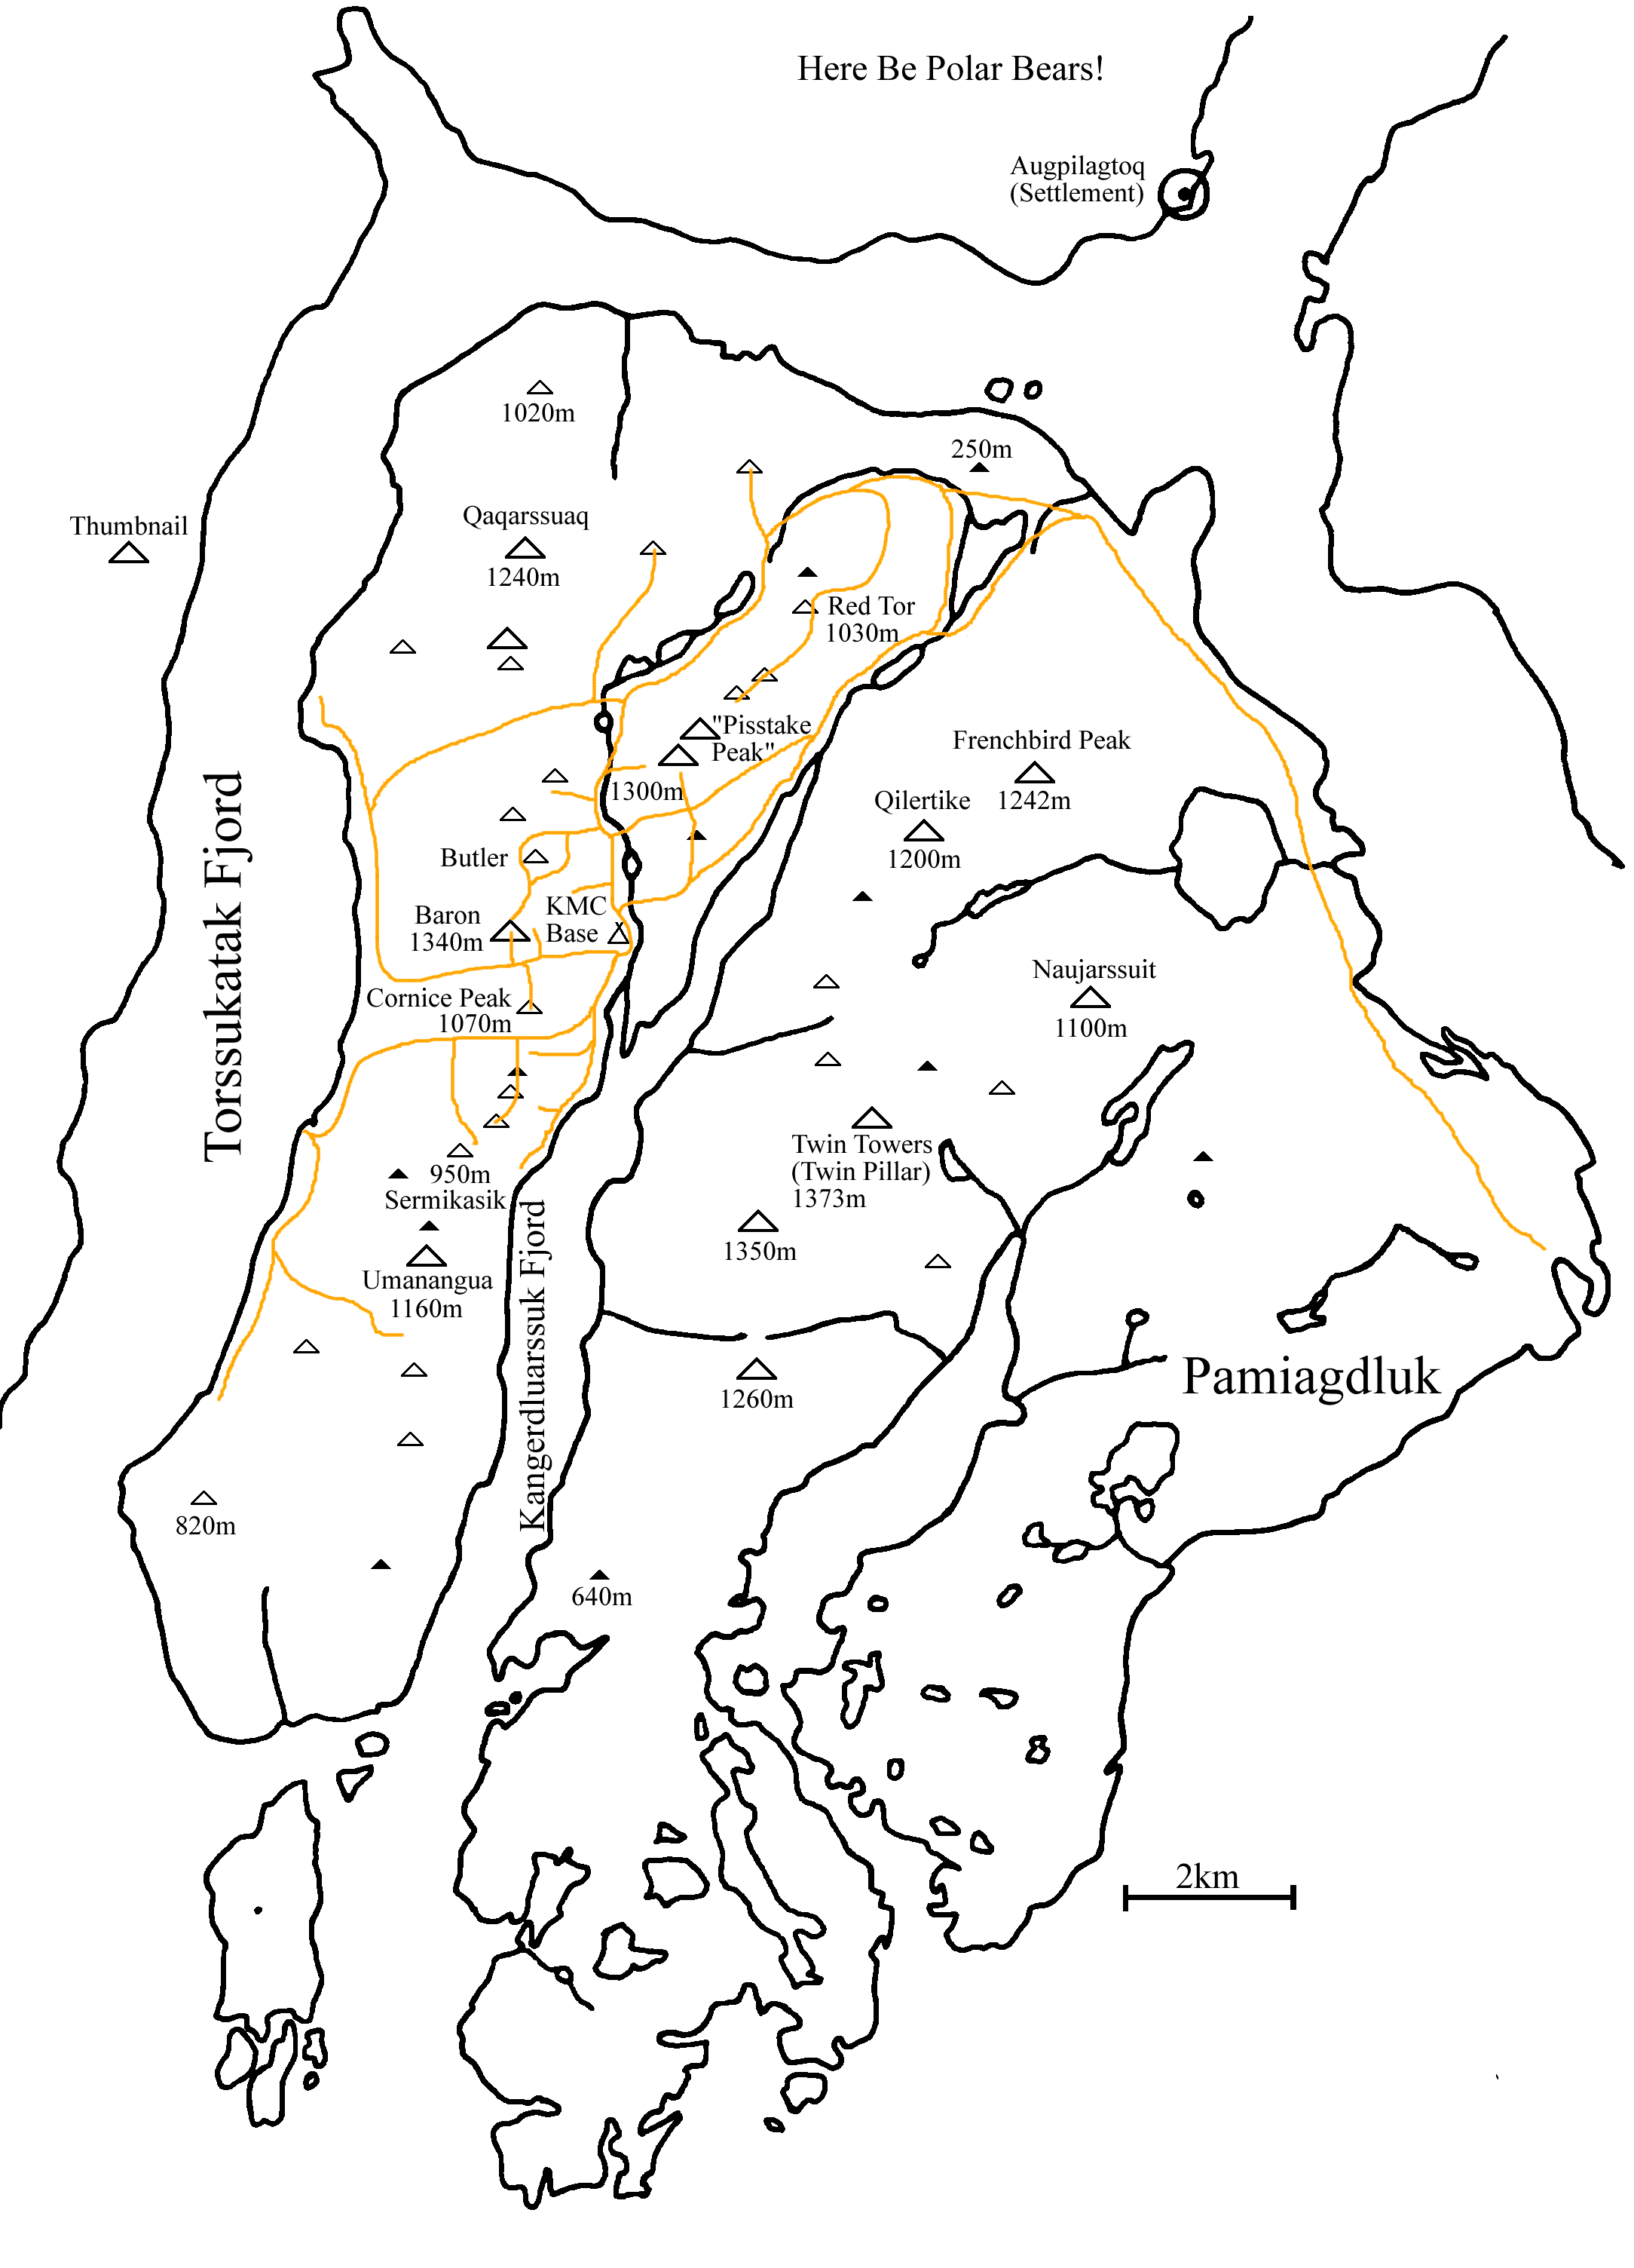
Figure 4. Sketch Map showing Expedition routes.

Maps & Photographs.
The Danish mapping service, Kort & Matrikelstyrelsen (KMS) have a neat ‘3D’ relief map of the whole of Greenland to download. The ‘best’ map to the area is unfortunately only to 1:250,000 scale. Most of the following maps can be ordered from “www.stanfords.co.uk”.
- Saga 1:250,000 Map, sheet 1. “Qaqortoq-Julianehab”. [Stanfords Cat’ 31154]. Uses the KOM mapping below but has joined the central regions of the three area sheets into one map – the best one to use.
- Greenland K.O.M. Geodaetisk 1:250,000 topographic survey. “Kap Farvel 59 V. 1”. [Stanfords Cat’ 29805]. One of three joining in the vicinity of Pamiagdluk but it does not have a lot of land on it.
- Greenland K.O.M. Geodaetisk 1:250,000 topographic survey. “Nanortalik 60 V. 2”. [Stanfords Cat’ 7996].
- Geological maps from the Geological Survey of Denmark and Greenland – GEUS: 1:2,500,000 and 1:500,000 scale maps are available on an expensive CD, but you can download jpeg’s from the website (the larger scale has no key!). For some time this was our best map of the area.
It was on the ‘Ketil’ en-route to Pamiagdluk that our eyes were opened to the possibility of charts, for the local chart was to a larger scale and showed good contour information on the land without the clutter of text.
There is an Aerial photograph to 1:150,000 scale that covers Pamiagdluk, available from the National Geodatabank at KMS in Denmark, as we found after presenting a list of latitude and longitude positions. Two laminated copies were taken with us. They take practise in interpreting, but they gave strong supportive hints, and they really came into their own on the island, when one had reference to points actually observed. Despite much searching, no useful, affordable satellite imagery was forthcoming.

Later information.
The discovery of an ancient cairn on top of the Baron, and some hints of earlier visitors (cairns) in ‘our’ valley, fuelled a desire to fill in the missing gaps in the history. Back in Nanortalik, we got to talk to the Irish Cape Farewell sea kayakers – two of their team were lapsed climbers and Dave had climbed in Greenland in 1975. He was able to suggest that a small Irish team had visited the area in 1978, and records had been kept of activity in the area but had subsequently been lost.

Logistics.
Alongside the research into the climbing possibilities we also started to get some ideas of the logistics of getting a large number of people and their kit to the target area. It soon became clear there were many different strands to this and that this should not be left too late. Early on we made contact (delayed as he was in Scotland at the time!) with Niels Taekker Jepsen at the Nanortalik Tourist office, and started a long chain of Emails.

Flights to Nanortalik.
Early research, based on the 2003 timetable, indicated two choices of getting to Greenland, arriving at Narsarsuaq International Airport, either with Air Greenland from Copenhagen or with Air Iceland from Iceland. We could only make tentative plans as both Airlines did not release timetables until the New Year, and even then they were provisional. This also applied to onward travel from Narsarsuaq and for some time we could not be sure Air Iceland would run (given their passenger loading, don’t be too sure in future years), and on what days Air Greenland would fly in the year.
We couldn’t book much over the Internet then, though Air Greenland offered Internet booking from the spring onwards, so we had to go via travel agents. In practise, you have to deal with Danish travel agents – as you get referred to them anyway from the likely looking UK agents we tried. However, this went well. The first response in mid December was from Topas Travel in Copenhagen, though we actually continued dialogue with the second from Greenland Travel in Ilulissat, Greenland since they were quicker on the return with more options. Both are worth contacting, as they were really helpful. Throughout January we must have tried their patience in trying out different variations, but Espen was always cheerful and prompt with the reply. Niels Jepsen in Nanortalik offered assistance as well, but we gave him a break on this one.
The picture eventually became clearer. Air Iceland flies from Rejkjavik to Narsarsuaq on Tuesdays and Fridays. Air Greenland flies from Copenhagen on Mondays, Wednesdays and Fridays, followed by two choices, Air Greenland Helicopter or Ferry. Helicopter connections to Nanortalik are Wednesdays and Fridays. The ferry timetable is complex as you have to stop over en-route, and not easy to understand – we emailed the ferry company direct for a ‘definitive’ timetable. Arctic Umiak Line Ferry to and from Qaqortoq is on Mondays and Fridays going on to Nanotalik on Wednesday, returning Thursday (actually, the timetable was different when we arrived in Greenland!). We had some rough prices to compare; (a) Air Iceland + helicopter both ways, ~£1110. (b) Air Iceland + ferry both ways: ~£954. (c) Air Greenland + helicopter: ~£917. (d) Air Greenland + ferry: ~£761.
It proved difficult to link up all the travel efficiently, particularly involving the cheaper ferry. The advantage of selecting Air Greenland, was that if the weather caused a connection to be missed, they would put you up and get you there at the next possibility – a feature we were grateful for in the event. The return ferry on the return day gave little time to make the connection – ~2 hours for the 2km from the port, and check in closes one hour before departure. In the end we selected an itinerary that got us there in one day using the helicopter, and gave a day’s grace between stages on the return. Our group of 12 counted against us here since we couldn’t fit on the busier connecting helicopter flight, but were placed on the day’s second returning flight. Though the rest days were a bit tedious, we had first hand proof of their worth especially as some of us had stretched our holiday allowance and had at all costs to return to work on the Monday. We ended up with 4 weeks and 2 days off work, with the next best being 7 days less without losing out on the maximum days on the island.

Day | Activity | # of people
Thu 8th July | Travel to Stansted Airport | 10
Thu 8th July | EasyJet Flight 3563 dep. 13:05 to Copenhagen, arr. 15:55 | 10
Thu 8th July | Overnight at Youth Hostel in Copenhagen | 12
Fri 9th July | Air Greenland Flight GL785 dep. 11:00 to Narsarsuaq, arr. 11:40 | 12
Fri 9th July | Air Greenland Flight GL391 dep. 15:20 to Nanortalik, arr. 16:30 | 12
Fri 9th July | Overnight at Youth Hostel in Nanortalik. | 12
Sat 10th July | Shopping in Nanortalik. Afternoon boat to Pamiagdluk Island. | 12
Sun 11th July – Sun 1st Aug | Expedition Activities | 12
Mon 2nd Aug | Boat to Nanortalik. Dep. ~10:00. Overnight (2) in Nanortalik Youth Hostel. | 12
Wed 4th Aug | Helicopter flight GL391/378 to Narsarsuaq, dep. 16:45, arr. 17:35 | 12
Wed 4th Aug | Overnight (2) in Narsarsuaq Youth Hostel | 12
Fri 6th Aug | Air Greenland flight GL786 to Copenhagen, dep. 13:35, arr. 21:50 | 12
Fri 6th Aug | Overnight (2) in Copenhagen Youth Hostel | 12
Sun 8th Aug | Easyjet flight 3562 to Stansted, dep. 10:30, arr. 11:20. Car to Manchester. | 10

From the start we were conscious of the need to make early bookings, and flights would fill up quickly, compounded by us being a large group. The travel agents had access to the timetables before they were released on the ‘net, for example so it was worth starting in December. With us being a large group, we also inquired about group bookings and were able to make use of this. Air Greenland did a group booking for 8+ - though we are not sure it saved us money, as our last person missed out on the group arrangement, though did get the same fare, it did seem to help with flight booking and a much more relaxed payment schedule. Our arrangements were finalised by late January and were paid up by February. Dealing with payments to a Greenlandic company was OK, though the leader gained rather more insight in international banking procedures, and the extra effort in shifting more than £10K at a time. Just allow some time with your bank and it doesn’t seem too expensive if dealing with large payments.

Travel to Denmark.
A quick comparison between the feasible cheaper flights to Copenhagen (BA – Heathrow, Ryanair – Stansted, EasyJet – Stansted) led to the choice of Easyjet, with 3 flights a day, principally because of a 20+5kg luggage allowance. We needed all of it and more, and there’s a 10kg Sports Gear allowance though we never had to call on it. This was an easy booking for 10 since our Czech friends made their own arrangements to meet us in Copenhagen. Note; Stansted in August isn’t a pretty sight and Bristol or Newcastle alternatives were no better for us.
The final leg was left until last – getting 10 from Manchester to Stansted Airport in the early morning. We thought there would be no problem, but in fact it turned out to be the most difficult section to organise. Trains were too unreliable, buses far too long winded, travelling via London at unearthly hours, and one way vehicle hire far too expensive. We couldn’t hire minibuses for such a short time, and minibus ‘taxi’ firms were too expensive, so it turned out about the cheapest option that retained flexibility and ease of use, was to drive down in 3 members vehicles and park them off Airport for a month! Trouble was, it didn’t seem sound that we had to resort to that – no wonder we’ll not drive people off the road!

Boat charter.
For the Nanortalik to Pamiagdluk leg we prearranged boat hire with Niels at the Nanortalik Tourist office, and negotiated details on arrival. Available is the “Ketil”, a 35ft boat licensed to take 12 people and 1000kg of luggage with a crew of two. It has a rubber dinghy for off-loading. It isn’t available on a couple of days (variable) of the week, since it also does the local ferry run, and is well equipped and fast, except when loaded to the maximum with 12 and gear! The cost each way is determined by the crew hours. The journey was ~60km/32n.m and the boat fully laden does about 13knots. The journey out took almost 3 hours. This stage of the journey may be hindered by sea ice – the Nanortalik harbour is prone to being filled with drift ice early in the season as it is blown in by any southerly wind. We had no trouble leaving harbour but played dodgems with the ‘growlers’ (ice under 1m high) in sea mist on the way round – in contrast the ice was well out to sea on the return.

Accommodation.
En-route we used various types of Youth Hostel – the only realistic choice in Greenland.
We made use of the Danhostel Copenhagen Amager on both outward and return journeys. It’s the largest hostel in Copenhagen with 528 beds in shared rooms, within a sprawling array of halls – very convenient and only 15 minutes taxi ride from the airport, or a bus ride. Going out, we took the train towards town on a 10 click 2 zone travel card, changing after 2 stops for the elevated Metro, alighting at the Bella Centre. The hostel is a 10min walk west then north. Karel & Helena took the wise move of paying the 60Dkr per piece left luggage charge at the Airport. We booked in February via the Internet and Email from the UK, and with us being more than 10, made a Group booking. The group price includes a buffet breakfast (only) and only the leader needs a Youth hostel membership card. The Leader has the extra benefit of a room to his/herself! Sleeping bags must not be used, so hire linen. The hostel was very busy with the reception usefully staying open past midnight, though the beers (in plastic bottles) stopped flowing at midnight. Just remember to send the confirmation slip back – it can be missed among the raft of Emails their automated system sends out.
There are two ‘hostels’ in Nanortalik at around 200DKr a night per person, “Tupilak” sleeping 14, and “Mathildes House” sleeping 8. Niels managed to book “Mathildes” for us. Camping outside is possible, and there is a kennel like outhouse on the shoreline, but we squeezed inside with a bit of crowding, to avoid the need to unpack the freight. You’ll need your sleeping bags. There’s a kitchen & dining ‘room’ and a shower handy for the return to ‘civilisation’. It gained the nickname “the Wendy house” in certain quarters, as it’s not exactly large, but on a wet & icy evening, it’s very comfortable.
We stayed in the Narsarsuaq Youth Hostel on the return journey – this was booked via Greenland Travel at 225DKK per person. You need your own sleeping bag. Meals are not available but it has good kitchen facilities, showers and laundry facilities – recommended, and they’ll even cart luggage to and from the Airport. The Hotel Narsarsuaq (only hotel, with steep prices) has a dining room (fixed menu) and cafeteria, which isn’t great. If you’re there when the hotel is doing an all you can eat “Greenland Buffet”, book it and go for it - excellent, provided you’re not vegetarian! Apart from the Hotel bar, there’s not a lot of entertainment in Narsarsuaq! You can hire mountain bikes or do the tourist thing and hike up to the end of the glacier.

Freighting.
It was necessary to ship out equipment and some food supplies in advance due to the limited flight’s weight allowance. Equipment and waste (if sensible) was be freighted back after the trip. Shipment was in a mixture of watertight ‘blue’ 60L or 120L (no handles) barrels, and stout double-walled cardboard boxes from Aid-Pack. The latter did for items that didn’t mind a little water (though not a single one got wet), and were disposable, minimising the return freight. These held the bulk of the communal kit with an allocation for personal kit.
We tried a number of shipping firms but only Blue Water Shipping had the courtesy to reply to Emails and were helpful. Conveniently, they have their UK consolidation warehouse just round the corner in Bredbury, Manchester and Niels is their Agent in Nanortalik (He gets everywhere…), which clinched it so we used them, despite later having warnings of problems with them. Total shipping time (via Denmark) depends on the service schedule as well as the travelling time. Using Air freight, the latest drop off time would be mid June, whereas by Sea it would be late May at Bredbury. They advised us to allow some extra time as a safety net, having had a bad experience the previous year, and eventually gave us a latest pickup time of 18th May.
Air Freight is charged by the ‘kg’ [30DKK per kg, Basic charge 480DKK per shipment], whereas Sea freight is charged by the cubic metre [950DKK]. There was a charge of 195DKK for export documentation according to our quotation. The break-even point for 1m³ was 16kg, or 47kg for 2m³. We used Sea Freight! The shipping principle is – you should concentrate on heavier, low bulk items, but in practice, we just used as many boxes as we needed. Note that from personal experience with freighting, there is a potential for damage (on one trip I arrived to find our computer a bit distorted and two holes in the crate the right distance apart for a fork lift truck tines). So we didn’t want to pack much glassware or expensive electronics.
After the big packing weekend we had 17 packages, 10 60L drums, 2 120L drums and 5 double-walled cardboard boxes, 1 much larger cardboard ‘pig’ for the big tent. Volume came to 2.14m³, assuming we could treat the volume of a drum as a cylinder. These were tripped in two journeys the 20min to the warehouse in Duncan’s van on the 12th and were taped onto pallets, looking rather forlorn in the vast space. The leader was armed to the teeth with lists and forms expecting a long session of paperwork, but left, stunned, as they weren’t interested in much of it.
The gear arrived in Nanortalik by mid June, and was waiting in the middle of Niels’ warehouse for us. Once back in Nanortalik at the end of the expedition, we just had the barrels to repack and note down the contents (We had a pre-prepared pack of labels and plastic sleeves left behind for this), before they were carried by JCB to the Royal Arctic line terminal building. We just needed the receipt from Niels to set the barrels off on the first leg to Denmark, and notified BWS the shipment number back in the UK. We didn’t actually get an invoice until September, just as the barrels arrived in the UK on the 21st, and found it more than expected. It looks like we paid for 3m³ , each way – you need to optimise the packing onto standard pallets.

Customs & Excise Documents.
The freight agents did not appear too forthcoming about the customs documentation in the UK, and it appears that re-importing the gear is the difficult bit. Enquiries with the RPA and DTI showed that we do not need any export licenses because our goods were of low commercial value or were not high tech’ enough. It didn’t seem to matter what you sent to Greenland, within reason.
It initially appeared that we had to fill out a C88A SAD form for both export and import of the goods as we were misled at first by the Customs & Excise national helpline. However, at the eleventh hour, with advice from the Cardiff Customs office and others, the procedure was greatly simplified. We still presented the export information on a single C88A form (But, by using the “non statistical goods” procedure, provided the description of goods is adequate, there is no need for a commodity code). The advice was to call the entire shipment simply “Mountaineering expedition goods”!! Customs really aren’t bothered about such shipments we were told. A packing list is still advised, though it is unlikely anyone will look at it – the freight agent certainly wasn’t bothered. Only a few obvious details, like destination and the consignor, were needed on the SAD, or hand written, and the freight agent would finish off the few fields only they know, and sign it too! On return, a packing list had to be produced, and to go with it the Leader should sign a C3 form, stating these are personal effects returning to the EU, and listing dutiable goods (watch out for the list of prohibited goods. This meant checking the drugs in the medical kit carefully for example). A C3 can be downloaded from the C & E website, and is filled in on your return to the UK.

Lessons learnt.
The first thing we learnt was not to worry as much about excess luggage. We had heard unpleasant stories about Copenhagen and the limit was 20 + 8kg on Air Greenland with just one piece of hand luggage on the helicopters. There were no problems at Stansted, but despite sharing things out, most of us were 2-5kg over the hold limit in Copenhagen. There wasn’t a comment on the whole way out – indeed, all we heard was a warning about keeping the hand luggage to one item next time as we were being urged onto the helicopter. Well, that had grown with the statutory bags of duty free alcohol brought for the stay on the island. Guess it depends on the luck of the draw. The same on the return, but with a jarring note that 3 of us would be charged for ~4kg of excess luggage on the Helicopter out of Nanortalik. Oh dear, a bank breaking £6-50… Still, if only to ease the physical effort, we’d probably freight more next time.
I’d think about avoiding Stansted, and look for a more expensive option from a nearer Airport to counter the Parking charges. Maybe even BA would have been better – there ought to be a more sensible plan.
Minimise the number of big barrels – with no handles they were real pigs to move from the beach to base camp without emptying the contents into rucksacks.
Get a detailed quote for the freighting and clarify the volume calculation just before delivery (in £ with VAT etc.).
Don’t pack anything damp – the drums make good saunas and the condensation will corrode metal and promote mildew on textiles. Barrels make good rubbish bins – when lined with strong Garden bin-liner sacks.
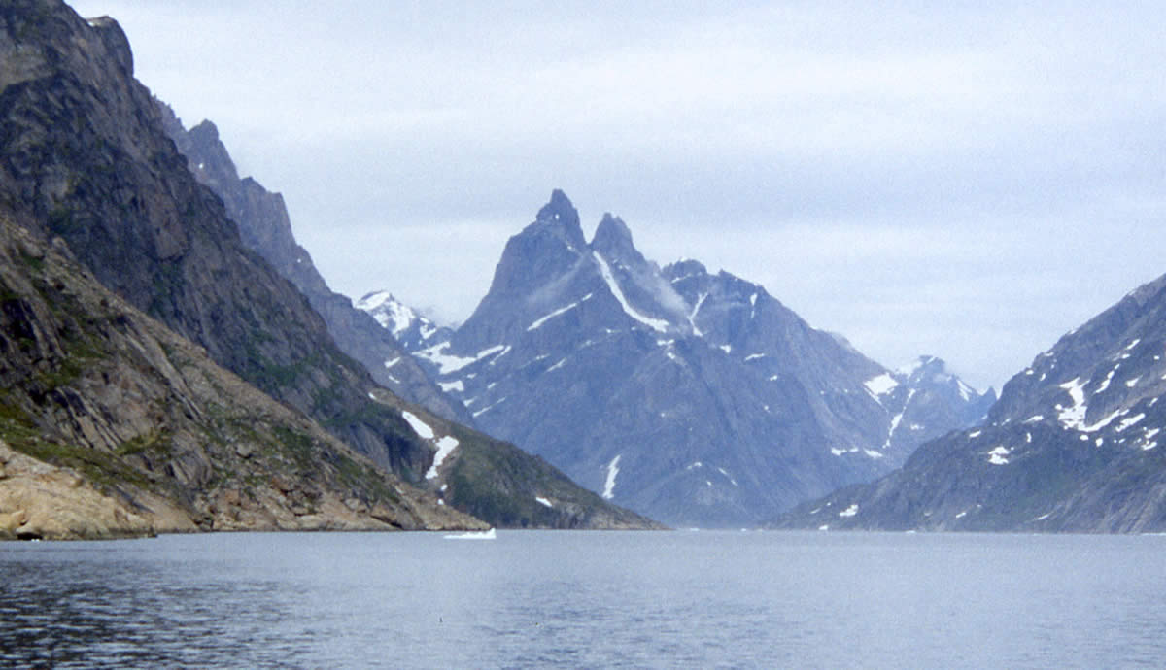
Figure 5. First view of Pt.1300m at head of fjord.

Expedition Diary.
The Overall expedition dates (UK to UK) were 8th July to 8th August. Here is an account of our experiences.
Thu 8th July: Leave from Manchester and Warrington at about 5am and arrive at the Bridgefoot Cattery before 9am in 3 cars. Easyjet flight leaves more or less on time to arrive late afternoon in a cloudy Copenhagen. Chose train and Metro to Bella Centre stop, then 10min walk, fully loaded, to Youth Hostel. Ate at hostel, then most sat around reception drinking beer from plastic bottles at ludicrous prices. Having temporarily lost their baggage, Karel & Helena arrive 11:15, with bags sensibly stowed in Left Luggage.
Fri 9th July: Up for 7am Breakfast, leaving Hostel at 8am on foot for the Metro. A longer wait in the rain for the train (50min), and much re-packing of bags still left many 2kg over weight, but were checked in, no questions asked, and the hand luggage wasn’t weighed (just as well). There was thick cloud all the way to Narsarsuaq where it was sleeting hard. Plane attempted a landing, but aborted as snow covered ground loomed out of the mist rather close, then diverted to Kangerlussuaq, north of the Arctic Circle (furthest north for all). The place is the Airport, and is like a desert. Air Greenland put us up, expenses paid, in the Airport hotel in the terminal building. A line of enticing cliffs was on the far side of the runway, but unfortunately on the far side of a river. The ridge behind the terminal was fronted by a line of broken, gneiss slabs and as something to do for the afternoon, Duncan and Scott put up “Scott of the Arctic”, E1 5a,5a here. First sight of the inland ice and place’s name was mangled into “Kangeroo Squat”.
Sat 10th July: Flew out at 9:30 in business class – low over icecap on the hour’s flight to Narsarsuaq and lakes of incredible blue could be seen. Very overcast and gloomy but some were excited by the first view of ‘bergs (to dwindle 24hrs later!). The standard S61 helicopter wasn’t available, so there were to be 4 flights of a 9 seat helicopter instead. However, we were all spread about amongst the flights – just as Karel & Helena finished checking in, they were bustled out the door, to fill in for two missing on the first flight. So they got there first, meeting Niels, bought some supplies for the evening meal and waited at the Youth Hostel. Even the flight order changed so the bulk of us arrived on the penultimate 45 minute flight – a most exciting low level ride. The seating had “side gunners” and even through the provided Ear defenders, one could almost hear “Ride of the Valkyries” as we swooped, metres over the first ridge.
Sleeting hard on arrival in Nanortalk, we all finally met Niels, who then ferried us to the tiny Youth Hostel, soon to be “the Wendy House”. The small diesel stove performed a vital function while we waited for the final flight to bring in Karel & Helena’s bags. Were told by Niels, forecast poor for a few days but we should have a boat tomorrow (1 day late), but not on Monday because of ferry duties, so tasks were distributed for an early start. One supermarket would open at 9am, but not the hardware/gas store. After the meal, headed into town looking for the hotel bar, to be met by artillery fire – a firework party was in progress, and the rockets being fired out over the harbour should have been classified as military weapons. A warm reception at the bar, but at the rate of 38Dkr a bottle of Carlsberg, funds dwindled.
Sun 11th July: Leader up at 6 to a cool, overcast, flat calm with the sea full of ice of all sizes, and was in the tourist office at 8am to arrange things with Niels. The gear was in an ‘icebox’ cold warehouse behind the office, together with the freight of another 4 or so expeditions. Duncan and Anna were left to freeze and sort out the items to stay behind. By then there were four or five in the supermarket, getting the best match they could to our list of requirements – Sunday proves to be restrictive. Checked out gas regulators and found new ones required, but the hardware store was shut, so Ian was whipped away by Niels to get cylinders and regulators from the store owner. Others were collecting the hardware we needed as the boat was due at 12. Having seen some second hand timber from a failed house construction, we gained permission for a few lengths. A quick collection of our valuables to go into Niels’s safe, and expedition non-valuables not needed on the island to go into the back room, was made. More things were borrowed from Niels, and the boat hire details finalised – pickup due on the 2nd at 14:00.
By now the ‘Ketil’ had arrived at the pier, and trolleys of supplies were wheeling to the pier. We were even lent Niels’s van to move the barrels the short distance to the pier. The boat was gradually loaded down to its marks, leaving scarcely any room on the aft deck – and numbers to the viewing deck had to be limited to 4. All away at 12:40 and a fascinating journey began. There was a lot of sea mist about, and large areas of pack ice to weave about in – at one point bumping a growler out of the way. Passing the Torssukatak Spires was impressive but then we had the first view of Pamiagdluk with the Baron prominent. From then on into new waters and the crew had the chart out as we crept round the southern arm of the island where the bifurcating ridge ends. The open valley between is a possible landing area and there’s an interesting steep SE facing wall on the E ridge. The ‘Ketil’ squeezed through the narrows behind an islet where a large iceberg virtually filled the gap, and entered the mouth of Kangerdluarssuk fjord. The first sight of the reality behind the aerial photograph had the team excited, apart from one with a double dose of sea-sickness pills! There were many big walls and ridges dropping into the sea on either side and it was clear walking down the coast would be difficult. In particular, we marked a large concave slabby sea-cliff rising into complex walls that, apart from a break, reached the summit ridge.
Our small inlet/bay on the western side of the fjord opened out and we looked for a place to land – a boulder beach on the west appeared to be the best, allowing the better ground for carrying gear inland. We couldn’t be landed but the Ketil’s rubber dinghy made numerous short trips ashore, emptying the boat. The ‘captain’ must be the last to leave, so the leader completed the efficient operation, jumping ashore some 30mins later. A poignant moment as the Ketil turned to leave – we were now on our own resources for 3 weeks. However with a dull overcast sky and rain imminent, we had to find a base camp. The river was not passable with the boxes, and most places were stone fields or sloping, but 700m up the river a promising site was found. About 5pm the big, tiring carry commenced, with some clever use of the timber as a stretcher for the boxes. The big tent went up allowing a temporary kitchen facility to be built and for Ian to start chef duties. The remainder of the kit was brought up and placed under cover meanwhile. A long day so an early night, with rain starting at 11pm.
Mon 12th July: A late start but then it was still raining – a day to set up base camp properly. The big Boulder was clearly dry underneath so became the climbing kit and tool store. Ian and Dave undertook a frustrating search for a latrine site, finding little soil but many rocks, eventually conceding that a depression under a large boulder in the boulder field up-slope would be the best option. A four man working party was dispatched with shovels and crowbar to construct Pamiagdluk’s finest facilities, whilst Dave, Karel & Helena constructed and sited our grease trap. Meanwhile, the ‘inside’ section of the team were creating order inside the mess tent, locating the food supplies in an organised manner. Our meat and cheese supplies were dropped into a barrel, sunk into the river, as a fridge. The afternoon continued with the waste disposal arrangements, and sorting out the hardware and emergency kit. The first check in call home was made, with a quick connection and the base camp position (60° 4.166’ N, 44° 24.15’ W from the GPS) relayed to Dave. After dinner, a group meeting established the camp ‘rules’ and where everything was, which was soon forgotten.
Tues 13th July: An excellent morning – the only problem was deciding what to do first. Karel and Helena set off on the first on many explorations, crossing the river, plodding up and over the ridge separating Eagle bay from the main valley and proceeding north up the Antonio valley to the final short drop into the sea at the northern end of the island. They returned the same way, correcting a cartographic error – the lake drains south into Kangerdluarssuk and not northwards as shown. Al and Jenny headed for the tarn and an exploration of the gullies to the west, under the Butler. Good snow in the widest (to be known as ‘B’ gully) took them to a stopper at a true waterfall (grade I) where they turned back and looked into the entrances of more gullies. Steve, Rob, Julie and Anna headed up the short slope to the right-hand portion of the blunt buttress or ridge directly above base.
Scott and Duncan followed Karel to the top of the spur and walked up until the south ridge proper started as a wall onto the small fore peak of pt1300. 3 pitches of good climbing at E1 took them to a moderate angled knife edge ridge above the huge inset slab. The summit (around 650m) of “Punta Cosulich” was a long way back and from that a short wall led down to a small col to its north. An abseil down a small, west facing gully with loose wet VD down-climbing, took them into a big, steep couloir of snow. Unfortunately, not having axes they were forced to descend a long way on the snow protected with nut keys.
Directly above base to the west rose the imposing summit of the Baron, 1340m. An open couloir from the Crowberry slopes above base could be seen heading for a broad col at the foot of the Baron’s south wall. Another, smaller peak rose to the south, and beyond that, a prominent, stony, slanting couloir rose to the right of a spur to another clear col to that peak’s south. Ian and Dave, taking a light rack, headed up the easy vegetable slopes to the left of the Baron south couloir, entering it above slabs, to gain the open col via snow patches and scree. The south wall of the Baron is a huge sheet of compact vertical, red granite with few weaknesses and no obvious continuous lines. Dropping into the col, on the right of the wall, was a shallow dihedral leading into a large scoop where there were possible lines going both out left and right. It was still wet from melting snow, as there was a thin layer of fresh snow on the hills. They headed south over a scree fan, breaching the buttress by shallow ramps and corners, and onto the loose upper slopes of the next peak south. The north ridge was followed over 2-3 false tops – often narrow and overhanging the east face like a rock cornice, hence the summit became “Cornice peak”, 1070m. There were superb views of the Baron with more possibilities to the right of the scoop. Returning down the couloir, they met Rob and team, heading up for a look around at the col – their buttress had repulsed them with its compact, and wet rock.
Wed 14th July: More fine weather saw Ian and Scott head south from camp for the spur to the left of the slanting couloir. Starting on its right hand slabs they found some intricate, mostly easy, but dirty in places climbing, with sections of scrambling. They saw some immaculate rock further round to the south for a return visit. Rock tripe (Black cornflakes) made the main jamming crack painful. A final wall below the summit took them to a small neck of land, that was the col, as seen from base, but to nowhere as the far side was a snow and scree funnel plunging into the fjord below. Descent was down the easy slanting couloir, leaving them “Mingy midge ridge” route, HVS. Rob and Julie inspected the slabs near the start of the route, finally walking up to meet the other pair at the col. Steve and Jenny went fishing on the spit of land on the east side of Eagle bay, catching 6 Guppies and a small Cod.
The explorers, Karel and Helena, set off up the valley intending to make the circuit round the north coast to the large lake and back via their previous day’s route. They returned late, having bagged one peak in the north west corner of the island as a diversion. Al continued his solo explorations of the innermost parts of the Earth, climbing up the snow couloir slanting to the left behind the blunt nose above camp. The snow finished at a waterfall and after scree he reached a neck overlooking the Baron couloir, spotting climbing potential in the corner and gully system to the left of the waterfall.
Dave and Duncan had point 1300m in their sights – heading up the valley, they turned right and perspired their way to the head of the snow couloir so familiar to Duncan, arriving at noon. During the ascent, it gained the name “SOB couloir”. At the end of the day, its soft snow and furnace like heat, gave a truly high speed, glissading descent to the tarn. The task was the south ridge, where scree and easy scrambling for 150m led to a VD slanting chimney/gully cutting up left to the ridge crest, followed by a 4b pitch up steep cracks in the nose of the ridge. Two pitches (30m VS 4c/5a, 25m 4c) up crack systems just to the right of the ridge apex led to a flattening. 200m of easy scrambling and moving together brought us to another flat area overlooking a couloir at 1225m. Point 1300m is actually twin peaked with a secondary big summit cone a little further NE. We’d seen the snow couloir that ran up the east face to the notch between the summits, but not the steep branch that led here. Below us, a small snow bowl curved round to another deep notch whose appearance was unanticipated from below. A loose abseil could get us to the snow (and a probable return), but then we’d have to traverse the steep snow in rock boots without ice axes. The summit tower itself was well defended, steep with ledges piled high with loose blocks perched over the cracks, it ended in a top consisting of 3 huge flagstones stacked on top of each other some ~90m above the notch. Prudence dictated that bagging the fore-top overlooking the notch was the consolation prize, at 1250m this became “Consolation point”. Returning to the top of the pitched climbing they abseiled to the east, aiming for a terrace under the face, on a level with the easier lower section of the route. The descent involved the usual worrying spikes and boulders, and the statutory jammed rope. Leaving the terrace required some gnarly down climbing.
Thu 15th July: Early morning fog. Karel, Helena and Anna wanted a view of the Baron, so took the couloir to the Baron Col with the intention of dropping down the other side, but to give Anna a peak, repeated Cornice peak instead. Steve had the fishing bug, and went off up the Antonio valley with Julie to try his luck in the main lake there, but caught his smallest fish yet there – 5cm! By now we knew Sea Eagles had to be nesting somewhere in the area as we saw them quite often – Jenny and Al were at “Eagle view crag” opposite the end of the peninsula in Eagle Bay, putting up a couple of single pitch routes. Ian and Scott spent the morning looking for boulders with holds, then packed bivi gear and slogged their way to the Baron col to try a long route on the south face of the Baron on the next day.
Dave and Duncan went down the western side of the fjord, taking the rise over a shoulder and dropping towards a tiny bay on the other side, in order to inspect the sea-cliff and check if continuing further south along the coast was feasible. A chilly southerly wind. Climbed onto the lower slabs by a rotten corner, and found these slabs very compact but easy angled – progress south is possible if one is happy running about on sloping rock – one slide and it’s a cold bath. After ~80m the slabs turned steeper above a break into a big 850m face of walls and slabs with no obvious line. A series of buttresses broken with good ledges were in a rising line to the right above the headland/shoulder with a prominent gully just over the headland – these offered more amenable fare for the day. “Black Fly Buttress” is just left of the gully – the flies were bad that day at these low altitudes, and we longed for the sun to go round to give us deep shade in which we might have peace. A pleasant line started up a cracked buttress right of a roof, giving us “Irritating Parasites” E2 with descent down the gully and out to the right (facing the crag). Stances were on comfortable ledges from which many variants could be seen. The 5c thin crack and slab were excellent.
Fri 16th July: Frosty and clear day. Ian and Scott got off to a slow start up on the col, but tackled the scoop on the right side of the main south wall, pulling out and up a line to the SE ridge on the right. Starting at VD and with 15 pitches of up to E1 5b climbing, after ~900m of climbing they topped out on “Baron Greenback”, 30m below the summit. There to be surprised by 2 of the 4 person Sheffield team then based on the western shores, on the Baron for the second time. The summit had an old cairn and ancient peg, so the Baron had likely been climbed many years ago. Eight abseils, lots of down climbing and jammed ropes saw them back on the col 600m below at 00:30.
Al went off walking to the group of tarns up at the head of ‘our’ valley, and returning early had a look at a gully over to the left of ‘B’ gully. Though not passable because it was steep and full of jammed boulders, he did find the remains of an ancient yellow rope. Clearly someone had been here before – Karel had reported a cairn on a boulder by the first tarn, in addition to a cairn we had found near the beach on our landing day. The former cairn wasn’t obvious and it was some days before it was spotted again, so who knows what it marked. Duncan, Rob, Steve and Julie went down to Black Fly Buttress to climb in the vicinity of Irritating Parasites, resulting in “Mosquitoes in Mocassins” E2, “ ’uck a Duck”, E3, and Steve’s project, which was completed later on the trip.
Dave away solo up the slanting couloir south of camp – giving it the name “Pussy Cat couloir” as it turned out to be easier on ascent than expected, on generally large stable scree and vegetated spurs. The “Cornice peak “ridge terminated here in two broken towers with a loose scoop in between – some big, blocky overhangs attest to the poorer nature of the rock. From the first 700m col, following the gap between snow and rock brings one to the real 750m col, from where a steady descent on steep snow would take one into a snow bowl with scree and boulder fields running down to the Torssukatak sound. The ridge south of the col rose in 3 steps to the first 990m top, requiring intricate scrambling up groves. The western side had moderate scree and snow slopes while the east was vertical to over-hanging. 150m below, the ‘sea-cliff’ ended in a slanting partial ledge system, with no visible easy means of escape, while the ridge had a number of exotic rock formations, pinnacles adhered to the face with some form of rock glue. The summit itself looked like the superstructure of the “Ark Royal” as seen bow on, akin to a smaller Scottish feature. The summit was double topped, the second higher one lying beyond a dip and cleft in the ridge, and they were identified (in the absence of any local or prior names) as “Lord” (1010m) and “Lady Berkeley peaks” (1015m). The tops were made of orange, decomposing gneiss. Beyond this a dead-end ridge curved out to the south east, and an open ridge swept down to the head of a boulder bowl, rising to a pinnacle from which the ridge line south turned very impressive indeed (and very complex). Dave more or less retraced his steps.
Sat 17th July: A morning veiled in thin high cloud. After stirring late on the col, Scott and Ian retrieved the last stuck rope, and leisurely descended to base at 15:00. The peninsular into Eagle bay took a battering – first Rob via the first tarn and a look at the slabs opposite, then Steve and Anna on a mission to fish, resulting in Steve – 1 small cod, Anna 1 large char on a hand line. This was after Al and Anna had done a little climbing on a small buttress below “Pussy Cat couloir”. Later Julie walked out to join them. Meanwhile, Karel and Helena in exploring mode, packed for 4 days, and proceeded up the valley bound for the large lake, but continuing on round the north coast of the island through the area of German exploration, to perhaps try some peaks in the vicinity.
Dave and Duncan attempted to get onto the fine looking east face or NE ridge of the Butler from below, hoping one or another of the couloirs there would give them a good start. Entered the mouth of the slanting ‘A’ gully (left of ‘B’) and paused – the snow filled gully started with a chock-stone and waterfall. There was a lot of evidence of falling rock – such as the cratered crown of a neatly split boulder, and the air had an evil feel. The pair sketched their way round on mossy slabs to the left, returning to a tongue of rock in the gully bed. The anticipated side gully leading up and right did not materialise – it was an evil, wet, loose chimney and wall, so not wishing to remain, they returned to scramble up the left hand bounding ridge to see whether they could get back across higher up. Tricky scrambling and some terrifying perched monoliths on the slabs by a sill, led them on beyond the point of return to the summit where it necked into the main cliff. The main cliff above had a number of powerful crack and corner lines to a terrace, while a couloir to the left dropped into a couple of chock stone pitches. However, they were of one mind, to escape the place, and the only possibility was to descend into ‘A’ gully down to the right. This involved the most terrifying down climbing on unstable rock embedded in shale, before abseiling across the snow and back to the foot of the gully via the mossy slab. The first spots of rain dropped from the lowering sky as they packed and returned to base via a quick check of ‘B’ gully. The ‘route’ was “Shelob’s ridge”, and we’re not going back!
Sun 18th July: An overcast day saw some particularly late starts. Duncan and Dave left at midday under thickening cloud to look for crags and walls above the snow field in the valley narrows, where the river took a tumble. Leading into the narrows on the left were from left to right, the large ‘B’ gully, another blunt buttress, a narrow gully ‘C’ and a clean looking ‘A’ buttress with and apron of slabs and ledges sloping into the snow. This had the ‘easier’ looking lines of a reasonable length. ‘A’ Buttress was separated from the much bigger ‘B’ buttress above the head of the snow, by a narrow cleft or gully. The top leaned out in monstrous fashion and there would be a band of shattered rock at a quarter height to contend with. The snow was thin at the edges and beginning to crack. A useful single pitch crag stood at the head of the tumble on the right (east) side, but with rain in the air, and the Tower towers being decapitated, carrying on for a look around was the game. So, after boulder hoping along to the 2nd tarn up the valley, the lower right wing of B buttress appeared interesting. We returned as the rain started in earnest.
Rob had been checking the slabs and blunt buttress to the right of the Baron couloir above base, while Steve and Scott had gone a way down the west side of the fjord, fishing, returned with 4 good sized char. Another evening to call home with the rain fizzling out at 22:00.
Mon 19th July: The morning turned bright after light showers, so Duncan and Rob headed for the general area of “Mingy midge ridge”, finally retreating after 3 pitches on a red buttress to the right of Black Fly. Ian, Scott and Julie went to the lower tier of Black Fly Buttress for some cragging, putting up the off-widthy “Red Arse, White Rasta” E1 5b (trousers were now being taped up with (red) gaffer tape), “Short and Sweet” variations and the start of a project. Dave and Anna proceeded up the valley to look for further crags in the area of the Col, carrying a length of static rope. The latter was in order to do the decent thing and fix a rope across a section of the snow in the narrows that was becoming tricky – there would be continued traffic this way. The snow had retreated to allow a good deal more outflanking on ledges to the left as a safer option.
After that, they boulder hopped to the 2nd tarn and onto the snow field at its head – by now the higher peaks were shrouded in mist and there were light showers. From here the right hand flank of B Buttress could be seen as merging with the open, boulder covered slabs and scree slopes sweeping down from the “Baroness Col” above that led over to the west. Escape from ‘B’ buttress itself, would be to continue up the ridge, branching off and down another open ridge/slope to the Col. Away down the valley on the eastern side, an enticing tower perched off the side of the long high level ridge was vanishing into the drizzle. On the way back, they reconnoitred the mouth of ‘B’ gully. The waterfall breaking the snow slope had a bypass on rock around the back of a pinnacle on the right and a terrace line dropped into the gully above from the right. It looked as if it would continue out of the gully on the left, and could go on for some way round the hill.
Tues 20th July: A clear, frosty morning and much effort spent in organising people into setting things up for some big projects. Establishing a stash of kit for the sea-cliff was planned for the end of the day (somehow this never happened). Actually, for no good reason, not a lot happened – Ian, Julie, Scott and Rob set off up the valley for the 2nd tarn with vague plans of some climbing. In the end no climbing was done, but a 2nd fixed rope laid across the snow field and Scott left some gear and a rope for an assault on the west face of Consolation point. Steve also went walking to the area, returned to break the rod while hauling in more Arctic Char from the fjord. Dave and Duncan determined to sneak up on “Pisstake peak” from the east flank, and wishing to avoid the brutality of SOB couloir, crossed the river and ridge, and took a descending traverse into the main valley (quite a complex and arduous descent). Near the head of the fjord, the Killer Willow struck, rendering Dave hors de combat with scraped palm. Added to the underestimated approach, the climbing objective was out but while in the area, they took their opportunity to view the lake. The photograph seemed to indicate a rake (continuing from the terrace seen from the top of SOB) that landed just above the head of the fjord, but the gully ended in a waterfall and broken wall. Instead, a little further on, a vegetated rake did come to land, which ought to provide an alternative to SOB couloir. There were impressive walls and buttresses rising to the flanking west ridge of Antonio valley, and some good potential lines on the peaks to the east. Returned for an afternoon siesta, Karel and Helena still away in the north. By evening the afternoon haze had thickened, and heavy fog was wafting up from the south end of the fjord.
Wed 21st July: Low cloud and hill fog, very little wind and generally dreich, so it was another rest day for all. There was a new “bergy bit” outside our bay… The Arctic fox had been getting closer and left a ‘deposit’ on the grease trap, and Alcohol supplies are running low.
Thu 22nd July: The day started fine so various plans were formulated. Dave, temporarily a non-climber, packed for 5 days solo exploration of the land seen south of the Berkeley peaks, and slogged up Pussy Cat Couloir at 13:45, descending the snow into the boulder basin on the far side. A convenient base with a view was found under a massive, overhanging boulder with a patch of perfectly flat gravel under its lee, and the remainder of the afternoon spent wandering about, looking at the structure of the hills to the south, and possible routes up to them. The bowl under Sermikasik (complete with prominent ledge cutting across its upper face) with its seracs wasn’t one of them, and the pinnacled buttress at the back wasn’t territory for the solo climber.
Duncan and Ian set off up the valley to look at ‘A’ Buttress opposite point 1300. Starting with scrambling (VD) to a vegetated terrace they found an excellent ~665m E3 “Bone Idyll, and re-christened the area “Bone machine Buttress”. The route arrived at the head of the buttress as it turned into a shallow ridge. Descent was a zig-zag to the left, abseiling to a terrace, then traversing off to the right to the col under ‘B’ Buttress, and finally down the snow on our fixed ropes. Steve and Rob went to try a previously seen line on the right side of ‘A’, but it wasn’t as good as it looked from below, and they retreated after being repulsed by a horrible, wet, flared off-width. The others (AL, JV, AN, JOR) headed up the valley to the first tarn, through the familiar boulder choke, to prospect for shorter routes on the buttress (later, “Fat City Buttress”) to the left of the boulder choked gully. This was on the face directly above the western side of the tarn, and used an ancient rubble cone to approach.
Ominously, cloud appeared over the Torssukatak spires as the evening advanced.
Fri 23rd July: The day started with steady rain, and no wind, which continued to 17:00 and then remained darkly cloudy with a cloud base of ~900m. The leader spent the day reading under his boulder and contemplating the bright green lichens, with the drip points advancing ever closer to the bivi bag, but not quite making it. The most foul day of the trip by far. Meanwhile, back in the Big Brother Tent, the tent mates were having a fraught day as the tent turned into a leaky water bed – a spring had emerged in the shallow depression the main tent was in and like all Englishmen defending their castle, a moat was scraped out. Moods were at their lowest ebb, Ian and Scott peg a route on the Bar Boulder “If it’s not raining, it’s not training” A2.
Sat 24th July: A darkly overcast morning with a hint of drizzle in the air. The base camp residents emerged, desperate for activity, though not climbing. Ian, Anna and Julie went off Eagle watching. Steve, Scott, Duncan and Rob went fishing, final score; Steve 5, Scott 1, Duncan 0 & Rob 0. Steve demolishes yet more fishing kit.
Over in the west, the Leader, determined to do something useful, after all, it could clear up and the pigs take off, rose early and set off south down the coast to check out possible approaches to the ridge, and possibly the southern tip of the island. The going was fairly easy close to the shore along to a small rocky point backed by a lagoon, then came the vegetable and rock garden of the outflow of the next corrie south. Though nothing could be seen of the ridge, it had an intriguing inner corrie behind an arm terminated in 3 squat, bulging towers – the “Fat boy towers”. Proceeded along the shoreline under the towers to a perched, roofed boulder – the weather having turned showery. Coastal walking here was no easy matter – to proceed meant going up and over “Black Gull Bluff” with its resident colony of the birds. The journey was like one long escape from the top of Gogarth –2 km of it, complete with waterfall crossings, but eventually opened out into a vague bay where a low point in the ridge could be seen. Much more Gogarth could be seen going around the next point below height 820m, so Dave returned to the bivi boulder, suitably saturated from the waist high willow thickets.
Sun 25th July: Clouds clearing out in the early morning, a strong breeze from the north – could this be the start of better things? Rob and Duncan left to check out “Fat City Buttress”, and put up “Dr. Gonzo’s Deviations”, E2 5a,5b,5c,5a,- descending “Al’s ramp” to the left. There are further good looking lines here, but gear could be sparse. Steve, Julie and Anna left for a 7.5 hour circuit through ‘our’ valley, round via the large lake in the north, and back by the main ‘Antonio’ valley. Scott and Ian were top-rope practising some mean looking routes on the “Druid boulder” near base. Al and Jenny tried to further unravel the maze of gullies below the Baron.
Escaping from the bivi boulder, Dave charged up the boulder slope behind, aiming for the low point in the ridge south of the Berkeley Peaks. A long dogleg open couloir tight under the right hand buttress, led to a boulder bowl, and a slope up to a shoulder on the ridge leading to the first pinnacle on its way to Sermikasik. Just clung to the east flank of the pinnacle a few metres below the top where the rock was of adequate thickness – the rock being all made of the area’s worst orange, crumbly, gneiss/granite. Probably pretty solid on the large scale… There was another couple of pinnacles before the main, spearhead shaped summit, but retreated (no rope) from the abseil off the first. The walls to the west dropped sheer into the Sermikasik bowl, but the east flank was more broken and by descending a scree funnel for ~80m, and traversing, another gully could be ascended towards the next gap. Vague terrace lines tempted one onto traversing, round to another bottomless gully – instead, hard scrambling on dubious rock took Dave to the shattered ridge. Here the spearhead summit tower started with a obvious (not for a soloist) diagonal line of basalt holds on the vertical wall, heading round to the left, but an airy, narrow ledge system prominent in the view from the bivi, took him out across the face. This ended near the far side of the spear in a vertical dike of jammed (?) boulders and no sensible way to the summit. Further on, anyway, the ridge dropped considerably and wove about before ending in another serious obstacle. The good conditions having gone, Dave returned to the familiar boulder but it merely spitted with rain. On wandering about, met Karel and Helena out for a few days, planning on heading north around the coast as far as they could – unlikely much beyond the most western point in that direction.
Mon 26th July: Another bright start to the day. Dave headed south and entered the corrie bounded by the Fat Boy towers. The multi-topped summit at the back of the Sermikasik bowl was revealed to consist of a number of giant pinnacles in a staggered line, riven by deep jammed boulder gullies – the “tower hamlets” at the top left of this corrie. The final tower was heavily pinnacled, and the ridge descended over more of the things to a small col at the top right of the corrie (the aerial picture shows even more complexity, as the main ridge forks). Though the bulging apron at the back of the main corrie looks inviting, on climbing up into the hidden snow bowl of the inner corrie, the face ended in a terrace from which very broken rock seamed with steep loose gullies continued up.
The ridge line, curving round from the Fat boy towers to form the SW ridge of the main hill there, was further riven with boulder gullies. The peak dropped in the SE corner of the corrie has a narrow triangular clean face that could be of interest, and there was a deep corner fault line up to the ‘col’. Once on the “easy angled” slab of the corner, the compact, water worn rock, covered with broken material and streams say if you scramble up, you won’t come down. However, away out on the left face, vegetated ledges and gullies allowed me to scramble to a point on top of the slab just 10m horizontally from the col. To continue involved swinging down and under a 50cm detached cube of rock on the slab, holding onto it. Just say no – there wasn’t to be much progress southwards anyway – the peak was steep sided, and the narrow ridge beyond continued to a larger, difficult looking hill. The clouds were gathering over the Torssukatak spires again so a retreat to the bivi boulder – some good scree running down into the first spots of rain. Returned over the Pussy Cat couloir col in increasingly persistent showers, to be met at base by 19:00 by Duncan.
Duncan and Al had just returned from the Baron via the North-east ridge. They had started up the long ‘B’ Gully on snow, taking the left branch higher up (Grade I) above a waterfall (outflanked on the right), to arrive at a col between the Butler and the Mark. They climbed the middle of two peaklets, heading south and descended into the snow bowl on the western side, and contoured round and up to the col between the Butler and the Baron, where they found the remains of an old bivi site. The original intention had been a route on the Butler, but this was much more broken on this side than the good-looking easterly face. Instead, they ascended a long scree slope on the NE of the Baron, accessing a snow couloir between the Baron and the finger to the east – the Baron’s Appendage. They scrambled out of the top of this to the summit, meeting the rain on top. Returning to the bivi Col Duncan, acting on a hunch that the reconnaissance of the gullies was correct, descended the gully to the east for 100m to reach a grass terrace on the left. They then followed this reasonably consistent ledge round below the Butler, crossing two gullies, one with a snow field, to end up in ‘B’ (the Mark) gully below the fork – this is the best approach from the east.
Rob and Steve had repeated “Red Arse, White Rasta” on Black Fly Buttress, confirming the grade. Scott and Ian headed up the valley past the narrows, and scrambled up the broken, slabby buttress to the east, with the intention of a route on the western shoulder of Consolation point with its red wall, the prominent feature on the skyline from base. The lower buttress proved time consuming, leading to an apron of slabs below the wall proper – after 5 pitches of up to 5b, Ian had a massive hands/fist jamming 5c pitch on the main wall, whereupon the rain could no longer be ignored. Hence they retreated from “Unfinished Business” E3. Trying a more direct descent, southwards from the foot of the slabs, ate more time ensuring an 11pm return.
Tue 27th July: Morning mist came and went, but the high level cloud and on/off rain or drizzle continued all day at base, with a cold wind from the south. Yet another rest day, with much pegging, rurping and sky hooking aid traverses under the Bar boulder. Karel and Helena still away on the western side of the island. There really isn’t any point in exploring high since you can’t see anything. Leader treats those present to a moderately hot curry.
Wed 28th July: Not again! More drizzle and low mist patches so yet more pegging and dangling under shelter. By lunch it seemed to be lifting so in desperation so Ian, Scott and Julie crossed the river (by now we were going for the 30sec numbing wade) to “Nana Buttress” on the rock spur opposite, where Julie led her first new route in the wet, “Nana Disco”. Dave and Duncan went back up to Fat City Buttress to try a variation start, but the mist dropped onto the crag by the time they arrived, and it was dripping in the restarted drizzle so they slid off down the steep ‘grass’ back to base camp, totally dejected. Needing to take it out on something, Rob, Dave and Duncan went down to the fjord for a late afternoon fishing session with hand lines (rod and reel by now destroyed!), each catching a nice sized Char (the largest at 2lb). Karel and Helena had not been able to get far round the northern coast of the island due to the expected rock dropping straight into the sea. Hence they had returned by the afternoon on gentle snow over the much easier Baroness Col leading into the upper reaches of ‘our’ valley – of course, being unable to see anything. By 11pm the low cloud had disappeared to give a clear view of the peaks and a little high level cloud.
Thu 29th July: Omens for a long route were poor, by now dry but with a continuous sheet of high cloud and windless. However, by 9-30 it started to break with sunshine so Al and Anna headed for Upper Fat City Buttress, with Rob and Steve for Lower Fat City – who returned late from a hard variation, “Dr. Gonzo’s Deviations (variation)”, E1 (E2) and awkward descent. Karel and Helena headed up the valley with camping gear for 3-4 days, intending to do some unroped climbing on peaks above the 2nd tarn. Two teams set off for the Baron Col with differing objectives, Ian and Scott taking a night’s bivi gear and making a start on the left hand side of the south wall of the Baron and round onto the west face. After 4 pitches, they had had enough of big loose flakes, and returned to the col at 10pm, leaving “Baron Mϋnchausen” E3.
Meanwhile, Dave and Duncan travelling much lighter, having turned right, had gone for the east ridge of the “Baron’s Appendage” – a pointed peak that looked like the Baron’s summit from below, but was some 100 lower and connected to the main mass by a knife edge, almost level ridge. From below it seemed easy angled and a good afternoon’s sport. A 150m of scrambling, with the odd 4c-5a step, up a steep shallow couloir took them to a ledge on the ridge and the start of the climbing proper. The ridge was much steeper and harder than suggested, right from the start. After 5 pitches, arrived at the right end of a terrace leading to an open bowl/couloir below the neck of the connecting knife-edge ridge. The top they’d been heading for, wasn’t, and so as time was passing (18:00), with 3-4 more pitches of hard climbing to go, bagged it. Then nervously scrambled and abseiled over the overhangs in the couloir, down and across the face to drop back into the starting couloir, leaving “Drop the Dead Donkey”, E2. A racing descent to camp at 20:30 met Julie, who after having spent the day walking the circuit of ‘our’ valley, returning along the main fjord, was now heading up to the Baron Col to join the bivi.
Fri 30th July: The fox came very close in the night, walking over the ramp of planks, no doubt due to the biodegradable waste bin having been left open. Clear, frosty, still morning and Karel and Helena returned to pick up some climbing gear in order to continue operations in the area between the Butler and Mark, camping near the 1st tarn. Ian, Scott and Julie spent much of the day relaxing on the Baron col, and witnessed an undignified rush to the Baron walls by two more British expeditions that had just arrived.
Duncan and Dave packed two nights of bivi supplies, and headed up the valley with the intention of proceeding through the valley to the northern end of the ridge that extended from “Pisstake peak”. They would look for some medium length route to do on the way over the col. The snow over the narrows in the river was much more dangerous, with larger crevasses and thinning away at the edges. The water level in the upper tarns had noticeably dropped. The small crag to the right of the narrows could offer some easier single pitch routes, but we were more interested in a discontinuous line of thin cracks that were on the right side of the right wing of “B Buttress, offering perhaps 3-5 pitches. However these were still wet so we moved on, the North west view of “Pisstake peak” opening up above a large apron of broken slabs. The two main peaks are quite distinct with a large bowl below Consolation point and an interested big wall rising out of it to the summit. The blunt ridges are typically pinnacle infested – the side profile of one is distinctly precarious when seen from the NE. The secondary peak is actually a trinnacle.
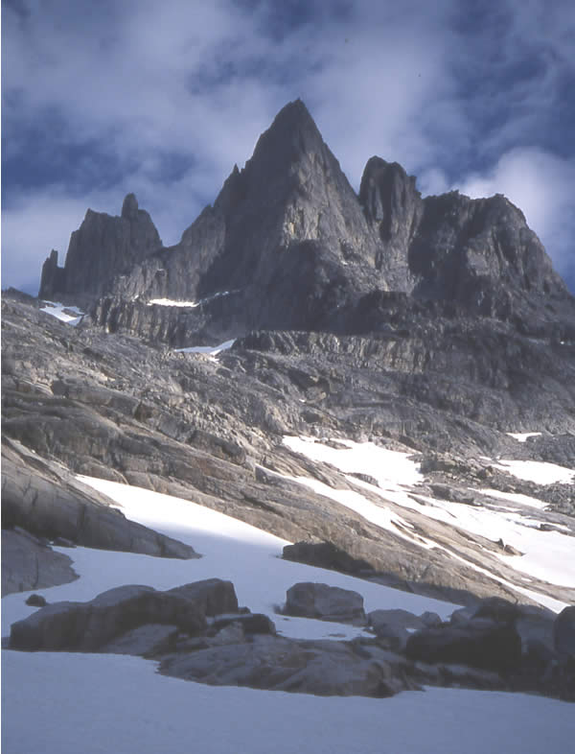
Very tiring boulder hopping led to the col, past 4 tarns, where the going miraculously turned to short, cropped turf and gravel. The hills to the west are very broken and not very promising for climbing – the continuous high level ridge to the right offers a wealth of possibilities as it falls in steep white-grey walls into the valley. The furthest end is the most striking from a distance, where a massive shield of beautiful brick red granite, some 600m high rises sheer to the summit. Further on, seemingly terminating the ridge, is a red tower some 400-500m high, ‘stuck’ to the side as an afterthought. It looked like there was no ‘easy’ way up onto the ridge, but dropping into the open northern plains and rounding the tower, we could see an open snowy couloir and a gentle NE ridge that we hadn’t imagined. The tower ended in shorter, bulging walls on this side. It was too late in the day for the length of route the area offered, so we checked out the boulders or wandered over the plains, finding a foxes’ den with hidden cubs on route, to a perch above the sea. The plains were a rich source of Boletus mushrooms, which went into the pot. A good spot to rest and watch a ship heading for a collision course only to disappear into Augpilagtoq’s hidden harbour.
Sat 31st July: Out on the northern end of the island it had been the coldest night yet with frost on the bivi bag. A clear start, but with a perturbing veil of cirrus creeping over (remaining largely clear to the north). We ascended the couloir/slope to a bowl below the NE ridge, with a short ridge out to the Red Tower, and from there to a shoulder on the left. Scrambling up broken slabs led to a short headwall and chimney, emerging on a plateau with a big snow-field. The 1030m summit further south looked like the Moroccan desert with decomposing red granite boulders and we named it “Red Tor” due to its southerly aspect (forming the top of the Red Wall) looking like a Dartmoor tor. The ridge onwards was like no other – a broad plateau of flat stones rising onto the next top. However, the crux of the day interrupted this in the form of “Almer’s leap” – a cleft sliced the plateau with a crumbly 12m neck bridging the sides, 8m down. Grim 5a climbing, with rope drag, out of the leaning corner crack gave the route a ‘D’ grading.
Figure 6. Pt. 1300 from NW.
At the next top, it became a true ridge. A cairn on “Los Capitanos” indicated that the Germans of 2001 had been here. By now, the cloud above and south had thickened to give the worry of an approaching front, though it began to break up late in the afternoon. Thereafter was ‘proper’ scrambling involving a rock bridge into the chimney onto the next summit at ~1100m, now “KMC peak” for the club. Next along was the Pt1300 secondary peak – things turned nasty here. We were on a dog-leg in the ridge which dipped sharply, narrowed, proceeded south over a small top and ran as a toothed, knife-edge into the bulging base of the secondary peak. Even the flanking terraces had run out. This was turn around, since we’d decided we would turn back or escape before the going turned really hard, and there was the thought of the thieves back at base drinking the last of the alcohol supplies. The vague hope of completing the full traverse dropped, we more or less retraced our steps, using bypasses on the east, down and back through the valley, where the going was much faster this time.
From the Big Brother tent, Al and Jenny had perspired their way up SOB couloir and cut down the NE flank into the main valley. The rake system was not as easy to trace going this way. They returned by the standard route down the main fjord side and over the neck of land to Eagle Bay. Steve, Rob and Anna had set off with the intention of repeating the NE ridge of the Baron and joined forces with Karel and Helena in starting up ‘B’ Gully, but missed the terrace and most turned back soon after reaching the ridge. Later, Dave and Duncan met Karel & Helena at the head of the fixed ropes after 1hr 40 from the ridge end. Karel had turned back in the gully, ill, so Helena had finished the day off with a solo ascent of the peak to the NW of the 4 tarns. Leaving the fixed ropes for Karel to collect as they had further plans, we had a knee-buckling descent to the 1st tarn where a last peaceful meal was cooked. And no, the remaining alcohol had not been broached by our return at 20:30.
Sun 1st Aug: A bright and sunny day with a relaxed start. Duncan, Anna and Steve headed out for some unfinished business on upper Black Fly Buttress and climbing in mixed pairs, as the ledge systems allowed, completed “Stevie’s Spider Spanking” 105m E3 5b,4b,5c. Meanwhile, Scott, Ian and Julie were finishing a project on the lower buttress producing “Mustn’t Crumble” E2. Karel and Helena had camped back up the valley to allow them to try a route leading up to above the Baroness Col area, starting from the top of B gully. They reported 5.10b climbing and recounted (on the following day) an anxious abseil descent with the rock strewn ledges forcing many short abseils, and a very close encounter with a falling rock. Back at base, Dave, Rob and Jenny made a start on preparing for departure, carting 8 barrels to the beach. The solar panel frame was dismantled and its wood joined the growing mound of flammable items. The evening required the last call home, and it was well rounded off by the bonfire at 11pm. No fireworks but we made do with bags of ready brek, flour and rye bread in stove fuel – the fire raged past midnight.
Mon 2nd Aug: Thick fog commenced the day at 6-30am, but Karel & Helena had returned in the night. Leaving day! Dave made a start on transporting stuff down to the beach and the morning transformed into a scene of frenetic activity. The main tent was emptied, and the pile of barrels and packs on the beach, comfortably above the tide, grew. On checking with Niels by phone, we found we had at least an extra hour as the boat was having a cable replaced on the engine. The latrine was filled in and fire pit cleaned up, while the Grease trap was dismantled, and the biodegradable waste was buried. A good drying day with clear, crisp conditions and a keen breeze, so all the tents could be packed away dry. All were down on the beach by 1pm, the original time, while I performed a final inspection and picked up a few bits of litter. While we were waiting for the boat, a local in a dinghy laid and pulled in some nets in the bay, complete with a small seal hanging over the gunwale – perhaps a cause of the cairn on the beach?
At 2pm a fine bow wave was seen coming up the fjord, past the new large ‘bergs drifting in – the ‘Ketil’ had arrived. We quickly set to, shifting things to the water line 30m away. Two were away in the first dingy trip to set up a loading chain via the stern, whilst with the flooding tide, the Ketil was able to nudge in to shore where a precariously greasy rock was conveniently situated at the waters edge. With a human chain loading via the bow, we were away within 20 minutes. It was saddening to leave our fjord, particularly with ‘Pisstake’ peak making the parting gesture. The return journey was closer inshore and with very much less ice about, took ~2.5 hours, even though the boat wasn’t at its best with a distinct vibration denoting a chipped propeller. Niels was waiting at the pier with the comment that the supermarket closed in 15 minutes – Scott ran for the beers whilst the rest unloaded, the tourist office truck taking the heavy stuff the short distance to the warehouse. We had eager assistance from a great bunch of kids, who were able to resume their game of bombing into the sea in wet suits, once the ‘Ketil’ had left the pier. Retrieved our valuables from Niels and retired to the Youth Hostel to cook there. Naturally the evening was rounded off by a cheery evening in the Hotel Kap Farvel bar.
Tues 3rd Aug: A fine sunny day and a happy few were off to the warehouse at 8am. Niels reminds us to keep the Gas cylinders locked away – he had just had one taken from his garden, likely by kids. The barrel contents were emptied and sorted, leaving the cheaper consumable items like plastic sheet and saw. It was all repacked, listing the contents in a notebook for Customs purposes, squeezing in the Benzin bottles. It all just fitted into our 12 barrels. The two large barrels were important for the main tent and long items like the ice axes. Our spare food was either taken up to the Youth hostel to possibly use over the next few days, or piled into the loaned barrels. However, some worthwhile bags of trail mix ingredients and so on were pushed into the freight to be distributed at home. Any spare food we have when we leave, would not be thrown away, but would go to a good cause as Niels would pass it on to the local house for the destitute.
The Cape Farewell Irish Sea Kayaking team returned while we were in the warehouse – they had been round the coast of Pamiagdluk, and the ferry came in, creating quite a local event with Niels there to meet it. Finished by lunch and time to join in the shopping, sightseeing and relaxing. Shopping started at the tourist office in which Niels sold a number of things – some returned with Greenland Mosquito Buster caps, which may see action at Stanage. If you have another pictures, charts, reports or other useful materials spare, please give them to Niels as they will help him in his plans of building up the tourist business, we’ll be sending a copy of this report. The Nanortalik museum is worth a look. Another evening spent in the friendly atmosphere of the hotel bar, with more in the shape of the Irish to partner the locals on the dance floor.
Wed 4th Aug: A cold, misty start with few of the team about (the last retired at 5-30am!). Dave off to settle up with Niels, paying by a mixture of cash and credit card. Some members had been asked to contribute by bringing a large bundle of Danish Kroner. Last step was to see the return freight on its way, Niels handing over the delivery note, and calling up the local freight office. Rob and I hastily stuffed a last item or two into the barrels as a JCB turned into the warehouse, and then trotted after it to the Royal Arctic Line terminal. There, with a mixture of pointing to paper and Danish, managed to get it booked on a ship to Aalborg, Denmark, from where Blue Water would take it forward.
We cleared out the Youth Hostel at 2pm, and Niels kindly ferried our bags to the Heliport. On checking in, 3 of us were charged for 4-5kg of excess luggage, even with some weight equalisation, but then we did have some left over food for the next day amongst us, such as the never ending cereal bars. The flight on a 25 seat S61 helicopter was dull in comparison to our arrival, though the extra sight seeing circuit around a spectacular waterfall was a nice touch. Back at Narsarsuaq, the warden met us with a pickup in which our bags were transported to the Youth Hostel, leaving us to walk the easy 700m. The Hostel is ‘modern’ and well equipped with cooking facilities, but we all tried the hotel cafeteria – not to be particularly recommended.
Thu 5th Aug: Bright and sunny dawn, Dave and Duncan were up early to take the climbing kit for a walk up the valley on the well used trail to the glacier, with the intention of locating something to climb. The best looking rock happens to rise out of the other side of the glacial river! The path is well used and has completely unnecessary fixed ropes! The rock is not suitable for climbing – too much glacial polish shining in the sun near the river. Others joined us later, while more just wandered about near the Hostel. Rob and Steve hired mountain bikes and headed towards the glacier (walking the last km’s). Their return ride saw the second ‘accident’ of the trip when Steve went over the bars. Back for “Happy 2 hours” in hotel bar – Carlsberg down from 37 to 27Dkr, then it was back to the hostel for the ritual burning of Duncan’s scabby trousers in the Barbecue. Cue a good display of the Northern Lights for those still awake (the nights aren’t dark enough in July).
Fri 6th Aug: Another bright day with high level cloud – time to repack and clean out. The hostel did do a ferrying run for luggage though most carried theirs. Were followed into the terminal building by an unusual Police and Security presence – later an executive jet landed and the Airport relaxed a while later. Killed time checking the souvenir shop, but with the Blue Ice Café closed there’s not much to do. We were squeezed through the security gate in the ‘lounge’ – they have just the one X-ray facility – and straight out to the plane. A very hot return flight to Copenhagen, arriving late evening. In order to catch the last beers at the hostel, this time, the first out elected to take taxis (~140Dkr for a 10min. ride). The final group, suffering from delayed luggage, arrived by Metro much later.
Sat 7th Aug: Our bodies need acclimatisation to heat and humidity – most members are in a coma and few enact the plan to explore Copenhagen. Leaving a ‘corpse’ in the grass outside the Hostel, Dave checked out the local vast Nature Reserve, whilst 4 went into town. At this point, say ‘Goodbye’ to Karel & Helena who are flying home that afternoon.
Sun 8th Aug: Another early departure from the Youth Hostel, 8 by taxi, 2 by direct bus (20mins longer). Return to a hot and sticky UK and our cars, to head our separate ways up the busy M6 & M1 – easily the worst travel stage on the hottest day of the year. Expedition Over – now for the mopping up operations.

Maps and areas of interest.
A sketch map of our local area, including areas visited (orange) is shown in Figure 7. Names added are just to identify features where no local name is known. The layout of ridges has been derived from maps and photographs, and of course, are more inaccurate, the further away from the viewpoint and the areas physically visited they are.
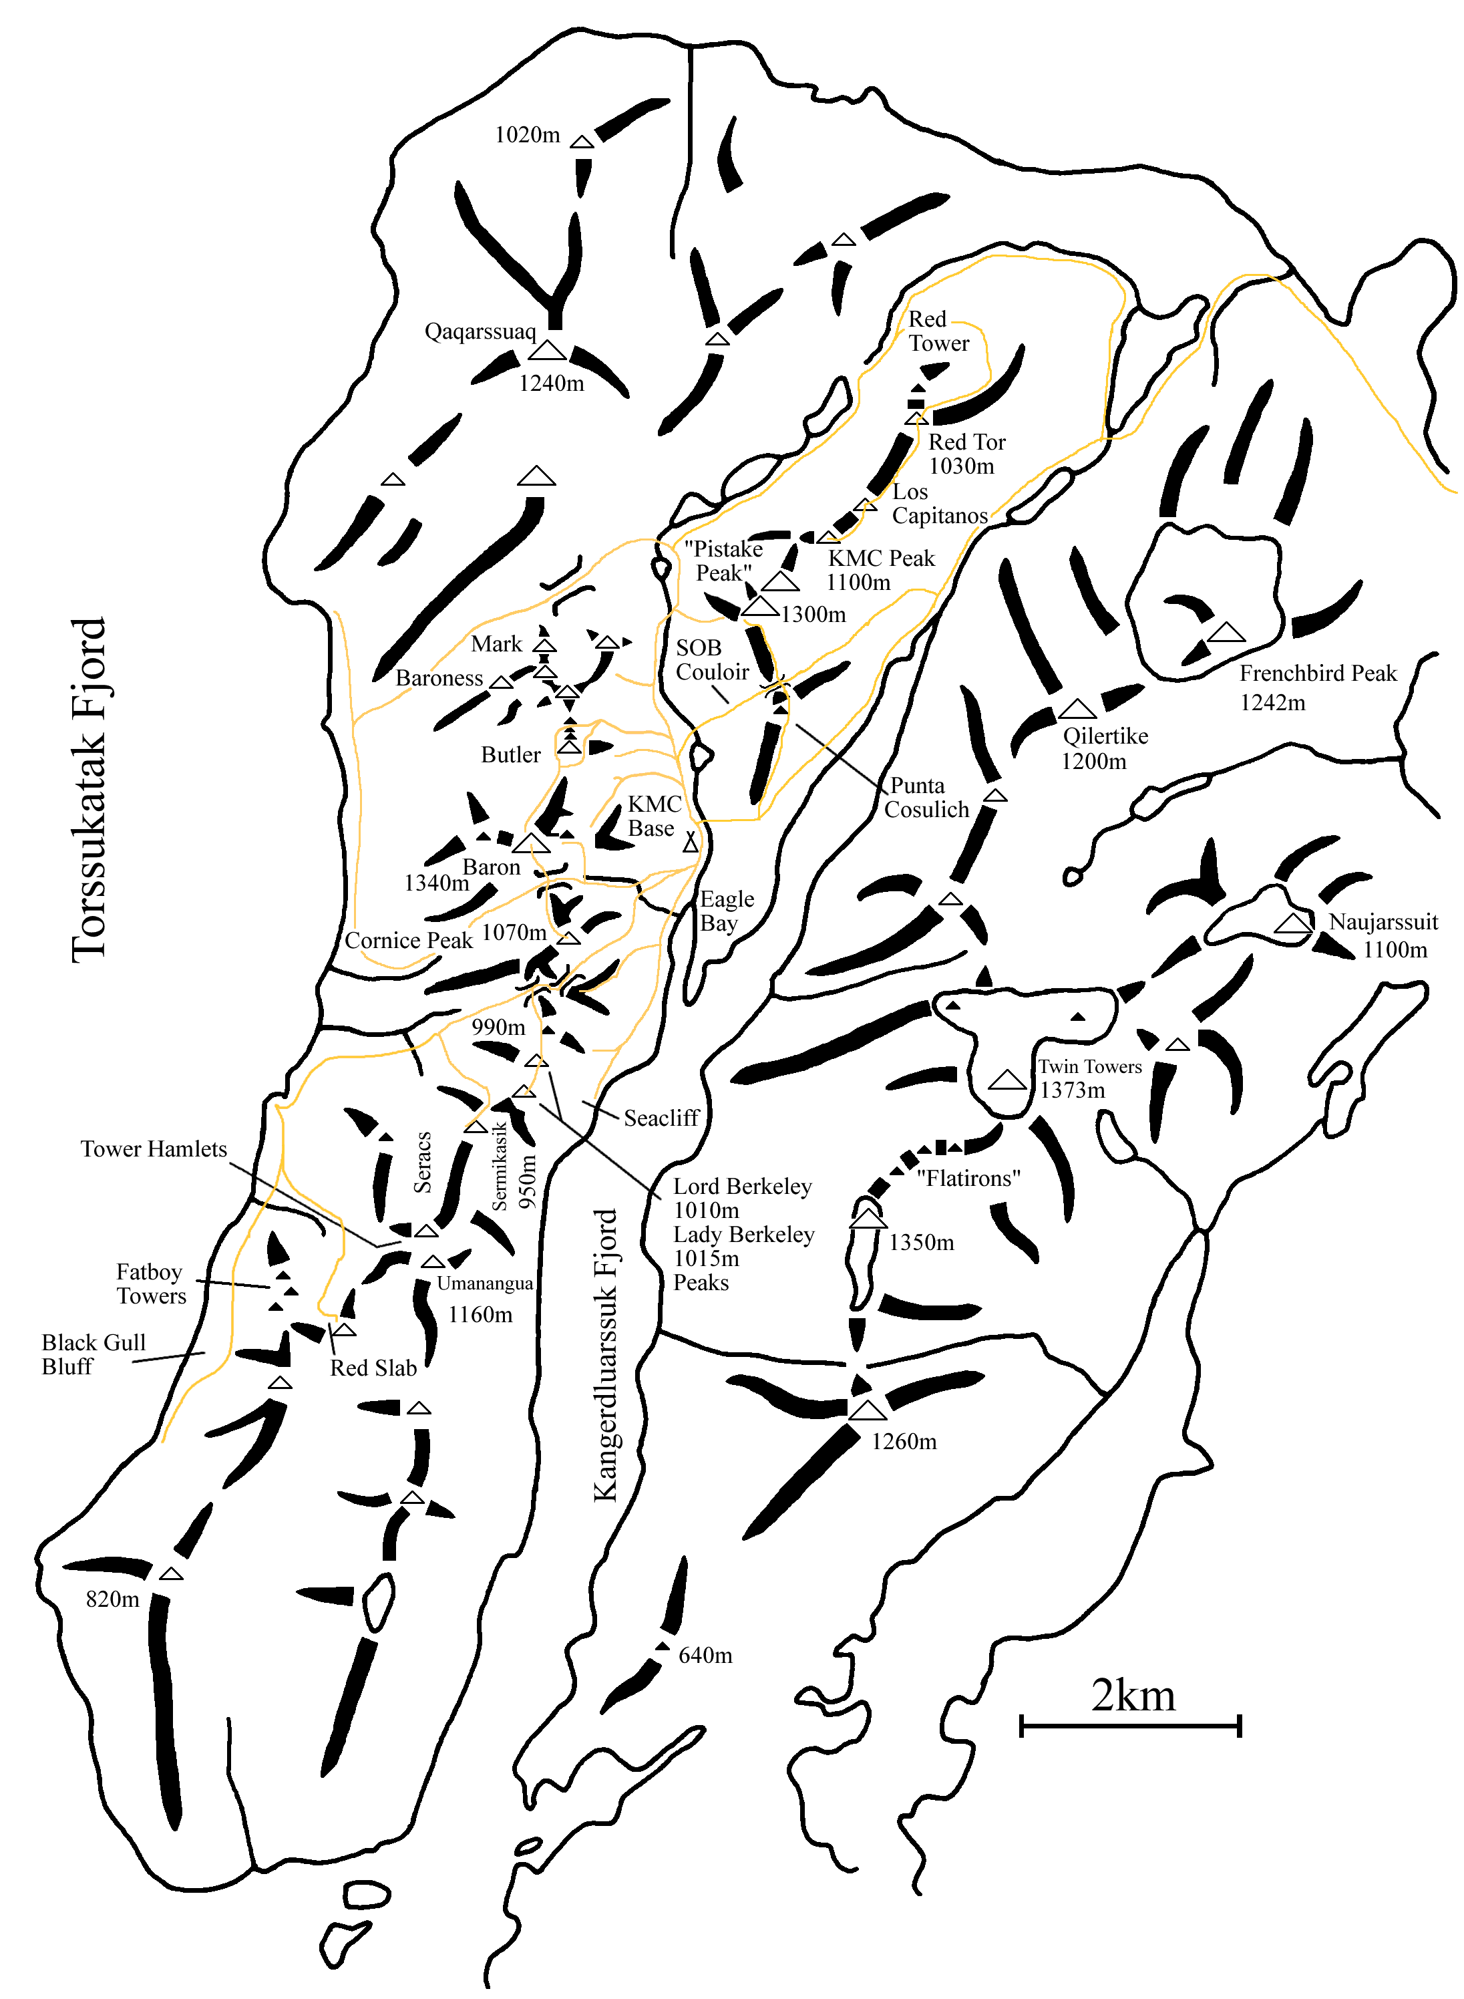
Figure 7. KMC Local area map of Pamiagdluk.
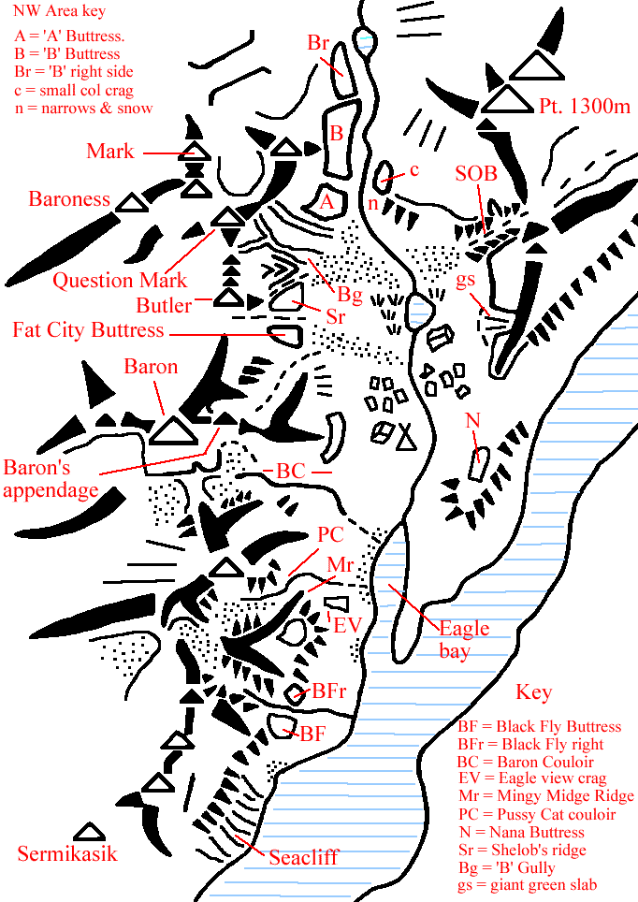
Figure 8. Local Crags location map.
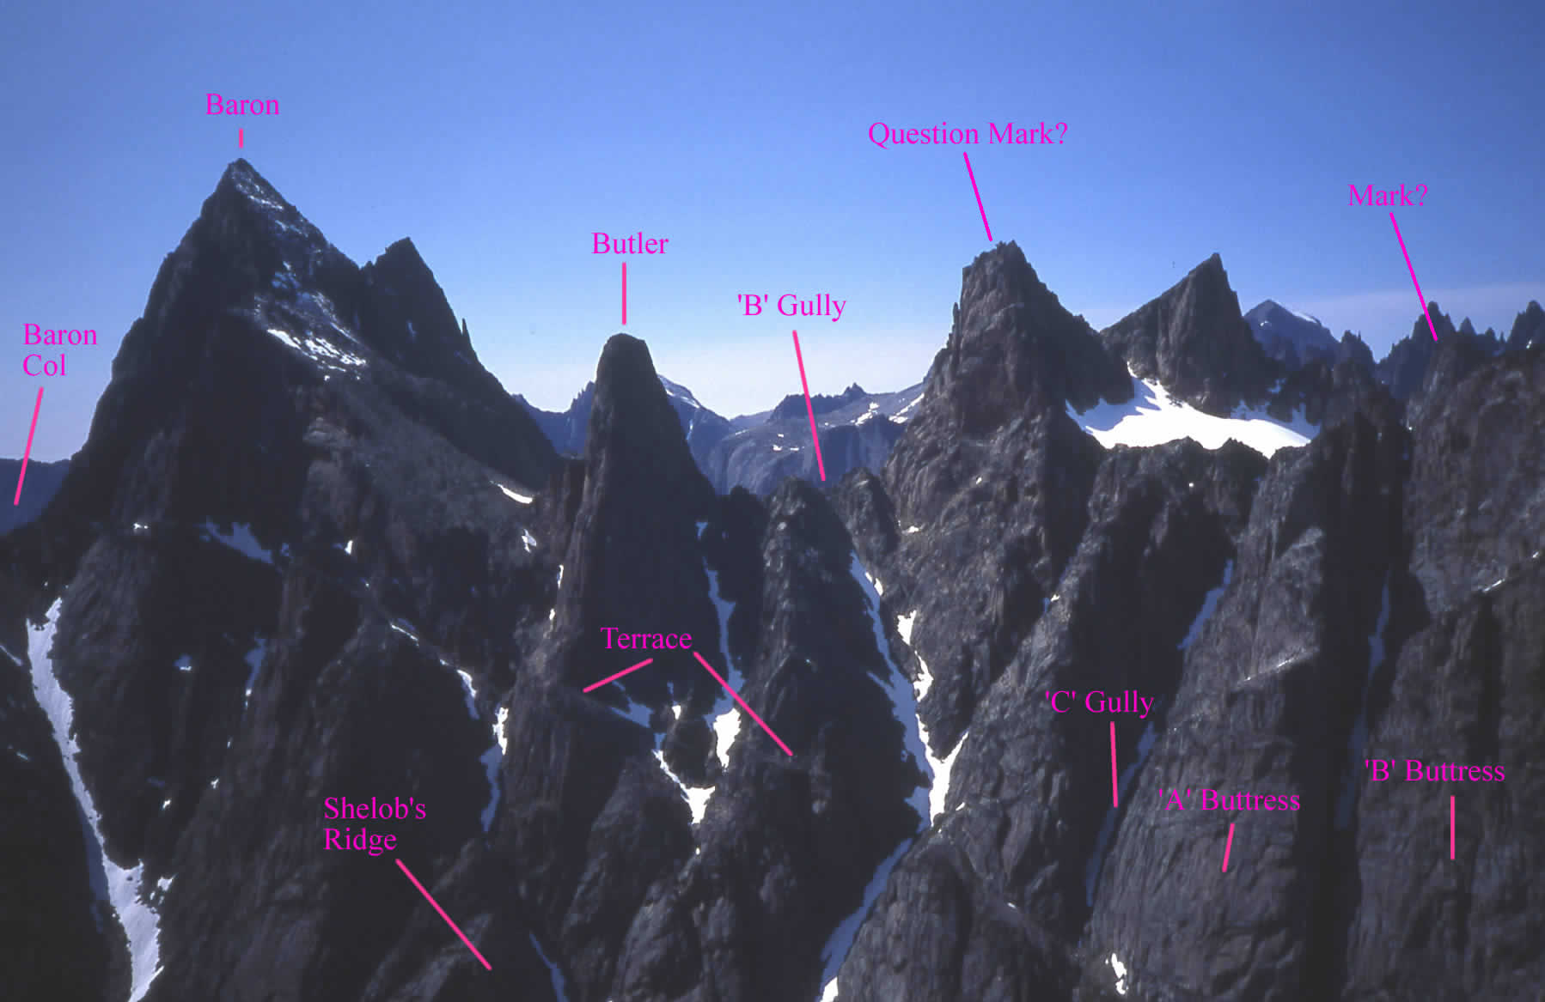
Figure 9. The Baron and Butler area from Consolation point.

Conditions.
Here we note the conditions as far as climbing and hill walking activities went on the main western side of the island.

Climbing and walking.
Much of the rock is very good for climbing being of Granite like or Gneiss (metamorphosed granite) rocks. It was generally well weathered on southerly orientations, and well featured. There were plenty of cracks, and thankfully few large blank slabs, but many apparently holdless walls. Areas that were water worn, like basins and open gullies, were smooth and compact, with little useful for abseiling. The strata were not consistent over a wide area, and the rock types were pretty mixed up. There appeared to be three main types of rock; a light grey to white compact, crystalline granitic rock that formed most of the lower strata of the hills. Secondly, a red to orange very rough, well-featured, medium grained, solid Granite or Gneiss like rock that formed the tops of the better hills. The Baron and Butler walls were of this mostly. Thirdly, a yellowish orange, very crystalline, baked granite that was heavily weathered, and decomposing chemically to leave a gritty surface of crystals often easily crumbled away. It could be unsound on a larger scale with apparently sound large features just coming away so was a very unnerving climbing or scrambling medium. It could outcrop anywhere, but did form the upper 200m or so of the ridge south of the Baron. It weathers into exotic rock formations – so much so that anywhere one could see crazy pinnacles, you could reasonably predict the area to be of this particular rock. There were many staircase-like, large, basaltic sills cutting through the ridges, upsetting the structure – one such gave us a heart stopping moment on “Shelob’s Ridge”.
We had carefully studied a geological map (which one can see on the GEUS website) while selecting venues, looking for a rock type with reported good climbing on, on the reasonable expectation that it would hold true throughout its range. There was no key, but I later saw the same full map in Nanortalik Heliport. Much of Greenland consists of rock first deposited as sediment very early in the Earth’s history. However, the material has been extensively reworked and folded, so that much of the coastal region is made of metamorphic rocks such as gneiss. The bulk of Pamiagdluk is of the same material as the Thumbnail, being late Granites. “pyroxene and Garnet bearing Quartz Monzonite of variable composition, with local gneissose foliation” for interest.
The rock was quick drying in the main, within a few hours, apart from some persistent weeps. One could certainly find something to climb shortly after rain and the sun coming out.
As we arrived in July, there were still considerable areas of snow about, principally in gullies or on plateau, some lying to sea level. Indeed, there was a light snowfall on the day after arrival. This mainly affected getting onto the ridges, and once there, there was little trouble (with one exception), in crossing the odd area without gear. The gullies were only moderately firm early in the morning after a frost, and in heavy shade, and we only took and used crampons on a couple of days. The general state was soft to very soft, and carrying an ice axe was definitely a wise move – we took to carrying them on most mountaineering excursions (embarrassing snow fields could appear out of hidden nooks). Nothing more than grade I was encountered, and the snow fields shrank considerably over the month. In addition to the transient snow fields there were some permanent snow and ice fields, or remnant glaciers high up (e.g. By French bird Peak), but we had no need to tackle them.
As ‘our’ valley was stony, it was well drained – indeed we found conditions generally dry underfoot on the western half of the island with just the areas around streams being at all wet. There were no bogs as such. Walking anywhere was fairly slow, with quite few areas where the walking was comfortable and reliable enough to go at speed, and much traversing and tackling of steep vegetated slopes – surprising just how steep a slope one can ascend on dry Crowberry.

Hazards.
As far as rock or ice fall went, the area was far quieter than the Alps are, with just a few days hearing the heavy guns. The falls tended to concentrate in particular areas, with one on the flanks of pt. 1350m away on the other side of the fjord being a pretty regular performer as the sun got to work. However, there was plenty of loose rock lying on ledges to make one tread warily.
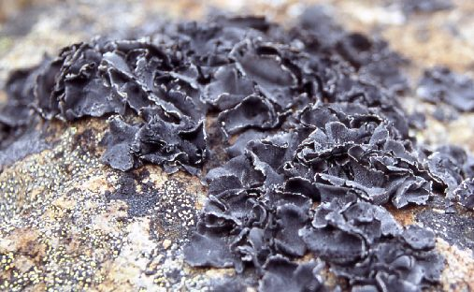
A feature of the area were half urinal shaped cirques of slabby, smooth rock with a small glacier in the bottom and a band of seracs overlooking the rock apron below, complete with incontinent dribble. We steered clear – one such feature was the regular artillery performer.
The snow fields within the large boulder zones, and over the river at its steepest point were an increasing hazard as they melted away underneath leaving a perilously thin skin at the edges. Falling through was a problem – the river area consisted of steep slabs under the snow, slanting into the torrent. As the water could be seen far down through a 50cm gap, and large crevasses developed, this was a serious worry and we fixed ropes across sections that, at the time, could be avoided by scrambling on the rock sides. On the last day, even these were risky.
Figure 10. Rock Tripe.
We found the lichen was of a rich and multihued variety, but a certain grey type was viciously slippery if other that absolutely dry. Another widespread type was a pain at altitude. This was Rock Tripe Lichen – forming wide areas of flowers of hard, black, cornflake like petals that dug into ones fingertips, and was quite painful on raw fingers as one attempted to find holds underneath. When wet they formed little dark grey oozing sponges…
There were many boulder and stone fields –‘our’ valley was rich in fields of enormous boulders giving intricate route choice and a worry of how far down one would go if you missed the jump. These stone fields were notorious for their “Killer Willow”. The ground would be covered in a creeping tangle of prostrate Northern Willow, which did NOT bind the stones together, and hid the footing from view. These were an absolute bane and constant Russian roulette.

Weather.
We had mixed reports of the weather prospects so expected about 50% of the time to be wet or damp, and looking back it was in that order. The southern tip of Greenland does see the wettest weather in Greenland, though it may merely manifest itself as cloud and fog. There were many days when the sea and any land south of the mouth of the fjord was covered in thick sea fog which would stay all day, whilst that thinner covering over us would break up by around 9am. More importantly, there are strong winds in Greenland including named ones, but we never experienced anything down in our valley, or on the hills, to stress our tents. Indeed, for much of the time winds were light to weak particularly on fine days, with the most cutting breeze reserved for the day we left. In fact we couldn't say that we had any truly severe weather. Temperatures were comfortable, with night time temperatures on clear nights dipping to just below zero to give a light frost, but usually to the 5°C mark. Daytime temperatures ranged from something like 10-18°C, giving shirt sleeve conditions on top of the hills on many of the clear sunny days. According to the locals, the weather is normally fine for several days, and when wet weather arrives, it hangs around for days too, so the unstable pattern of wet and dry to half dry days we had for the middle of our stay was unusual, and very Scottish like. A record of the weather is given in 14.3.

Flora & Fauna.
There were many other things to look at to enhance the hills. And some were hazards too…

Insect Life.
It is not the Polar Bear that is the king of the Low Arctic – it’s the Mosquito, with its peasant army of Black fly that we feared. We read up on it and came armed with every precaution we could think of. Long sleeves and trousers are not enough (shorts would be suicidal), Mozzies and ‘Blackfly’ love eyes, ears, mouths and noses so a hat and head net are essential. The Greenland variety will drill anywhere and through anything. We took a whole array of different repellents for use on skin or soaking clothing, including 50 & 100% DEET, (watching out for ‘melting’ of plastics) in the hope of finding something that worked for at least one person. We made sure all the tents had good mosquito netting doors.
As it turned out, the distribution of mosquito is not universal. In our valley they were not numerous, though worse in the north of the island and Karel & Helena reported clouds of them on their distant excursions to the NE of Pamaigdluk. They tended to be solitary and mainly operate in the evenings and night (morning killing sprees left coloured remains). They were also large and slow to bite, and most did not get much reaction from the bite. Better, the DEET and other repellents actually seemed to keep most of them off.
The ‘Blackfly’ do not seem to bite, but travel around in vast numbers, and love to explore shaded areas like the inside of ears and mouth. They liked nothing better than to buzz loudly and take a kamikaze dive into the throat – curiously they tasted sweet. Those with spectacles had even more difficulties. Beware a type of mosquito/fly with white feet – it likes to crawl under shade of clothing before having a bite. The distraction potential was immense, and they operated from the first warmth of the sun to the first deep shade – warm humid days were murder. Only in steady rain, really high on the hills or with a stiff breeze did they let up. In a tent it was hard to tell the difference between rain and flies, and, they operated in partnership with mosquitoes. These completely ignored all types of repellent and bathed in the stuff – the only way to upset them was to run the bottle’s roller ball over them. Oddly, they tended not to follow one into the cool shade of a boulder.
There also seemed to be the odd large fly with a vicious bite. Mind you, there were a few butterflies to brighten the scene, as well as a number of other more innocuous insects such as Bees. Thankfully, no midges!

Flora.
A few of us had a passing interest in plants so we packed a useful slim volume on the flowering plants of Greenland. In sheltered areas a sub-arctic climate can be produced, which can result in quite rich vegetation, and the lower slopes of the hills supported an aromatic “herb slope” vegetation. Even the tops of the hills supported dwarf growth of, principally, heaths. There are no trees, just shrubs and bushes that can grow quite thickly in stream outflows. The usual shrubs in Greenland are Birch, Alder (not seen), Juniper and Willow. In fact the Nanortalik area boasts Greenland’s only ‘forest’ where dwarf Birch and Northern Willow grow ‘vigorously’ to 3-4m with a few reaching a staggering 8m! The highest on Pamiagdluk was ~1m. The net effect is that you won’t find enough dead material for a campfire! Most of the ‘trees’ are prostrate, with willow in particular forming tough, tangled mats over scree slopes and boulders.
The main biomass was Crowberry with last year’s black berries still attached, mixed with birch and willow concentrations. There were a surprising number of attractive flowering plants around – the most common, Alpine Ladies Mantle forming large patches on the slopes.
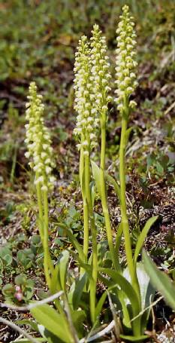
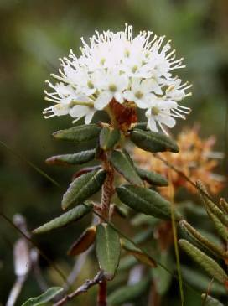
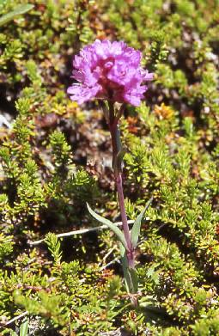
In late summer, the lowland areas are carpeted with the national flower, the Broad leaf Rosebay Willowherb. Other flowering plants include Small White Orchids, Dandelion, Hawkweed, Harebell, Angelica, Roseroot, Saxifrages, Thyme, Speedwell, Red Alpine Campion, Labrador Tea (aromatic leaves), Lapland Cornel and many more. There were rich communities on steam banks so much so that the outflows of corries and valleys were notable obstacles – almost anything in the way of streams, potholes and boulders could hide in there.
Figure 13. Small White Orchid.
Figure 12. Narrow Leafed Labrador Tea.
Figure 11. Red Alpine Campion.
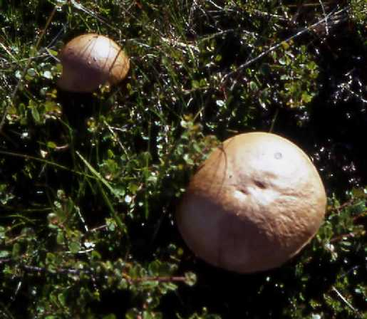
There were a number of edible plants, in theory, but after experimentation weren’t as tasty as made out to be. Bilberries were not ripe in time, nor this season’s inferior Crowberries. Several types of edible mushroom grow in Greenland, however there are poisonous funghi. A mushroom identification book was taken along, but experience is best and Karel was the best choice there. One species we soon were able to recognise – a smooth, dry, tan coloured cap Boletus with a cream to white tubular structured under cap with a scaled stem, varying from 5 to 15cm in diameter. Pick before the underside darkens with spores and the cap cracks. Infrequent at the start of the trip, by the end they were popping up all over, though much more so in the plains of the north of the island. The book identified them as a “Birch Scaberstalk” (a member of Leccinum scabrum) and as they were reasonably tasty, they dropped into several meals. Best found in widespread areas of prostrate birch as they are mycorrhizal with birch.
Figure 14. Boletus Mushrooms.

Fishing.
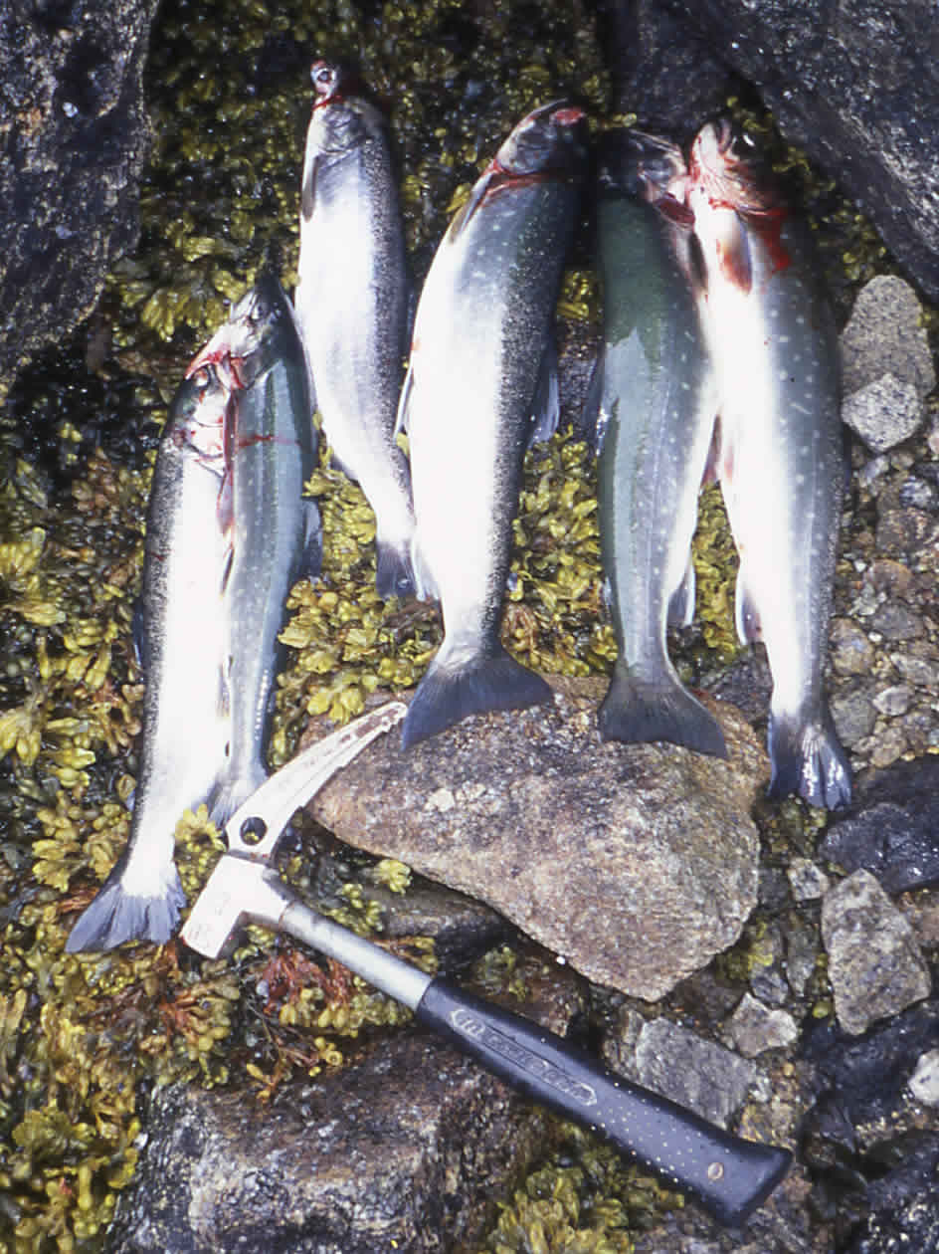
There is an abundance of fish in Arctic waters, many of which we understood were easy to catch (but see 8.5). So to keep the Carnivores happy, expedition kit included a fishing rod and basic lure fishing kit (take plenty of spares) for some alternative entertainment. From local advice, the best lures for Char should be shiny, and include metallic fluorescent orange or pink colours in dull conditions, or black with orange in bright conditions. Actually, almost anything attracted some attention. Note that in Greenland it is the tradition not to clean caught fish in rivers or lakes as it is said to ‘scare’ the fish. We saw many large mussel shells on the shore, but never saw any actual mussel beds.
Figure 15. Arctic Char.
In fjords, just a lure, hook and line should do as the Cod snap at anything, but we only caught a few small specimens. The most prized fish is the Arctic Char, a relative of the salmon. It’s common, easily caught, and very tasty. Our river had pools where groups of tiddlers would flash away on approach, so we were sure the fish were somewhere, and the presence of an Eagle was a good sign. In early summer (June-July) they proceed to sea. Best locations are close to rivers, or areas with a narrow channel and strong current. The Char head back up the rivers in July and August. They migrate further upstream with time and can be most easily caught with a spinner – we found good fishing some way down our bay. None of us could be considered anglers – Steve became known as the “gear destroyer” and the rod is no more – but by the end, 20m of handline and a lure was at least as effective. You could see smaller fish following the lure right to your feet. The fish were a good size, 0.5-1kg on our scales – from sea to pan in an hour. Don’t forget the fishing kit!

Birds and mammals.
The area was not especially rich in Birdlife though it was quite bold. Especially cheeky were the Snow Buntings with a cheerful song. There were some inquisitive Larks and other unidentifiable brown birds (our sole birder lapsed many years ago), but oddly no sign of insect eaters. There were a few gulls, Ravens, Ptarmigan with cute chicks, and Peregrines. We were privileged to share the area with a pair of nesting White tailed Sea Eagles and we often saw these magnificent birds.
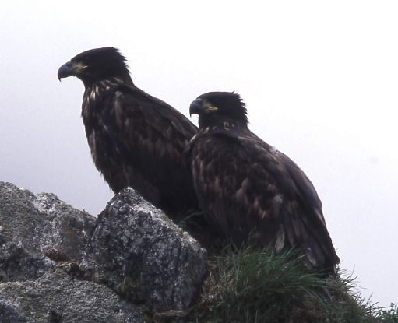
The only land mammal we saw was the Arctic Fox, a dark chocolate brown in this part of the world. Early on, we found these curious narrow tracks on either side of the river, and it took several days before their cause became clear. They were the regular beats of at least one fox, going down to check on the bay. It wasn’t long before a fox would regularly walk through camp, passing only metres away from us. They weren’t much trouble provided we kept food tidied away and the lids on the rubbish barrels, and they showed their disdain by leaving deposits on the grease trap. A den was found in the north of the island, where the young gave voice to oddly bird like calls. Fortunately no Polar Bears, but we did hear on the return boat journey of sightings during the period we were on the island just north on the mainland, near Augpilagtoq. Nevertheless, the chances of encountering one had been slim. On a few occasions, large schools of seals were seen fishing in our fjord and otherwise the seas were quiet.
Figure 16. Sea Eagles.

Emergency & Contingency Handling.
We also had to plan for any emergency or situation that occurred on the Island, or at home. Establishing plans of action would hopefully ensure a situation would be handled smoothly and prevent expensive callout of assistance because of a mistaken belief we were missing.

Communications.
As the expedition would be completely isolated on the island and unlikely to see passing boats without trekking out to the North coast, it was necessary to have a means of communication in an emergency. VHF radio would be unreliable, as we were in a deep valley, so we took a Satellite phone (Irridium) along. We rented this from Mobell UK (the most comfortable deal) and carried it (carefully) out with us. A hefty deposit with a call charge of £1.85 per min, so there weren’t many calls home! A phone could be hired from Niels in Nanortalik, with the advantage of fewer days’ hire, and would be cheaper. However, the UK hire included insurance, and the full charging option accessories – mainly solar. I wanted to check the whole system out in the UK by having the set arrive on the Tuesday before we went, to be certain we’d always have an operating communications system while there. It was switched on at fixed times in the day to pick up vital calls from home, and though it came with a spare battery, we could always keep the main battery topped up with the solar panel.
Having at least two mobile phones (GSM900/NMT900) was a feature of our “Communication Plan” as there was coverage out to Nanortalik. With a GSM range of ~33km, there shouldn’t be any signal on Pamiagdluk, thank heaven, and we left them in a box with all our other valuables of no use on the Island in Niels’ safe. Indeed, the leader threatened total immersion of any such outside Nanortalik!
We also took 4 European “PMR446” service small walkie-talkies along, which are dubious in Greenland, but no one was likely to hear us off the island. Though they only have a range of a couple of miles in line of sight, they could help teams keep in touch with base. As it was, they were of limited us to us, as going up or down the valley, base was rapidly out of line of sight, but there was good communication with the ridge and Baron directly above base camp. I would still suggest taking a pair or two but not placing much faith in them.
We also had 18 flares and 4 hand launchers, brought in Nanortalik for us by Niels, for backup local communications in an emergency. Never used, teams carried a few flares and launcher (~100g) in the bottom of the pack with an agreed signalling procedure, where the last flare or two was to be saved until dusk at the best possible time for it to be seen. We discussed hiring an EPIRB, but the majority felt that this one shot dumb beacon was over the top and that the Satellite phone should be sufficient. The phone worked well, though there were short periods when no satellite was overhead of our valley, and one or longer periods (10-15min) when nothing came over. I’m ashamed to say we did not always remember to switch on at the agreed times!

Communication plans.
We found a volunteer for the position of Home Contact who could relay messages and information via the satellite phone link using agreed communication periods, and act as a central contact point for information on the expedition progress and pass news onto the expedition website. They could filter out calls. Most importantly, if there was an accident, they would be able to supply information on the members of the expedition, since next of kin details were left with them, and may be able contact the appropriate authorities - this person would be a very useful backup in an emergency. Dave was kept involved in our communications plans as we built them.
We designed a plan of contact procedures for both directions at different phases of the expedition and distributed it in the form of a small factsheet to relatives and friends at home (for those members who wanted contact). We would switch the phone on morning and evening for an hour, and there were set points in the diary by which we had to have reported home. There were procedures should a call not be made, or be unanswered, but thankfully we did not have to use them.

Crisis Management Planning.
This was about thinking of the worst, and of putting into place risk reduction measures, considering the growing litigation culture. Between the group we performed a general risk assessment, to ensure that everybody was aware of the various hazards, knew what measures we would take to reduce the severity, and were comfortable with the final risk level – quite easy to do, as it was quite general. This focused our minds on the safety equipment and training measures. We felt that all team members should be made aware of at least the basics of self rescue and useful techniques, whether or not they had any prior practise, and so we arranged a very long day’s training course based on our Wales hut with a local guide, Dave Kenyon. This was just for the main climbers and we highly recommend such a brushup on skills – certainly it was one way of finding just how heavy some of us were! They later imported some of the basic techniques to the remainder at local crags. After First Aid training we had the mind set to lay down in an “Aide memoir” document, some guidelines for management of various types of incident on the expedition, such as the sort of materials to make a makeshift stretcher.

Medical & First Aid.
As we had no ‘official’ doctor on the team and for much of the time we would be operating as smaller teams away from base, it was decided to ensure that everybody had had a good level of First Aid training, particularly in wilderness areas. We could not expect to be able to immediately evacuate a casualty in all situations though the nearest medical facility was the hospital in Nanortalik (but it is only a small one!). Some had adequate training through work so as Steve co-ordinated the Medical and First Aid side of the trip, an onsite “Wilderness First Aid” weekend training course was arranged at the club hut. Through persuading others it would be useful to them, we got enough (8) numbers together to be able to run a course, part ‘subsidising’ it with expedition funds. The course run by staff of “Adventure Lifesigns” was very good, with the scenarios being particularly useful, and this gave us the confidence that we could stabilise a casualty until they were in a medical facility. We had access to advice at base camp at times also.
Steve organised the construction of a base camp “advanced aid” kit, with a small mobile kit for larger groups away from camp. This included Large size Army dressings (via Lifesigns), blow up splints, various bandages, dressings and plasters, the miracle “Quik Clot” and burn dressings. An emergency dental kit also went in, though no one was keen on the thought of using it. In addition Steve issued a list of the recommended minimum contents of a personal First Aid kit – everybody took their own First Aid kit, and this ensured that any pair in the field would have at least one useful First Aid kit with them. Each person was responsible for taking adequate personal supplies for any medical condition they may have had. A short Medical history form, including any serious allergies, was completed by all and copies kept with the base camp kit, and with our Home Contact. This, we thought, would fulfil our responsibilities.

Insurance & Permits.
No permits were required for this area by the Danish authorities, but we had to check on this. The Danish Polar Centre, which is responsible for administering the Greenland Ice cap and approving expeditions, can require that expeditions have 1,000,000DKK of Search and Rescue funds available before they will grant a permit to the expedition. In addition, each individual would need 280,000DKK of funds. In practise, this would mean ~£100 more in insurance would need to be paid. This is within the interior or uninhabited regions of Greenland, like the East coast – in other words, principally the ice-cap. The DPC website says that for activities in West Greenland, or near settlements on the East coast (within easy range of a helicopter, is the implication), you are not required to take out a search and rescue insurance. As the small-scale map on the website was open to question for Pamiagdluk, though it was felt unlikely as we were just 50km from the Nanortalik Heliport and Hospital, I did try contacting the Danish Polar Centre for confirmation, to get it at the eleventh hour.
A Fishing permit technically should be obtained locally, via the Post office in Nanortalik. A permit for one month costs 500DKr, though there was no one to check up on it. Note that the PO is not open on Sundays, but Niels can get one for you with warning (which we couldn’t give).
There have been two Helicopter rescues in the last five years that we knew of. Now that the cost of helicopter rescue has risen sharply recently, it is important that the insurance chosen has adequate cover for search and rescue (≥£40,000). The best thing to do is to avoid one – fortunately we didn’t have “Two helicopters Anderson” with us! We researched the then 4 options, one withdrew from the arena, and another declined to cover us, leaving the BMC insurance as the only acceptable option we could find.
The cover for most aspects is reasonable. There had been a question as to whether South Greenland falls within level 5, “Alpine and Ski” or level 6, “Expedition” cover. As it made a considerable difference to the personal finances, I obtained an Email from Ray Perry at the BMC, which confirmed that “Alpine and Ski” is indeed sufficient for the area – as we were near habitation on the coast, and couldn’t be said to be in a ‘remote’ area. Insurance has not been included in the expedition finances as people had different needs, and cover in some cases beforehand.
The insurance includes £1500 baggage cover, but this does not cover unaccompanied baggage such as the freight. The Agent should have some insurance for the ship sinking, so the only cover would be theft or loss, or damage on landing (a grey area), or in the shed. A rough minimum figure of £600 has been quoted, so it was been decided to forgo this expense, and suffer the slight risk of losing tents etc. I couldn’t find another expedition to South Greenland who had covered this.

Accidents.
We were lucky not to have any major incidents on the trip, though there was one extremely close incident of rock fall (human assisted). However, there were plenty of grazes and bruises due to falling over on the unstable terrain. Perhaps the Leader achieved the greatest skin removal feat in one go. A small number of paper-like cuts were received from tiny crystals projecting from the rock. Amongst the regular climbers, completely abraded and splitting finger tips were quite a problem as the rock is unbelievably abrasive – even brushing against the rock had a noticeable effect – so ensure your hands are toughened up beforehand. There wasn’t much taping up required. There was no real sunburn and not much need for a great deal of sunscreen. Hence in all, the first aid kit took a beating in plasters, small dressings, Tea Tree oil and Germoloid Nu-skin, but nothing much else.

Lessons learnt.
We would certainly take a refresher in the training courses we had on the next visit. We’d take more kit for handling skin abrasion, and would take fewer flares next time, since we realised that unless we agreed a fixed time period to fire the flares, there wasn’t much chance of anyone at base camp actually looking out for them!

Equipment.
Most of the equipment we took was shipped in the freight. Some was obtained especially for the trip and became KMC property for use on future expeditions.

Camping.
For camping on the island we took six two man tents, mostly Quasars or Trango 2’s, and these stayed at base in the end with the team split into pairs. Flat spaces were at a premium, but as all but one tent were on springy vegetation, extra groundsheets weren’t needed. None of the tents were put to the test. We also had a lightweight, two person tent, that our long distance explorers, Karel & Helena, used when out, and a few bivi bags amongst us, which saw more use and were more useful.
We saw the need for somewhere to cook and gather so decided to look out for and invest in a large tent of a size that could take 8+ and allow one to stand up. Later it would form KMC property for the future (if it survived). It was surprising how many weren’t suitable in one way or another but we eventually obtained an Outwell Hartford XL which took the 12 of us easily, had standing room and three side compartments, mosquito netting door and a full groundsheet. We only just found somewhere near flat enough to erect this massive structure, which was a big success and it survived the trip well, with a couple of overloaded clothes line tie in points and a couple of leaks in the groundsheet due to lying on rocks. Food supplies, cooking equipment and emergency gear was stored inside. People tended to gather here in the early evening, moving out to the “Bar” boulder later.
Nights were cool and duvet jackets were handy. Those, due to lack of space, who used a 2 season sleeping bag found it on the edge of comfort even with a liner, so a 3+ season bag is recommended. We had a mix of Karrimats and Thermarests (not forgetting the repair kit), either being effective.

Stoves & Fuel.
We took out in the freight (avoiding complications at Airports) seven liquid fuel stoves and bottles from MSR, Primus and Optimus ranges, not forgetting their maintenance kits. These were for teams to cook on when on extended journeys away from base and as a fall back should there have been a problem with the mess tent cookers. We knew the petrol was dirty, and had been recommended a mix of paraffin and lamp oil, but Niels suggested a Cleaner product labelled as “Rense Benzin” in 0.5L green plastic bottles to be found in both Nanortalik supermarkets. This is basically Naptha and burns as cleanly as Colemans – our MSRs etc. loved it. We estimated a use of 16L (with some spare), but only used 6L as there were far fewer away trips than we wanted.
For cooking at base, we bought a pair of Double gas ring burners from a UK camping shop. It was unclear what gas could be found in Nanortalik, so we took a selection of different types of regulators, hosing and jubilee clips so as to have a good chance at connecting to something. We had estimated 14 to 11kg cylinders for each stove would be needed. Forced into shopping on a Sunday, we had a little problem to tracing gas supplies – our thanks to the Gas store owner for getting up to help us! The town uses 11kg Propane/Butane BP Gas cylinders (www.bpgas.dk) and we bought 2 – unfortunately none of our regulators matched so we bought 2 of them (SRG) as well and will keep for another expedition. The stoves were a great success and despite heavy use on wet days between the 12 of us, neither cylinder had run out by the return to Nanortalik.

Kitchenware.
We required everyone to supply their own plate, mug and cutlery for ‘exclusive’ personal use, and to supply a light panset for two for each of the petrol stoves. Most of these were freighted and the pans could help out in communal cooking, but with, quite often, the need to cook for up to 12, we took out a communal collection of medium to large pans, frying pan, teapot, coffee makers, kettle, a wok and a pressure cooker. We did most of our cooking in the latter, though not under pressure, and it made a good steamer for fish. We had an impressive array of knives, allowing some meat/fish contaminated ones to be kept aside. With jugs, funnels, grater, peelers, fish slice, scissors, ladles and spoons we were sufficiently equipped to cook quite sophisticated meals (comfort food on the grim days). A stack of cheap plastic tumblers was vital for those who, inevitably, forgot their mug.
We packed a cheap collection of tea towels, cloths, sponges and scrubbers to help with the aftermath (we could have picked them up in Nanortalik). Also we took a few rolls of zip-lock and freezer bags, which were useful for making up trail mix in and so on – sadly we didn’t re-use them as much as we should have.

Electronics.
In addition to the Satellite phone, which came with its own battery packs, we had a smattering of other electronics as well, such as the PMR446 radios, and a couple of GPS units which we’d thought of checking the maps with. The latter were only used on a few occasions, giving a base camp fix home. They were difficult to use as altimeters since a lot of the time we couldn’t get a 3D fix with all the hills in the way of satellites. A watch type altimeter and an old mechanical one were both lighter to carry and more accurate (if reset every day), and were useful in filling in the gaps on the map. Amongst the group there were torches (seeing little use with the short ‘dark’ hours) personal radios and disc players as well as digital cameras and a digital camcorder. So we had a communal box of AA and AAA batteries with all discharged batteries returning to the UK, with a similar stock of rechargeable cells, but we only got through a dozen or so batteries. We had a flexible 11W solar panel with us, mounted on a DIY wooden frame (more material for the final bonfire) whose main purpose was to top up the Satellite phone. It was originally intended to have a solar powered, multi-function, battery charger that I was building at work, but a critical component self-destructed, only days before departure. However, the project will be finished for the next time, as I was impressed at how quickly the phone battery (built in charger) could be topped up.

Tools & building materials.
We took some basic tools since we wanted to be able to repair equipment and to have the means to put together some form of lean to shelter, as we didn’t know how kindly the main tent would take to the weather. We had ~6 lengths of 2x4 second hand wood which we had permission to take from Nanortalik – one formed a seat for the latrine, and the others a ramp into the main tent to save the ground. All these formed fuel for the final bonfire. We had a large sheet of heavy-duty plastic sheeting, and a section of mosquito netting, all unused and half a dozen 3x2m tarpaulins brought in a sale in the UK. The latter were useful in a variety of ways – they lined the cardboard boxes on the way out. We had a hammer, cheap wood saw, hatchet (no driftwood to chop up), nails, woodscrews and screwdrivers for the construction. We also took out a pair of essential Army folding shovels and a normal handled shovel that Niels loaned us, and together with a jemmy bar and a bit of brawn were the vital tools in latrine construction. There were also plastic trowels for pit stops on the go. Seeing less use in the kit were; pliers, wire cutters and wire, a Stanley knife, a file, hacksaw & blades, adjustable spanner, Allen keys for crampon maintenance, wire brush (not used on the rock), tape measure, electrical spares, jubilee clips, adhesives and cable ties. Finally there was a large roll of indispensable Gaffer tape, used on repairs ranging from trouser seats to groundsheets.

Climbing kit.
The idea was that there should be 5-6 full racks brought out to equip a full set of teams, but this was excessive as at no time were all climbing with racks. All our personal climbing gear was taken in our luggage, though some put some additional items in the freight, so that should we or our freight be delayed, we could still do some climbing while waiting. Each pair had to be self-supporting in terms of basic climbing, walking and mountaineering equipment for ‘summer’ activities. We settled on a standard of 60m 8.5mm ropes and shared the load. The communal equipment freighted out included a set of spares or so in case of loss, and some rarer items of kit, like large cams - making up a full rack with a double set of cams to size 5 and a size 6 – this turned out to be overkill. The remainder of the communal kit was;
Two spare 60m ropes | Spare harness, karabiners, helmet, belay plate & Nut key.
280m of 10m static rope in various lengths – saw a little use but could have managed with less. | Accessory 5-6mm cord & tape – not enough in stock for us.
35 Pegs – we used ~10 in abseils where no choice. | 3 Peg hammers – saw more use dispatching fish!
Rock peck & 4 Drill bits. | Pulleys –for possible rope tricks over rivers etc.
20 10mm Bolts & hangers – we reluctantly placed 4 in total, purely for escaping. Some didn’t see the need for them, but we had them on ‘loan’ for free. | 24 blocks of chalk – way too much as the conditions meant only 3-4 got used, but it was a job lot.
8 Cam and skyhooks – saw use in play on wet days with rurps and pegs. | 3 sets of ascenders – did very little rope fixing.
As our Ice gear, we decided minimum of 6 (had 7) ‘walking’ ice axes and 6 pairs (had 8) of lightweight crampons would be enough to go around as not everybody would need to progress on snow, and no ice as such was seriously expected. The axes were vital, but the crampons less so, and a couple of pairs would have sufficed.

Other Equipment.
The miscellaneous equipment, some carried in luggage, had; Books – we had at base, plant and mushroom identification paperbacks, books on the Arctic, a recipe book, equipment manuals and paperbacks. We had a selection of pens and notebooks for a daily log of plans (so we knew where people were going and when to expect them back), and records of their days as base material for this report. Other items;
Mini Tripod and Monopod – not used. | Foam seats – made packing material as well.
Large Binoculars – for communal use in addition to small personal ones. | Packing tape & permanent markers – left in Nanortalik for our return packing.
Bothy 2 emergency shelter – No emegencies. | Citronella candles & Mosquito Coils – used in main tent.
Sewing kit and nylon tape – we left repairs for home. | Games – only the indoor ones were used. Scrabble and a large supply of crosswords most popular for wet days.
Water repellent sprays – for cams etc. | Spare pegs and tent poles – turned into red flag pole!
Umbrella – good for fishing under. | Spring Balance – to check luggage weight (and fish size).
Washing line cord. | Compass – not much use when you didn’t know how to get to your target anyway.
Ortlieb Map cases – for protecting the phone etc. | Nikwax tin – frequently used as boots took a lot of punishment since everything was abrasive or sharp.

Lessons learnt.
As for stove choice, Niels had a small selection of smaller gas cans in the office, including the ubiquitous Camping Gaz 220g can, so bringing along a small gas burner could be preferable – just ask Niels if he can get a supply of your favourite cylinder well beforehand. Keep all gas under lock and key as it can disappear for gas sniffing (really!) purposes, sadly.
Another very large pot would have been helpful.
We’d cut back on the shelter building material, and tools.
Take as much abseil cord (best) and tape as you think you might need, and then double it. We were pushed for cord, and reduced a 57m rope to a 50m rope as a result. In general, decent abseil points were quite easy to find and we needed them.
Getting good descriptions of areas and what they’d seen from people was difficult, and the climbing teams required good reconnaissance, not least for prospective descent routes. We needed images to study, and in the demise of polaroid cameras we could have made better use of digital cameras. I’d have more of them and a good LCD back at base, perhaps with a laptop, particularly with solar recharging capabilities available.
Stringing up those who didn’t write their doings in the logbook at base, making report compilation frustrating!
Check with Niels – the YH ‘kennel’ is a store for items that expeditions and visitors have left behind, including gas cylinders and so on, and you may be able to borrow something rather than buy specially. He loaned us two more of the blue barrels to cart food out to the island with.
Gaiters are a good idea in the snow and to reduce friction through the vegetation.

Food & Shopping.
Of considerable interest to most, having a good supply of food was going to be an interesting task, particularly with the diversity of likes (and allergies) of a group of 12. From notes in previous reports, we gained an idea of what food items were difficult to get in Greenland, or not brilliant. We decided we should ship all our hill food and bivi style food out, a collection of basics that we wanted to be sure of, and a number of ‘luxury’ items including herbs and spices to vary what could turn monotonous. Our ‘Quartermaster’ was given the unenviable task of coming up with a list of suggested food supplies and quantities to be discussed and generally tossed about at subsequent meetings – these went on for some time! It was stated that if anyone wanted something in particular and it wasn’t on the general wish list, they’d have to pack it into their own freight allocation. We had to plan for ~27 days on the island, including a five day’s buffer in case the boat couldn’t pick us up.
50% of the team were vegetarian, but only 2 couldn’t eat fish, so all group cooking was vegetarian with fish on the side if on the menu.

UK Shopping.
A lot of our ‘bulk’ supplies came from the nearby Unicorn Grocery in Manchester where we could get a good discount. Without giving a full list, we indicate the sort of items we took.
- Teabags – 75% standard, Darjeeling, Green and Fruit tea. It really is true that all you get in Greenland is Herbal & fruit teabags – the closest to ‘normal’ is Earl Grey. We overdid it too.
- Coffee – picked up by Duncan on a shopping trip in Italy to be certain of the quality.
- 1.5kg Parmesan Cheese bought in Italy.
- Dried Fruit, nuts and Bombay Mix. Trail mix ingredients were brought in bulk bags with the intention of decanting, according to taste, into personal zip-lock bags at base camp.
- Muesli, Crunchy mix, Ready Brek and Porridge oats (1 large bag).
- Herbs and spices in plastic bags – much cheaper in this form and we ended up with loads. A whole array including the furnace hot chilli’s meant there was no excuse for a meal to be dull.
- Dried Black Eyed Beans, Chick Peas, Green Lentils and Cous-Cous. A basic supply that we were to augment with tinned/bottled stuff, which we didn’t see, and anyway, didn’t quite use it all.
- Powdered Drinks and Electrolyte drinks as a change from plain water. Not all were pleasant – why can’t we have Tang in the UK? Besides, we found a whole load in the Wendy House to add to on our return.
- 180 packets of instant Noodles – we felt it was our duty to eat them on wet days and found none of the flavourings were vegetarian. Too many!
- 2L Olive oil cans – again from Italy.
- Tabasco – a definite must!
- Packets of dried vegetables, Belladonna (peppers!), and mushrooms, particularly Italian Porcini.
- Beanfeasts (mostly for Bivi meals or Bolognaise) and Soya Mince.
- Express Rice for Bivi meals.
- Cheesecake packets and Pancake mix.
- Chocolate & Sweets – Ritter sport is ~£1.5 a bar in Greenland.
- Cereal bars - ~450 of a wide range of types thrown into a barrel to eat whenever. (75% would have done).
- 125g Cookie bars (vegan) from Unicorn. Eaten as cakes.
- Cup a soups – variety, but don’t get Pea!
- Duty Free Alcohol in Copenhagen Airport, but watch the limit – it is seriously expensive in Nanortalik.
For camp we put in some rolls of freezer/zip-lock bags, bin-liners, washing up liquid, sponges and cloths etc.

What and where to buy in Greenland.
Once we packed the UK supplies into the barrels, we looked at the remainder and formulated a generic shopping list for Greenland – in not knowing what was available, we’d look for the nearest equivalent. There are two Supermarkets in Nanortalik, the Brugsen, which has a bakery and payphone in the entrance, and the Pilersuisoq. Due to enforced changes of plan, our shopping was done on a Sunday and only the Brugsen is open in the morning. We had to compromise, but it did seem to work out. Niels generously loaned us his credit card and store account for a small discount on the Brugsen shopping.
As kitchen/camp supplies we picked up some plastic bowls, a wooden chopping board, matches, and some candles (just our citronella candles would have done). They returned to the Youth Hostel so some may be spare now.
On the return I noted for future reference what you could buy from the supermarkets – both have largely the same range though the Pilersuisoq had a somewhat greater range of Veg’ and has a kitchenware and clothes side too. There were; Cornflakes, Cruesli cereal, Chocolate (e.g. Ritter Sport), sweets, a few herbs and spices, decent rice, proper noodles, a selection of pasta and not just spaghetti, Rye Bread, tinned fish & meat, eggs, cheese, salamis, bacon, tinned tomatoes, sweetcorn and carrots. Also there were; Apples, oranges, bananas, kiwis, carrots, potatoes (which last a long time), cauliflower (which won’t), onions, garlic, jam, butter, flour, sugar, Nutella, Milk cartons and powder (we didn’t use it), raisins, prunes, ketchup, vinegar, vegetable oil, lemon squeezies, Pesto, Soy sauce, soups, fruit juice, crisps, pickles, biscuits and cakes. You can buy your telescopic fishing rod, lures and equipment from them too. Liquid fuel is obtainable in both.

Lessons learnt.
Try not to arrive on a Sunday!
I think a couple of day’s buffer in the total rations would be sufficient – the boat pickup is pretty reliable now. We were also over ambitious in allowing for 15 days away from camp. On the whole, the sort of things we brought out from the UK were right.
Don’t count on a particular item being in stock in either or both Supermarkets – deliveries can be far apart. We had to do without Onions for example, and make use of packets of dried fried onions. Interesting but not quite the right thing in some meals.
Trail mix is rather dry to eat in bulk – we could have halved the total mix since much came back to the UK – and we should have put more than 1kg of dried Banana sticks in!
Don’t go for much Rye type bread – it was far too dry and indigestible, and we abandoned it for the bonfire. This meant we didn’t use much of the jam etc. intended to go on it. Sadly, we missed the bakery out.
The things that were not popular or we could have heavily reduced: Porridge (our porridge lovers found cleaning the pan with cold water a chore), Ready Brek (we had far too much for the people who could eat it, and it leaked everywhere), Flour (wholemeal type too coarse) Spaghetti (use other pasta – it turns to slime), Noodles (too boring), soups (choose flavours carefully), Soya Mince (bloating), Tinned fish (Fresh much better), Jam, Fruit & herbal teas, and Rice (we had a starchy variety that was hard to cook).
The things that were popular, some being a surprising hit, and might consider more of: Crunchy Mix (Muesli less so – the porridge eaters switched to it), Tabasco, Cheese with caraway seed, Pancake mix (on rainy mornings), Olive oil, Dried Fried onions, Cookie bars (excellent), sweets (though it took a while for the chocolate to move?), lemon juice, honey, biscuits and oranges.

Environmental Practice.
The BMC and MEF recommend that each expedition establish a clean Environmental and Waste management policy. Indeed, it should be standard practice. The size of the group would have a significant environmental impact, so we all had to be very aware, but were keen to do well.

Great Plans.
Early on in the planning I did some research into suitable environmental protection practice and drafted some ideas for discussion. Out of these rose our guidelines/plans, which could only be based on the best guesses on the nature of our area and to what would be appropriate, and of course we had to modify them to suit what we found.
Waste Disposal:
- Minimise the amount of material brought in to the island that will be waste, by removing extraneous packaging, and/or replacing with disposable materials using recyclable or combustible (minimal plastic content) materials where possible.
- Reuse packing material (Freight returning to UK).
- Recyclable materials like glass, PET etc. plastics, and metals (cans) to be returned to the UK for recycling if practicable. Note. All must be cleaned before packing, and crushed where applicable. Cans can be incinerated before crushing.
- Non-combustible or recyclable materials (plastics, foil...), obtained locally, will be disposed of in Nanortalik.
- All batteries to be returned to the UK. Use rechargeable batteries where possible as it was hoped to have a solar panel powered charger available.
- We shall try to burn combustible materials, but only if there are materials to produce efficient results.
- Food waste to be burnt or buried deep enough to avoid attracting animals, and away from water sources.
- Unused fuel to be returned to Nanortalik. Avoid spilling fuel and pour over gravel, not water or soil.
- Shallow (well – as deep as we can get) latrines will be dug at base camp and advance camps, at least 75m from water and ‘downstream’. Kit will include a shovel or trenching tool. To reduce smells, shovel should be used to cover lightly with some of the removed soil and fire ash. Trowels can be used for miniature versions on away camps (bury at least 15cm deep). These will be filled in during the expedition and on departure. No detergent or disinfectant to be poured in as it delays decomposition.
- Toilet paper and sanitary products shall be burnt if possible, after being collected throughout the expedition. As recommended in the USA parks, using “zip-lock bags” for storage.

Campsite: The island was uninhabited (No sheep farm) so we could choose the most suitable site, and as no known expedition has been to the proposed area, we should not accumulate environmental damage to the area. The principles should apply to all other camping or bivi sites. The guidelines are relevant to hygiene too.
- Avoid fragile biological communities as much as possible. Arctic ‘tundra’ takes a long time to recover, with the short growing season, from continual trampling. Consider moving tents from time to time. Placing of communal areas to take into account any trampling of vegetation on ‘walk-ways’.
- Site at least 75m from watercourses to avoid contamination. Besides, there could be flooding.
- Water from streams should be safe to drink (no need for purification). Water should be collected for drinking (and washing teeth!) in containers approved by all members present (so we don’t drink water contaminated with detergent for example!).
- Minimise construction. Site(s) should be as near as possible returned to the “as found” state on leaving. For example, rocks should be returned to their original positions, ideally.
- No general campfire but one or two waste disposal fires will be lit on rock/gravel, all incompletely burnt material to be removed on leaving and the ashes scattered and mixed with the gravel, or into the latrine.
- Only dead material to be gathered and only safely combustible materials placed on the fire.
- Liquid Biodegradable soaps recommended – supply to be taken on away trips. However, even biodegradable soaps affect the environment, enriching nutrients, so use only when necessary, and well away from water courses, over soakaways or grease traps where they have been built.
- Water gathering, grey-waste disposal and washing zones will be established (soakwaways constructed). No washing should be done in any water courses. Use only the designated areas for food storage and preparation, and human waste disposal. These will be appropriately arranged in the direction of water flow.
- Base camp will have a grease trap built at the grey waste disposal area – used for all washing, including teeth. This will need an old drum, barrel or large bucket we can perforate. Contents will be destroyed or buried at the end of the trip.
- Site must be kept clean and unused food stored away in containers (Barrels) to avoid attracting scavengers. Burying food scraps may not work as they could be located by smell and dug up.

Climbing considerations:
- Avoid leaving any materials behind like tape etc. unless essential to safety (abseils).
- Bolts only placed to safeguard a retreat when the ‘summit’ can’t be reached, and where there is no real alternative. That saves weight, as only equipment for hand drilling will be taken.
- No proliferation of cairns please – remove on way down (Small one on summit acceptable).

… go astray – actual practice.
Being in a steep sided valley, with mostly scree underfoot, we didn’t get a lot of choice in the campsite on the landing side of the river. We weren’t about to wade across the river with 17 heavy packages, so our area was the best within reach of the ‘beach’ (still an effort full 700m away). The main area was on a shelf 20m above the possibly flood prone riverside flats, with smaller single tent spots nearby. A large overhanging, rectangular block above the mess tent on the widest point of the shelf provided a dry gear store – the ‘TV’ boulder. Another was situated well over to the left (south), whose roofed nose gave a sheltered site for one tent and the alcohol supply, and much aiding practise on wet days – the ‘Bar’ boulder. A spring well up the slope (west) was the source of a small stream which flowed some 10m left of the mess tent down to the river, with drinking water collected in 10l water bladders from a designated spot up from the tent. Most of the ground was a springy carpet of Crowberry.
Pretty quickly we discovered the vegetation is not as tough as it appeared. After only a few footsteps in the same area, the Crowberry turned brown, dropped its leaves and looked dead. The ground was naturally dry here. Thereafter, we kept to a common, now marked, route between tents and salient points to reduce the total damaged area, and laid a slippery ramp of our planks into the entrance of the mess tent to prevent a rut digging down. The leafier grass, and so on, in the damper areas by the river were more tolerant, nevertheless a distinct path grew on our regular jaunts up the valley. However, we were merely widening the foxes’ path. The high impact use area under the main tent was a goner from the start, but the areas under the smaller tents were in better shape, as they didn’t receive a trampling, but a distributed load. They were surprisingly fairly green, but then the place is under the snow in the winter. Unfortunately, 12 could only leave too many footsteps…
The washing area was just downhill of the main tent, where the stream dropped into a small pool, and where we set up a “grease trap”, 5m away. This was taken from the RGS Expedition medicine handbook. We’d found an old fish crate, ready pierced, on the shore in Nanortalik. It was filled with layers of stones, gravel and vegetation as a filter, and a section of plastic mesh stretched over the top. All washing, with biodegradable washing up liquid, of dishes etc. was done over this. The mesh had to be scraped into the biodegradable bin at intervals and at the end the vegetation and top layers went into the biodegradable disposal pit, with the stones back to where they came from. Though close to water, it was on the brow of a slope so it wouldn’t immediately drain into water, and the slope beneath remained clean. We didn’t construct soakaways as the ground was gravelly and drained well under the vegetation. For clothes washing we collected (very) cold water from the river in bowls and poured the used water into well-drained areas instead. Biodegradable Fabric Wash does an excellent job.
The text book ideas of pit latrines rapidly evaporated on the first morning – finding soil, let alone anywhere we could dig in a sheltered spot was hard enough. Eventually we investigated the boulder field above and right of camp and found an overhanging boulder within it, under which the rocks looked moveable. With much effort, a pit was excavated, a paved edge formed, a modesty preserving wall built and a plank laid across the void as a seat – no one fell in. A nearby pile of earth was constantly replenished and a spade left to lightly cover the deed. Used toilet paper (we went through 20 rolls) was bagged to be burnt on the fire, or there and then. A red ‘flag’ on a tent pole indicated occupancy. Though 100m uphill from camp and 80m across the slope from the stream, the fall line was to the right of camp so we got by. It lasted the trip and was filled in, first with ash and soil then the boulders to restore the area. An area, hidden from direct view, to the south of all the tents was allocated as the liquid waste disposal area – rather ad hoc but it seemed to work out.
We got much of our food in the UK from the Unicorn Grocery, which is an environmentally aware group, and supplied it in bulk bags to our requirements keeping packaging simple. We did a lot of package simplification of supplies in the UK. A blue barrel sunk into the river (and tied there!) was our fridge.
Blue barrels lined with bin liners were used to store the different types of waste; plastics, paper and flammable waste, metals (foil and crushed, washed tins), glass and biodegradable waste (food scraps, teabags…). We dug a pit, as well as an earlier smaller hole, beyond the Bar boulder literally down to bed rock (60cm down), to dispose of the last waste barrel contents at the end of the trip back filling and re-turfing. Hopefully too deep to be dug up and it will be several seasons before it decomposes. The flammable waste, together with anything else that could be burnt cleanly and efficiently, including the sawn up planks, went on a bonfire on the last night. A fire ring was pre-prepared for it and we discovered that rye bread soaked in fuel made good firelighters. We attempted to get all the ash into the latrine before leaving but it was still hot and melted the tarpaulin. Our plan to restore the fire site was made more difficult by the fire outgrowing its pit, and so it was not as tidy as it should have been. Still, a final check round the whole site only picked up a couple of tiny pieces of litter.

Disposal in Nanortalik.
The segregated waste (crushed tins, plastics, some glass) was brought back to Nanortalik in doubled bin-liners with the good intention of disposing of it properly. However, at the pier it all disappeared into the pointed out skip before we had time to think about it. But then recycling facilities were not evident in Nanortalik, apart from returning your beer bottles for a deposit – we had a good view of the ‘landfill’ disposal tip arriving in the helicopter. We might have returned some to the UK, but the return freight came to more than we anticipated and there were no spare barrels. The grease trap crate returned to its origins.
Excess food etc. Half-used items and unwanted kitchen goods like bowls were donated to the Youth Hostel or its store ‘kennel’ after checking with Niels. The building materials were left too for others to use. Do bring back excess food in good condition as Niels can find a welcome home for it at a shelter for the town’s needy. We certainly had a fair amount that wasn’t worth shipping home, apart from some vast bags of trail mix materials.

Lessons learnt.
I wasn’t entirely happy with all that we did, and we could improve our act next time. The Grease trap seemed to work most effectively, as rice didn’t wash down the river! A metallic mesh cover would have been easier to clean. I think we kept soap out of the river, though we ought to have put more washing water through the trap.
Establish more specific directions as to what is defined as plastics, foil and flammable – we didn’t get this right all the time.
The fire was our biggest disaster. Lesson one – don’t leave it to 11pm on your last night – the ashes won’t cool down. With a longer time on hand, we could have had someone up with the last embers ensuring the very last piece of wood was fully burnt – we had some small dog ends left. We should have had a larger area prepared – there wasn’t enough unburnt turf left to cover up, and we didn’t dispose of the ashes as effectively as we should. Also, had the ashes been cold, we would have sifted them for the remaining staples from the cardboard shipping boxes and other remnant metal. And no, we hadn’t remembered to incinerate the tins. Annoyingly, the final sweep showed we hadn’t been careful enough in selecting the flammable item as there were fragments of thin foil from foil lined packets and Tetra packs in the ash, and there are certainly some there still. Our scar will take some time to heal.
Don’t leave full bin-liners around accidentally – the foxes will shred them!
And finally, make sure everyone is fully aware of the disposal plans even as they change.

Conclusion.
Much of the planning actually worked for us, though the famous Greenland weather threw us out for a day at the start. Certainly nobody starved, or went looking for a corner shop. We made good use of the early fine spell of weather and established some good new routes and lines onto virgin hills, as well as gaining a good sense of the geography of the area. Had we known how long the unsettled period would last, we might have pushed on in the less ideal conditions, but still snatched some good routes here and there. When the final spell of fine weather arrived we were poised to make a mark and complete at least a few remaining projects.
Most importantly, everyone returned safe and well, and enjoyed the experience. Many wish to return and yes, we left plenty to do, and probably much of it remains after the two other expeditions on the island after we left. The trip may well help boost the KMC membership.
Point 1300m needs an ascent, best as a traverse of the full ridge. The line of walls along the north-western side of the ridge, all the way to the Red Tower look good. Our Sea Cliffs down the fjord need a line, but check out a good way onto the ridge first. Had we decided to hire a dinghy, instead of rejecting it on cost grounds, the going round the point to the main valley would have been less tiring. Then we could have had a look at the peaks on the East side – those we could not reach along the shore because of slabs and walls dropping into the water – and getting down to the sea-cliff would have been less effort. The ridge line running south down the island still needs a route along it, and the gullies dropping into Kangerdluarssuk fjord may provide routes to the top, while more good faces were seen there. There’s plenty more and will give routes over a wide range of grades.
- The compilers of this report and the members of the expedition agree that any or all of this report may be copied for the purposes of private research.
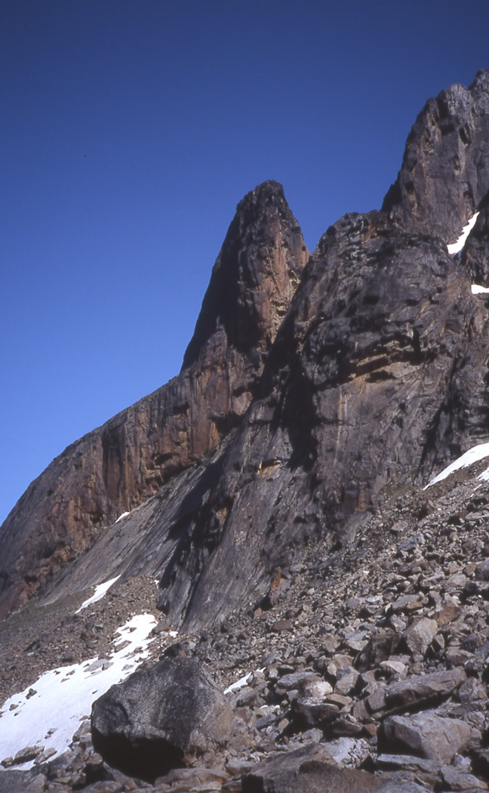
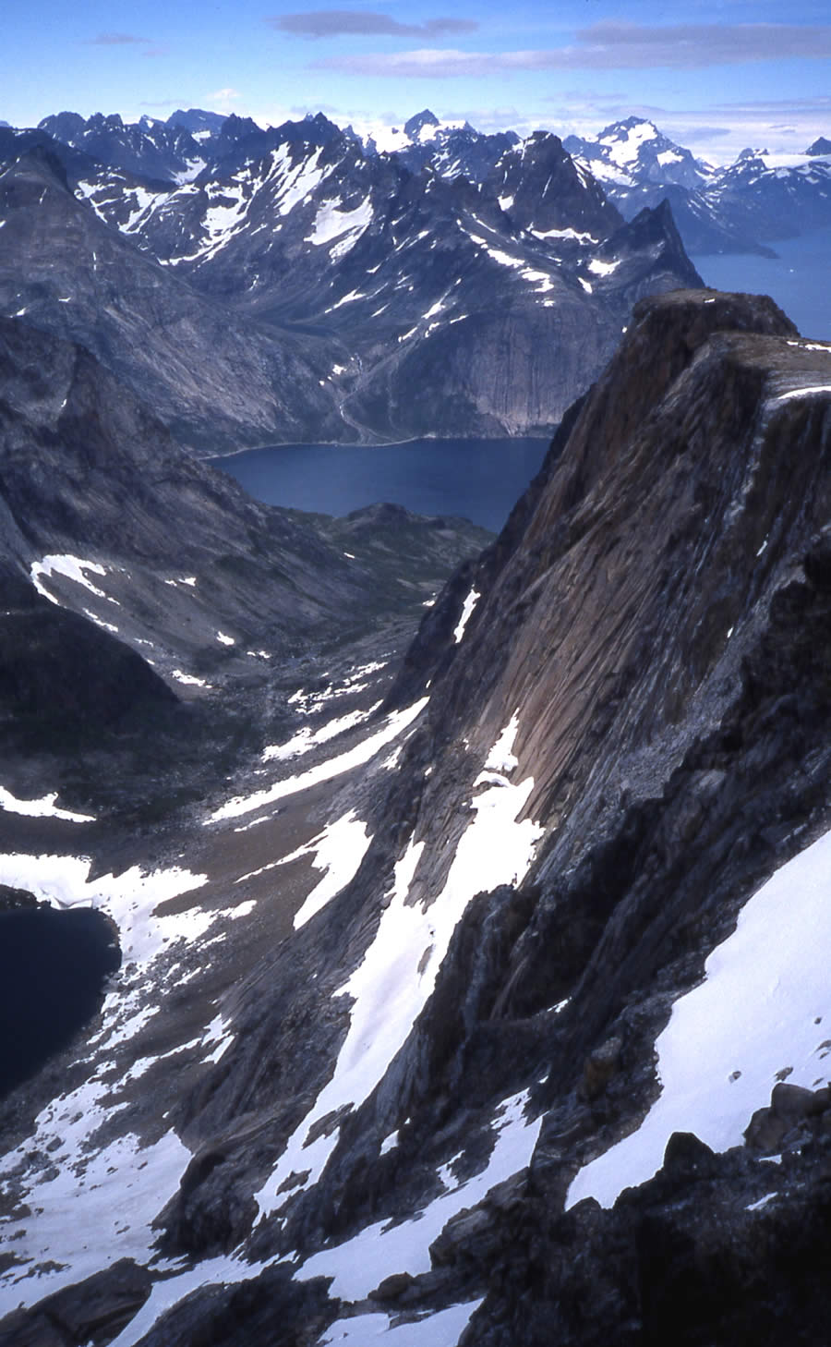
Figure 17. Two views looking north of the Red Tor ridge and Red Tower.
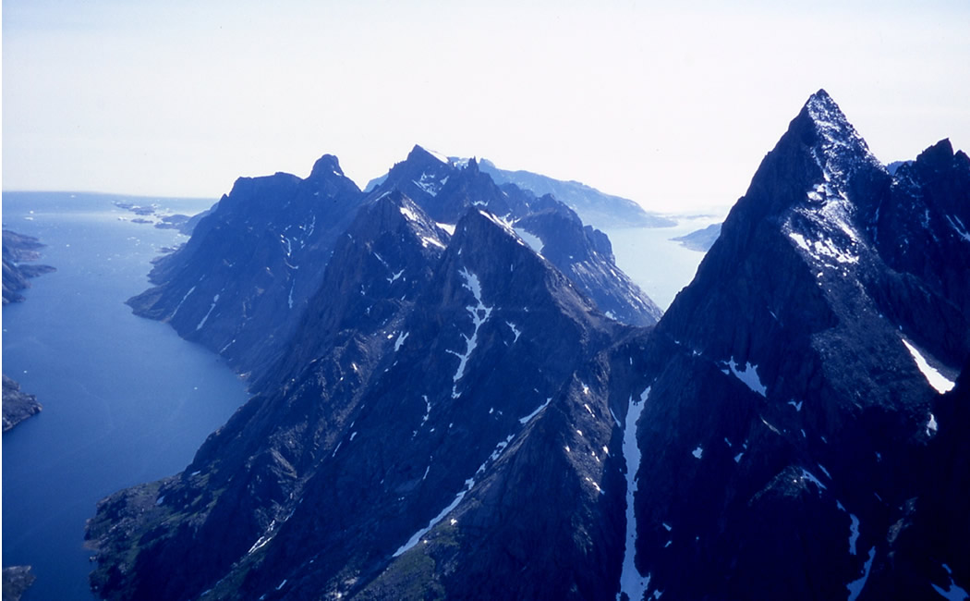
Figure 18. The view south past the Baron (right) from Consolation point.
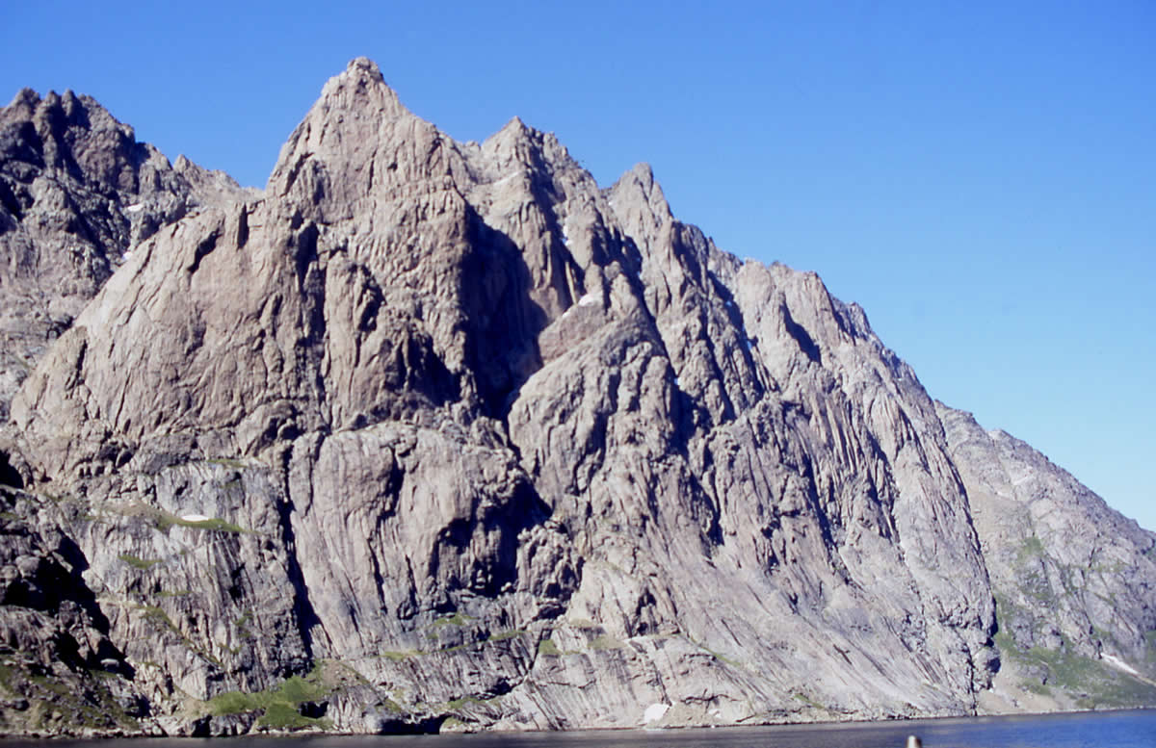
Figure 19. The “Sea cliff” on the western shore of the fjord below the Berkeley Peaks.

Acknowledgements.
All the expedition members would like to thank the following for their contributions towards the financing and success of the expedition.
- The Mount Everest Foundation for financial Support.
- The UK Sports Council and BMC for financial Support.
- The Karabiner Mountaineering club for financial and moral support.
- Alan Jones.
- Norcott Technologies for electronics support (solar panel) and provision of “office facilities” for the leader.
- Unicorn Grocery, Manchester for discounted groceries. (www.unicorn-grocery.co.uk).
- Cotswolds, Manchester for their efforts in getting some of the gear we needed, and discount.
- Fuji & Agfa for donations of Slide Film.
And of the others who gave of their advice and assistance;
- Niels Taekker Jepson of the Nanortalik Tourist Office, the “Mr. Fixit” to whom nothing was too much trouble.
- Tony & Sarah Whitehouse for advice.
- Jim Gregson who started us off.
- Ian Hey for some ‘advertising’ slides.
- Dave Wylie for waiting by the phone, acting as our Home Contact, and posting the expedition progress on the club website www.karabiner.org.
- Dave Kenyon for going that bit further on our self-rescue training course.

Appendices.

Routes.
Route Name | Grade | Length | Climbers | Where | Date
Baron Greenback | E1 -,4a,4b,5a,5a,-,5a,-,5a,5a,-,5b,4a,5b,5b | 900m | IH, SS | South face of Baron | 16/7/04
Baron Mϋnchausen | E3 4b,5c,6a,5c | 225m | IH, SS | South face of Baron | 29/7/04
Baron NE ridge | AD | ~1500m | DL, AM | The Baron | 26/7/04
Black Fly Chimney | S | 30m | AM, JV | West side of fjord below PC couloir | 15/7/04
Bone Idyll | E3 -,5c,4a,4b,5c,5a, 5c,6a,- | 665m | DL, IH | Bonemachine (‘A’) Buttress | 22/7/04
Chicks | HS 4a | 27m | AM, JV | West side of fjord below PC couloir | 15/7/04
Consolation point, S ridge | D+ 4c/5a | 1000m | DL, DB | Pt 1300m | 14/7/04
Cornice Peak, N ridge | PD | 700m | DB, IH | S of Baron | 13/7/04
Dr. Gonzo’s Deviations | E2 5a,5b,5c,5a | 200m | DL, RA | Fat City Buttress | 25/7/04
Dr. Gonzo’s Deviations (variation) | E1 -,5a,5b | 90m | SC, RA | Fat City Buttress | 29/7/04
Drop the Dead Donkey | E2 5c,4c,4c,5b,4c | 260m | DL, DB | Baron’s Appendage | 29/7/04
‘uck a Duck | E3 5c | 22m | DL, RA | Black Fly Buttress | 16/7/04
Irritating Parasites | E2 5a,5a,5c,5b | 120m | DL, DB | Black Fly Buttress | 15/7/04
KMC peak and Red Tor from NE | D | 3500m | DL, DB | N of Pt.1300m | 31/7/04
Lord & Lady Berkeley’s Peaks by N ridge | AD | 1000m | DB | S of Baron | 16/7/04
Mingy Midge Ridge | HVS 4b,5a,-,4c,-,5a,5b | 760m | SS, IH | West side of PC couloir | 14/7/04
Mosquitoes in Mocassins | E2 5c,-,4c,4b | 140m | DL, RA | Black Fly Buttress | 16/7/04
Mustn’t Crumble | E2 6a | 25m | SS, IH | Black Fly Buttress, lower tier | 1/8/04
Nana Disco | VD | 42m | JOR,SS, IH | Nana Buttress (on peninsular) | 28/7/04
Punta Cosulich S ridge | E1 4c,5b,- |  | DL, SS | S of Pt.1300m | 13/7/04
Red Arse, White Rasta | E1 5b | 30m | IH, SS, JOR | Black Fly Buttress, lower tier | 19/7/04
Scott of the Arctic | E1 5a,5a | 110m | DL, SS | Kangerlussuaq | 9/7/04
Shelob’s Ridge | AD | 200m | DL, DB | Below Butler | 17/7/04
Short and Sweet | E1 5b | 15m | IH, SS, JOR | Right of Black Fly Buttress | 19/7/04
Stevie’s Spider Spanking | E3 5b,4b,5c | 105m | DL, SC, AN | Black Fly Buttress | 1/8/04
Unfinished Business | E3 4b,4a,4c,5b,4b,5c |  | SS, IH | Consolation Point west face | 26/7/04

Topos & pictures.

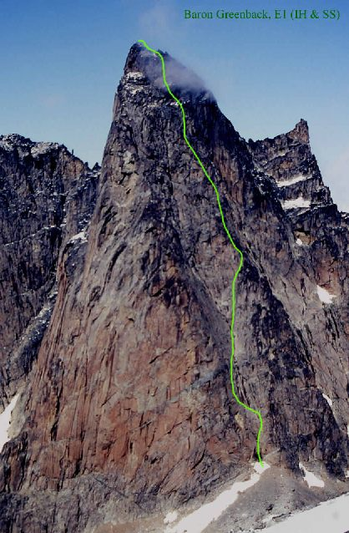
The Baron area.
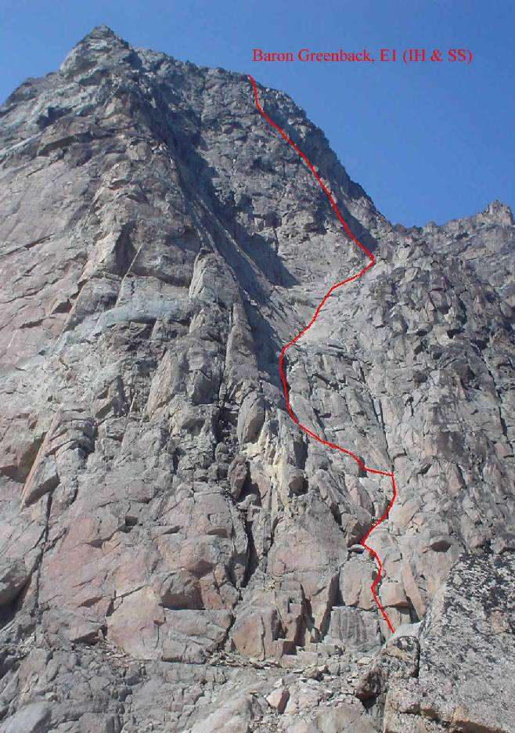
Figure 20. Views of the SE face of the Baron.
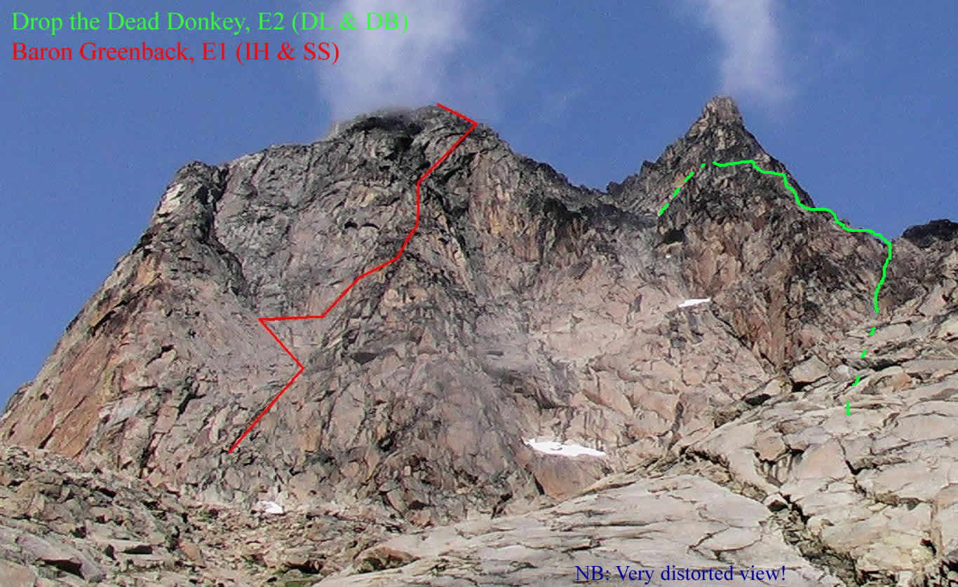
Figure 21. The East side of the Baron & appendage from the Baron Couloir.

Baron Greenback.
P1 – 60m: Start just to the right of the scree of the col, below the scoop – easily up steps and corners slightly rightwards to a deeper corner.
P2 – 4a 60m: A ramp to the left, then up cracks to the left of some slabs, belaying on the left.
P3 – 4b 60m: Up then to the right and up a 2nd crack to level with a ledge with a large block. Up the crack on the right to stop where it forks.
P4 – 5a 60m: Take the right hand crack-line with the harder moves round a bulging section.
P5 – 5a 60m: Cracks lead up and left to a double tiered ledge. Take steps up and right, then up a crack to below a small pinnacle.
P6 – 40m: Up a crack behind the pinnacle, then out right to a flattening in the SE ridge of the Baron.
P7 – 5a 60m: Up and round flakes to the right, then up a crack onto a black cornflake covered slab. Follow intermittent cracks to exit up a short crack to a pinnacle.
P8 – 60m: Chimney behind a pinnacle, then follow the ridge.
P9/10 – 5a 60m, 10m: Cracks lead right to a pair straddling a pyramidal block, then up left to an area of slabs with a hanging belay on their left. Cross the slabs to the right.
P11 – 60m: Easily up a system of ledges, then scramble left to a toothed block.
P12 – 5b 60m: Up the left of the block, onto the pinnacle behind, cross to its left arete, then to its top, stepping onto more slabs, which are followed leftwards to a ledge.
P13 – 4a 60m: Follow a crack in the slabs to the right, then another up left to a small roof. Two more sections of crack in slabs follow before a ledge.
P14 – 5b 60m: Up hollow flakes and slabs, to a rightward slanting crack under a roof, exiting via a crack that zig-zags left ending in another area of slabs.
P15 – 5b/c 60m: Up the slabs to the right, to zig left between two small overlaps, then out right to the summit ridge – 30m scramble to the summit.
Descent: 8 abseils and down climbing straight down the centre of the scoop to the start.

Drop the Dead Donkey.
Approach: Turn right out of the Baron Couloir and ‘scramble’ up a prominent square cut gully in the south side of the Appendage east ridge, with a couple of 4c-5a steps, to arrive at a platform on the ridge.
P1 – 5c 55m: start at a shallow left facing corner off the left side of the platform. Up the thin crack with hard moves round a small roof and continue up the crack-line to arrive at a small ledge below a wall.
P2 – 4c 25m: Take the deep crack in the wall to a deep platform to belay at the back in the leftmost corner capped by blocks.
P3 – 4c 60m: Up the corner to the blocks, traverse left under the blocks to the arete, then up the arete to a crack leading to a long narrow ledge.
P4 – 5b 55m: Take the leftward slanting ragged crack-line in the wall behind and pull over onto a triangular ledge. Jam the corner crack over a small roof, then traverse left and up to a ledge. Take the left slanting gutter, to belay by some blocks.
P5 – 4c 60m: Continue to the top of the gutter, then swing right and up under a block onto a ledge system. Work up left via ledges and walls to a forked lightning crack landing one on a ledge with a belay block.
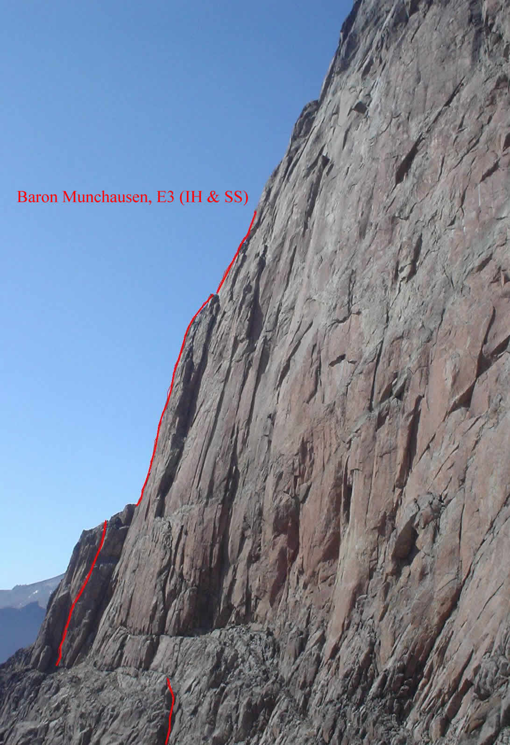
Descent: The last belay is on the level of a terrace – scramble down the open gully at its centre, abseil over the overhangs, then scramble on down then east across the face to level with the starting platform, then abseil down into the approach couloir.
Figure 22. Baron S wall from col.

Baron Münchausen.
P1 – 4b 60m: From left of col, climb up chossy ledges and crack to the right end of a ledge system (peg). Walk left for 50m to below a 10m column leaning against the main wall.
P2 – 5c 60m: Follow the sustained crack to the bottom of an overhanging block/flake – gingerly over loose blocks and flakes to belay on the left. Scramble for 10m to a ledge with jammed flake.
P3 – 6a 55m: Take the 20m crack and corner from the right end of the ledge to another ledge, then the finger crack and slab, past a chock-stone, to a belay on the left on more flakes.
P4 – 5c 50m: Up the flared crack/chimney, then break out right on hollow and loose flakes to the foot of a slab. Abandoned due to a surfeit of hollow flakes, and abseiled down the route.

Black Fly Buttress.
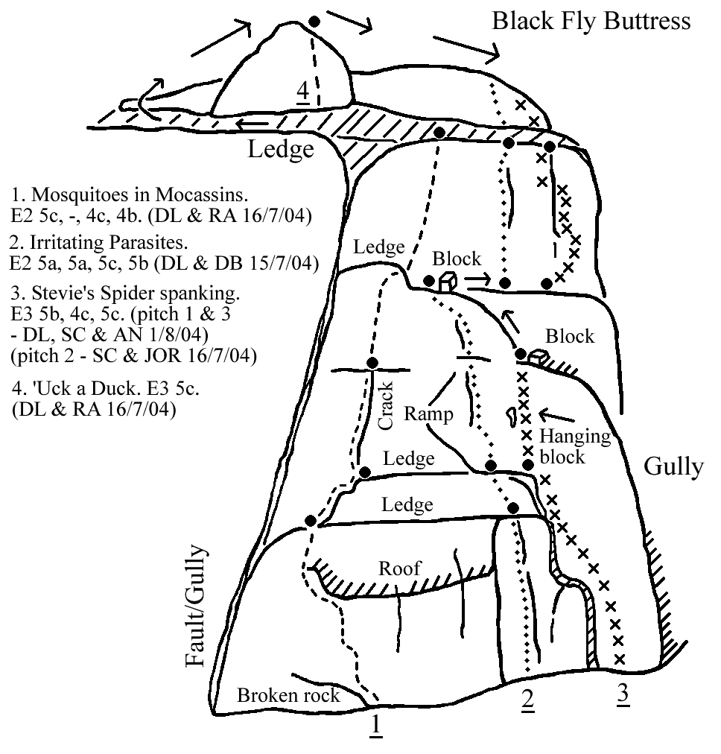
This buttress is the upper tier of a broken series of rocks to the left of a deep gully heading skywards, separated from the lower tier, which is immediately left of the foot of the gully above the snow patch, by a grass rake. The prominent feature is a roof in the centre, low down, with a bulging nose to the right split by the crack-line of Irritating Parasites.
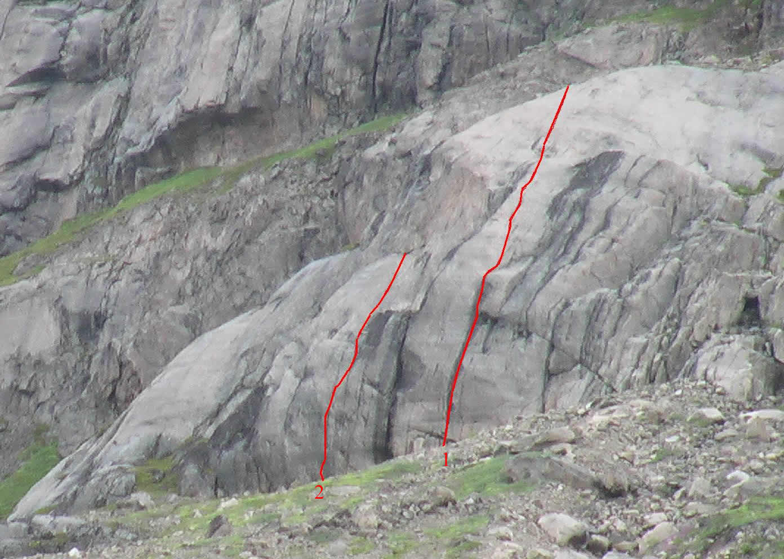
On the lower tier, there is to the right of a deep, wet crack, the crack-line of;
Figure 23. Lower tier, Black Fly Buttress.
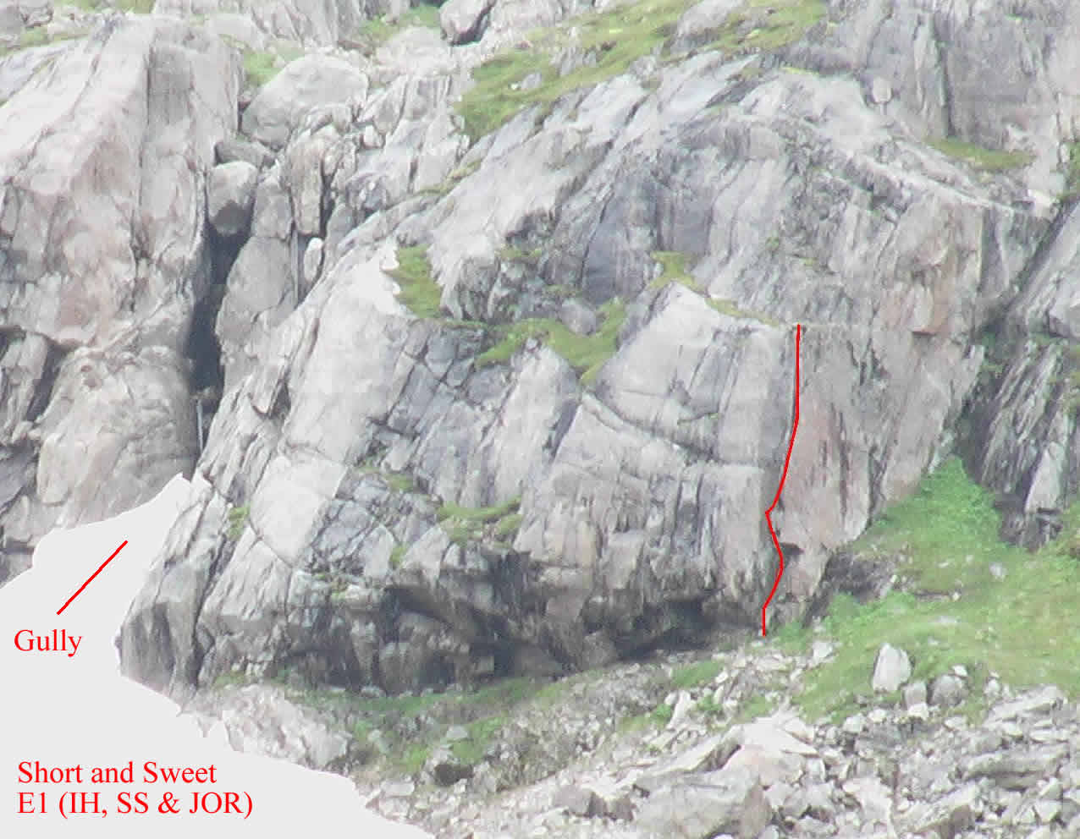
- “Red Arse, White Rasta”, E1.
Figure 24. Lower Right Black Fly Buttress.
And to the left…
(2) “Mustn’t Crumble”, E2.

Fat City Buttress.
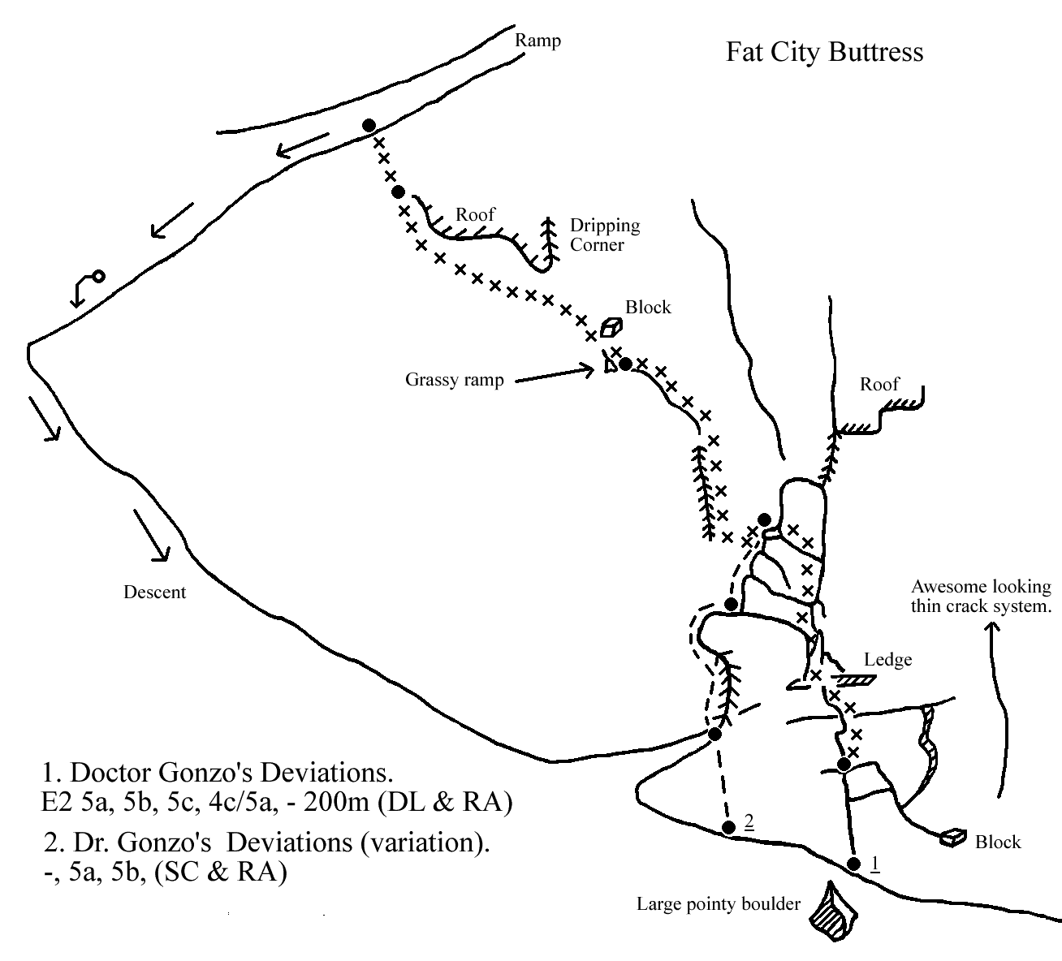
This buttress rises above the top of the first large scree cone encountered just before outflow of the first tarn, to the left of Shelob’s ridge and ‘B’ Gully.

“Bone Machine Buttress” (‘A’ Buttress).
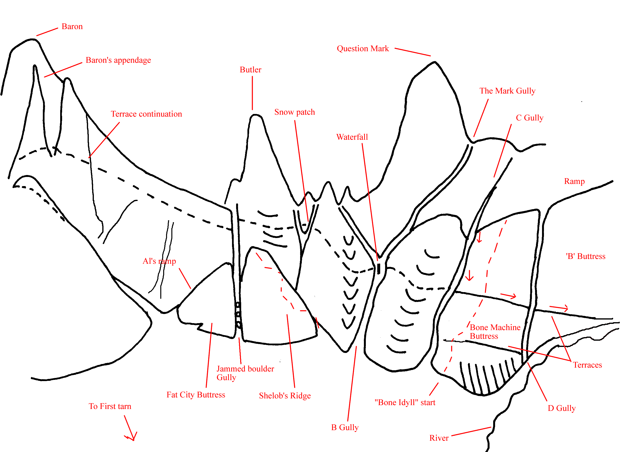
Figure 25. The Gullies and Buttresses to the East of the Butler.

“Bone Idyll” E3.
P1 – 250m: Start at bottom left corner of the buttress and scramble up to gain a large vegetated terrace, belaying where a slabby rib drops down to the middle of the terrace. (Flake belay).
P2 – 5a 60m: Climb the slabby rib and cracks above, moving slightly left to climb a blocky corner.
P3 – 4a 60m: Vague chimney system and vegetation.
P4 – 4b 60m: Cracks and slabs directly above to reach another large vegetated terrace.
P5 – 5c 55m: Follow the right hand of 3 corners to a small ledge.
P6 – 5a 50m: The slab above, moving slightly leftwards to gain a right slanting stepped corner. Climb this for 10m to a belay.
P7 – 5c 60m: Step down then move left round the arete to gain a flake system – run the rope out.
P8 – 6a 50m: Climb the groove and its left arete to reach a thin crack below a prominent red corner (peg). Teeter right, then up into the corner, which is followed to a ledge at the top.
P9 – 20m: Escape left up the lower of two ramps.
Descent: Scramble left towards gully for 50m, then follow a grassy ledge, back onto the face. Climb down 5m to a spike, two 60m abseils, and a 50m abseil to the top of the vegetated terrace. Follow this towards the col.

Point 1300m Area.
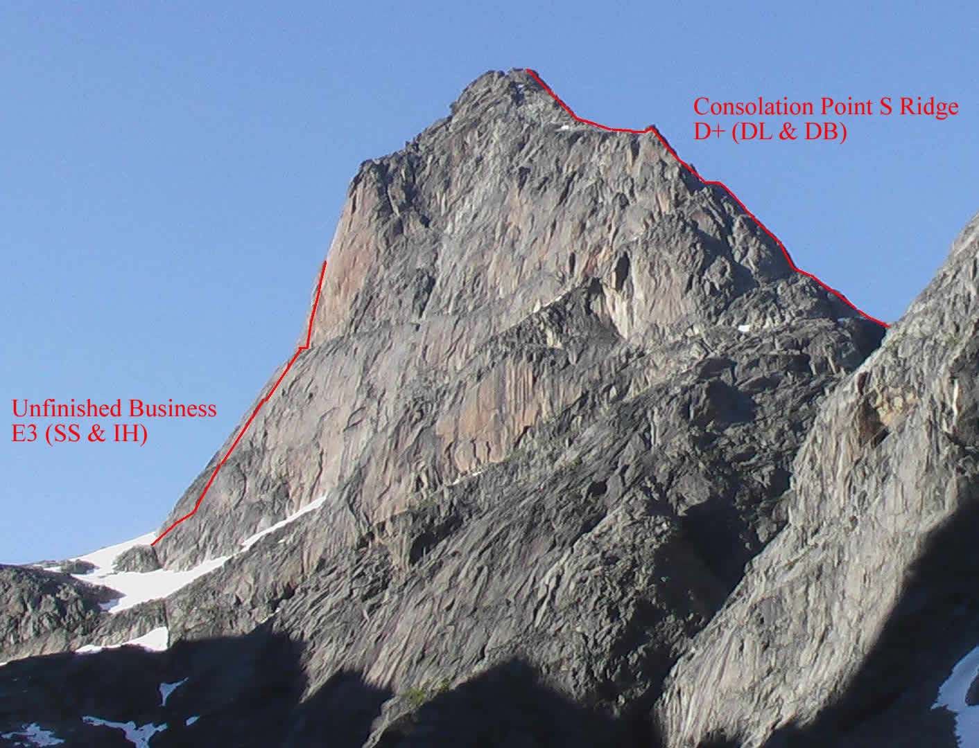
Figure 26. Pt. 1300m from the SW.

“Unfinished Business” E3.
Start from the top of the steep river narrows – crossing to the east and up scree and ledges to a terrace above the bluff that faces the tarn, then up to another terrace with a snow patch. Descent is possible over to the left here.
P1 – 4b 60m: From bottom right of snow, climb the walls leftwards for 20m, then up a chossy groove.
P2 – 4a 60m: Continue up the chossy groove then ledges. Climbing becomes cleaner at end of rope.
P3 – 4c 50m: Climb the offwidth crack for 20m, then up easy ground. Belay on big ledges below a slabby crack and corner on the left side of a pinnacle.
P4 – 5b 50m: Climb to the top of the pinnacle, then up a slabby hand jam crack. Near the top (wet), delicate moves right for 3m, followed up traversing up and right leads to a very hollow sounding overlap (crux). Pass this with a tricky move up the crack on the left. Belay at a small grassy stance in the crack.
P5 – 4b 50m: Continue up the hand jam crack to belay on big ledges below the steep upper walls.
P6 – 5c 65m: Layback up a huge flake for 10m, then traverse left over slabs to a steep crack. Hand/fist jam this until it eases back , to the foot of a flared chimney. Climb this strenuously (or escape round to the left) to a sustained corner. A large sloping ledge is a few metres above.
Descent: Abseil to the snow patch (abandoned due to rain).
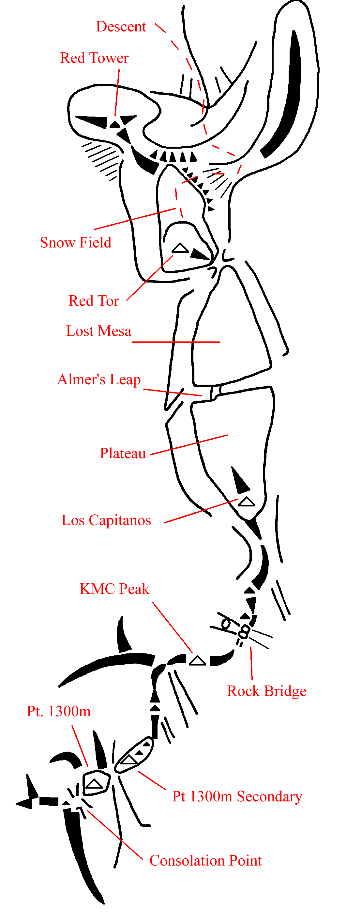
Figure 27. Pt 1300 to Red Tor ridge topo.

Punta Cosulich.
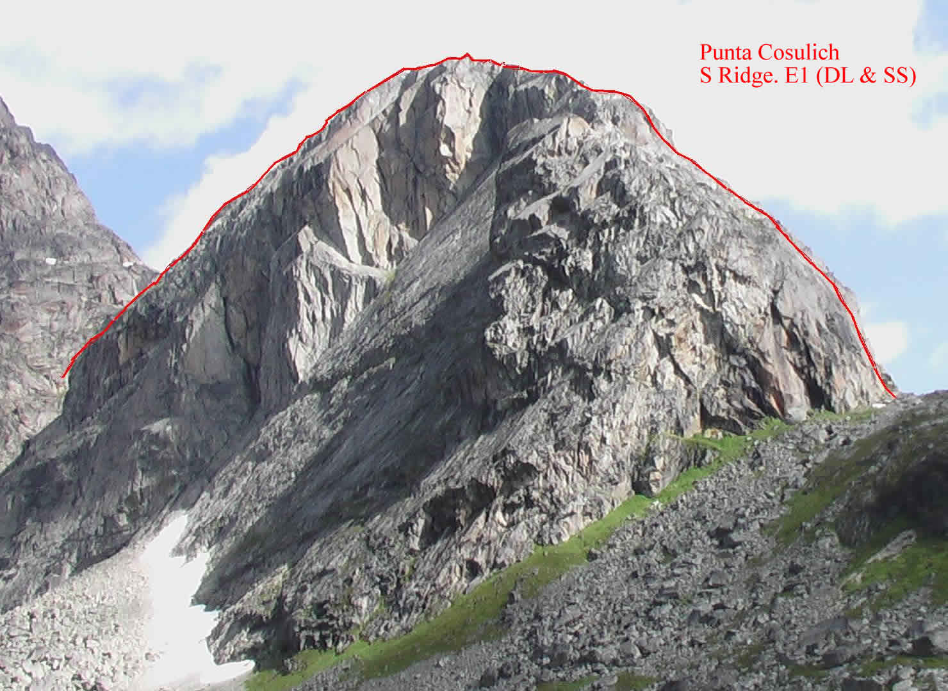
Figure 28. Punta Cosulich from Base camp.

S Ridge.
P1 – 4c: Start at crest of the flat ridge – climb up and left to a chimney. Up this to belay on the top of a slab to the left.
P2 – 5b: Jam a wide leaning crack above, to work back left via a loose crack, belaying to the left of a grassy ledge. From there a VD pitch leads to an exposed loose ridge above the giant slab. The summit is a long way back.
Descent: From the summit continue north and descend into the west facing gully. One abseil. A steep wet gully is followed to SOB couloir.

Mingy Midge Ridge.
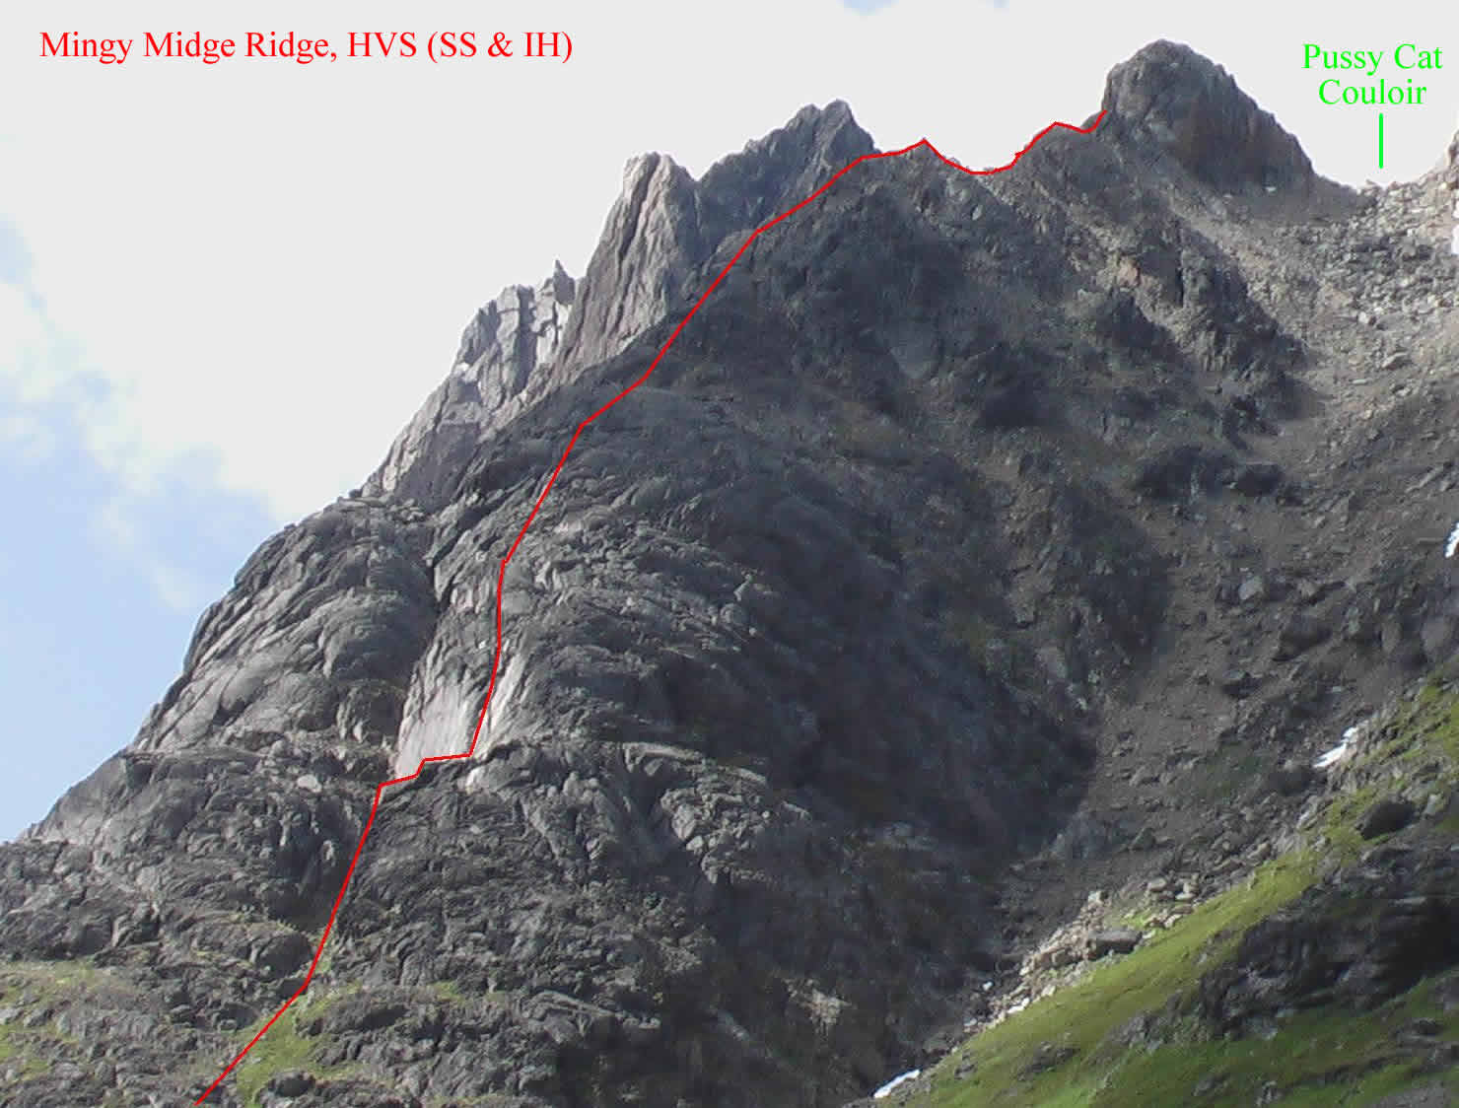
Figure 29. Mingy Midge ridge from Base camp.
Start at the right hand slabs above a steep grass/moss slope, left of Pussy Cat couloir – another grassy slope leads to a spike belay at the base of a big right facing corner, which is climbed for 5m. Traverse right onto slabby arete, and up for 20m to poor belays. Climb the loose gully to the left for 20m, then traverse up and right to belay on the ridge. Follow the ridge to a boulder, scramble up right to a huge slab, and climb the groove to its right, finishing up a black cornflake crack. Scramble up the ridge to a final wall below the summit. Take the lay-back crack to a boulder pile.

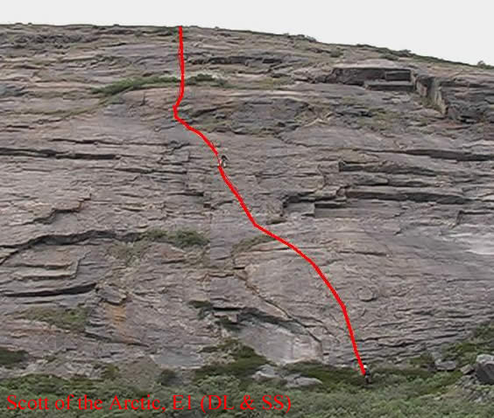
Kangerlussuaq amusements.
Figure 30. Ridge backing the Airport.
The walls and slabs behind the airport terminal building are often loose and vegetated and have disheartening protection. This two pitch route is found by turning left out of the airport building and its start is in front of a culvert, 20m beyond a painted boulder. Descent is well off to the right.

Weather record.
Greenland’s weather for a month…
Date | AM | PM | Evening | Comment
10th July |  |  |  | Sleeting on Arrival in Nanortalik
11th July |  | ⋅ |  | Dull overcast day
12th July |  |  |  | Rained lightly for 18 hours
13th July |  |  | → | Start of a fine spell
14th July |  |  | →
15th July |  |  | →
16th July |  |  | → Γ
17th July | ➢ Γ | ⋅ | → Γ | Start of unstable period
18th July |  F |  F |  F
19th July |  Γ | ➢ F | →
20th July |  |  | 
21st July |  |  | 
22nd July |  |  | →
23rd July |  |  |  | Wettest day of all – stream appeared under base camp tent. Leader away all day under an overhanging boulder.
24th July |  |  |  | Dull Driech day
25th July |  |  | 
26th July |  | ➢ | 
27th July | ➢ F |  F |  | Light showers all day
28th July |  |  | 
29th July | ⋅ |  | → | Return of a long fine spell
30th July |  |  | →
31st July |  | ⋅ | →
1st Aug |  |  | →
2nd Aug | F |  F | →
3rd Aug |  |  | →
4th Aug |  |  | →
5th Aug |  |  | ⇒ | Finest Display of Northern lights
6th Aug |  |  |  | Unfortunately clouding up as we flew out.

Finances.
The final ‘detailed’ accounts of the expedition are given below.
Detailed Expedition Finances
Income |  | Expenditure
MEF Grant | £350.00 | Airfares | £11,003.20
BMC Grant | £900.00 | Boat Charter | £1,192.30
KMC Donation | £500.00 | Travel to & Parking at Stansted | £522.00
Donations | £50.00 | Other Travel expenses | £52.21
Personal Contributions | £18,216.42 | Accommodation (Youth Hostels) | £1,752.43
 |  | Food Supplies in UK | £777.78
Average UK personal contribution = | £1,538.90 | Food Supplies in Greenland | £785.25
 |  | Fuel Supplies (Gas & Benzin) | £119.27
 |  | Tools, kitchenware, Gas regulators & hardware supplies | £250.76
 |  | Climbing Equipment | £52.45
 |  | First Aid Supplies | £330.85
 |  | Satellite phone rental & calls | £561.96
 |  | Expedition Emergency Equipment | £161.89
 |  | Expedition Research & reporting costs. | £121.24
 |  | Drums & packing materials | £105.92
 |  | Freighting Costs (return) | £850.00
 |  | Basecamp tent | £299.00
 |  | Pre-expedition training | £510.25
 |  | Other Equipment & expenses | £567.66
Total Income | £20,016.42 | Total Expenditure | £20,016.42

After subtraction of the donations, the average personal contribution for a UK member was £1540. This does not include the cost of Insurance arranged by the member, and does not include the inevitable new gear buying for the expedition. Some of the equipment obtained (£500+) then became property of the KMC for use on future expeditions.
The Leader’s bank account was used for the expedition funds with other members paying deposits into it, so the leader paid for much of the logistics. As there were large sums of money moving around, a spreadsheet, to keep track of funds, was constructed early on and all receipts for goods recorded there. For a group this large I’d recommend you didn’t do this but opened a ‘Club Treasurer’s’ style bank account, keeping personal finance separate.

Risk assessment.
The ‘simple’ risk assessment we did for the expedition.
Assessor: D.A. Bone | Revision: 02 | Date: 7-June-04
Risk Assessment for:  KMC 60th Aniversary Expedition.  Unsupported Rock and mountain climbing. | Location:  Kangerdluarssuk Fjord, Pamaigdluk Island, Southern Greenland. | Period Covered:  10th July – 2nd August 2004  1st Day in Nanortalik to return to Nanortalik from Island.
Exclusions:
Travel within UK.
Travel to and from UK to Greenland.
Stays in Copenhagen.
Internal flights within Greenland
Days in Greenland outwith the main expedition timespan.
Affected Persons:  Expedition members. | Reviewed by:  R. Allen, D Lee, S. Sadler, S. Cheslett, J Varley, J O’Regan, I Heginbotham.

Hazard | Risk Level | Probability | Control measures | Additional Controls for ALARP | Final risk level after measures
Polar Bears | Serious | Remote. Bears rarely seen in summer this far South (shot by this time!) | Greatest danger at basecamp – keep unused food in barrels.  Keep a tidy camp.  Flares kept to hand as deterrent. | Constructing trip wires and alarms around camp.  Would need a rifle to be carried (with permit etc) for lowest risk from bears at least. | Tolerable
River crossings (with significant water flow) | Serious | Probable.  River near basecamp could have melt water. | Lengths of Static rope and other equipment available to set up rope protected crossing points. Crossing points to be selected with care. Cross only in groups. | Long detours or a part of the island is inaccessible. | Tolerable
Tent Fire | Critical | Occasional | Cooking at base camp done only in the group tent. All cooking based on individual tents will be done in the open. Only in dire weather would tents be used | Water containers available to douse flames. Rear exit or knife for emergency exit. | Low
Crevasses | Critical | Remote | Areas with hazards small enough to avoid – snowfields rather than glaciers present. | Parties to rope up if suspect areas must be crossed | Low
Avalanche | Critical | Remote  Wet snow type. | Campsites not sited below large snowfield. Hazard will be temporary so areas at risk would be avoided for a stabilisation period | No further action practicable | Low
Slips, Trips, and Falls (unroped parties). On rock or snow. | Critical | Occasional | Solo forays in risky terrain discouraged. Parties to rope up and belays used were required when risk level rises. Ice axe arrest techniques. PPE (ice axes, crampons), training & experience – individuals will not cross large snowfields without equipment/skills. Individual judgement/responsibility. | Groups to carry First Aid kits. No further action practicable. | Medium
Slips and Falls (roped parties on steeper “climbing” terrain) | Critical | Occasional | PPE (helmets, climbing gear), training and experience (required by all party members). Experienced leaders in parties. Training in self rescue and advanced rope techniques. | No further action practicable | Medium
Rock/Stone Fall | Critical | Occasional. | PPE (helmets). Experience. Climbing as single group (most rocks dislodged by people). Observation prior to approach. Avoiding areas at major risk or at peak stone fall periods. Route choice and careful ropework. | No further action practicable | Medium
Cuts/wounds | Serious | Occasional | PPE (gloves, jackets, trousers), Medical supplies (personal/group/basecamp First Aid kits). All Team members strongly encouraged to have some form of field First Aid training. Medical experience of some members. | No further action required | Low
Serious Illness & condition | Critical | Remote | Basecamp First Aid kit, Medical experience of some members. Satellite phone for assistance (Hospital in Nanortalik, 50km away). Flares and backup supplies for phone. | No further action required | Tolerable
Foul Weather | Serious | Probable | PPE (suitable clothing, tents and sleeping bags). Base camp tents. Spare tents, equipment, and repair equipment. | No further action required | Low
Food shortage | Serious | Occasional | Food supplies to be calculated before expedition. 5 days spare food in case of delayed pickup. | No further action required | Tolerable
Fuel Shortage | Serious | Occasional | Fuel usage to be estimated before expedition (liquid and gas), and extra taken to cover for emergencies. | No further action required | Tolerable
Poisoning (eg. Food poisoning, Wild foods like mushrooms) | Critical | Remote | Mushroom/plant identification books taken. Only unambiguous identification will be consumed. Trial samples initially. Only fresh supplies consumed and storage minimised. Camp Hygiene. | No further action required | Tolerable
Water supply contamination (Giardia, silt, bacteria, etc) | Minor | Remote | Careful selection of water source (no Glacial flour, no regular inhabitation so Giardia unlikely, few animals). Camp hygiene. Basecamp First Aid kit. | No further action required | Tolerable
Immersion in Sea in unloading/loading | Serious | Occasional | Lifejacket borrow/hire for use on dinghy. Safety ropes on people & goods. Unloading ramp made of timber. Spare clothing available. | No further action practicable | Low
Insect Bites | Minor | Frequent | Variety of insect repellents available. Protective clothing. Mosquito netting for shelter. | People with known bad reactions will take after bite care (anti histamines etc). NB: Allergic reactions to be made known on Medical record and personal protective measures taken along if appropriate.. | Medium
Rabies | Critical | Remote | Avoid Dogs in Town. Avoid contact with Foxes on Island (Camp cleanliness). Keep clear of unusual animal behaviour | Rabies vaccination expensive. Further action impracticable. | Tolerable
Sunstroke | Critical | Occasional | PPE (hats, sunscreen UVA & UVB, lip salve, clothing). Hydration. | No further action required | Tolerable

Bibliography.
A number of books gave useful, not necessarily climbing related, information on the character of Greenland, etc.
- The lonely Planet Guide “Iceland, Greenland and the Faroe Islands”. Graeme Cornwallis & Deanna Swaney. ISBN 0-86442-686-0. Recommended.
- The Lonely Planet Guide “The Arctic”. Deanna Swaney. Covers North of the Arctic circle but has a useful supplement on Nature in the Arctic.
- Greenland Tourism brochures for Greenland and Southern Greenland. Available online (PDF) from www.greenland-guide.gl.
- A Tourist guide to the Nanortalik area is available from the Nanortalik tourist office on www.nanortalik.gl.
- Skarv Guides 1990: “Trekking in Greenland”. Torbjorn Ydegaard. Unfortunately out of print – keep an eye out in second hand shops.
- “The Arctic, A guide to Coastal Wildlife (field guide)”. Tony Soper, Dan Powell. Good for identifying whales if near the open sea.
- “The Arctic and its wildlife”. Brian Sage. Flora and Fauna.
- “A Naturalist’s Guide to the Arctic”. E.C. Pielou. ISBN 0226668142. Arctic landscape features as well as flora and fauna. Very good.
- “Greenlandic for Travellers”. Birgitte Hertling. ISBN 8755809804. Two dialects in Greenlandic – a phrasebook, that may supplement a Danish phrasebook. We ordered one but cancelled, for it to arrive at NHBS the day before we left!
- “Flowers of Greenland”. Feilburg, Fredskild & Holt. ISBN 8799713071. Bilingual. Essential and easy to use book for identification of plants in Greenland.
- “Groenlandske fugle”. David Boertmann, Jon Fjeldsa. Bird book in Danish, which we couldn’t buy for the trip.
- Mushrooms: Dorling Kindersley Handbooks. Thomas Læss∅e. ISBN 0-7513-2727-4. Clear pictures.
- Mushrooms: Peterson Field Guides. Kent McKnight & Vera McKnight. ISBN 0-395-919900. Good range – North American based.
- The Lonely Planet Guide “Denmark”. Glenda Bendure & Ned Friary. ISBN 1-74059-075-9. Useful information for transit through Copenhagen.
- Royal Geographical Society “Expedition Handbook”. Ed. Shane Winser. ISBN 1-86197-0447. Useful reference text for planning expeditions.
- Royal Geographical Society “Expedition Medicine”. Ed. David Warrel & Sarah Anderson. ISBN 1-86197-4345.
- The Mountain Traveller’s Handbook. Paul Deegan. (BMC) ISBN 0-903908-47-6.

Websites & Contacts.
Adventure Lifesigns. http://www.adventurelifesigns.co.uk. Will run in-house or residential First Aid Courses, and supply First Aid Kit items.
Air Iceland: www.airiceland.is.
Air Greenland: www.airgreenland.com.
Arctic Experience arrange tours to Arctic regions: www.arctic-experience.co.uk.
Arctic Umiaq Line (Ferries in Greenland): www.aul.gl.
Blue Water Shipping: General Freight firm who arranged our freight: www.bws.dk.
Contacts: Steve Townsend. stownsend@bws.dk (0161 406 3380). Ole Ulriksen. oulriksen@bws.dk.
The BMC: www.thebmc.co.uk. Contact for Insurance.
Bridgefoot Cattery: 07775 943601, 01279 871701. Parking near Stansted.
Customs and Excise (UK) – essential source of notices and forms: www.hmce.gov.uk.
Local help: “enquiries.nw@hmce.gsi.gov.uk”.
Customs and Excise (UK) – helpful contact from the Cardiff Office.
Glynn Williams. 02920386255.
Danish Polar Centre: www.dpc.dk.
Contact: Poul Henrik Srensen. phs@dpc.dk for expedition approval.
The Danish Polar Centre has a section on mounting expeditions to Greenland, with many fascinating pages on all aspects.
Danish Youth Hostel Association: www.danhostel.dk.
DTI – for licensing of technical goods (can it have a military application?): Contact eco.help@dti.gsi.gov.uk.
EasyJet for Flights to Copenhagen: www.easyjet.com.
Eimskip (Danish shipping Agents with offices in UK): www.eimskip.com.
Mike gave us useful advice on customs procedures they use.
Contact: info@eimskip.co.uk.
German climbing activities on Pamiagdluk in 1995: www.vogeley-unlimited.de/activities/ uummanarsuaq.htm.
German climbing activities on Pamiagdluk in 1996: home.t-online.de/home/stefanholzmann.
Greenland Geological survey: www.geus.dk.
Greenland Tourist information: www.greenland.com.
Greenland Travel: www.greenland-travel.dk.
Contact: Mr. Espen Andersen. ea@greenland-travel.gl. Arranged our travel – very helpful.
Harcostar Drums Ltd. Local supplier of plastic drums and containers in Disley: www.harcostar.co.uk.
Contact: Deborah Sixsmith.
Iceland Express: www.Iceland-express.com. Cheap flights to Iceland.
International Youth Hostels: www.hihostels.com.
Kort & Matrikelstyrelsen (National Geodatabank, Miljφministeriet, Kort & Matrikelstyrelsen, Rentemestervej 8, DK2400, Copenhagen NV): www.kms.dk. For mapping of Greenland and Aerial Photos.
Contact: Nina Skaaning. nks@kms.dk.
Leman (Danish shipping Agent with office in Bradford): www.leman.dk.
Contact: koebenhavn@leman.dk.
Mobell Communications Ltd (satellite phone hire): www.mobell.com.
Contact: Jane Legzdins. jane@mobell.com.
Mount Everest Foundation: www.mef.org.uk.
Nanortalik Tourist office: “www.nanortalik.gl”.
Contact: Niels Taekker Jepsen. nanortalik@greennet.gl.
PO Box 43, 3922 Nanortalik, Greenland. 299 613633. He’s the local tourist officer with a lot of knowledge and contacts. Has “fingers in every pie” and travels a lot. Very helpful indeed.
NHBS Ltd, Totnes Devon. www.nhbs.com for general & specialist Science, Natural History and Travel Books (Our Greenland book supplier).
Private kayaking trip with a hike to Naujarssuit: see www.cortex.informatik.tu-ilmenau.de/~shauer/privat/photography/GREENLAND/gl_guide.htm for account and pictures.
Royal Geographical Society: www.rgs.org. Source of Expedition planning books and online articles. Index of past expeditions.
Rural Payments agency – for food export/import restrictions: Contact enquiries@rpa.gsi.gov.uk.
Snowcard Insurance services: www.snowcard.co.uk.
“Topas” – Travel agent in Copenhagen, partner with Arctic Experience, who can also book flights: www.topas.dk.
Contact: Mogens Gislinge. MG@topas.dk.

Picture credits:
Pictures from the team members, specifically; Fig.1 Rob Allen, Fig 16 Karel, Fig 18 Duncan, 20b, 21-24, 26, 28-30 Ian, Fig 15 Scott, with the remainder the editor.

